Table of Contents
Catalog
Table of Contents 1
Read Me 2
Part 1: Environment Setup 5
Part 2: User and Group Management 11
Part 3: Device Enrollment (Entra ID Join) 20
Part 4: Intune Device Compliance and Configuration Policies 27
Part 5: Email Configuration and Management 43
Part 6: Application Deployment and Management 51
Part 7: Security Baselines 54
Part 8: Device Maintenance, Updates, and Backup 55
Part 9: Windows Autopilot and Enterprise Onboarding 59
Part 10: Remediations and Scripts 65

Read Me

Overview
This project demonstrates the full design, deployment, and management of a Microsoft 365 Enterprise E3 environment built entirely within a personal home lab. It recreates the core functions of a real enterprise IT environment — covering identity management, device enrollment, security enforcement, collaboration tools, automation, and enterprise onboarding.
The lab was built from the ground up to simulate how IT administrators manage a modern cloud-based infrastructure. Every configuration, from initial tenant creation to automated remediation scripts, was performed through the Microsoft 365 Admin Center, Entra ID, Intune (Endpoint Manager), and Microsoft Defender for Endpoint.
Each section is documented in detail, including configuration steps, reasoning, and verification, reflecting hands-on understanding of enterprise-grade Microsoft 365 administration.
This project serves both as a learning environment and a portfolio demonstration, showcasing skills directly aligned with helpdesk, systems administration, and cloud security roles.

Objectives and Goals
The primary goal of this project was to replicate an enterprise Microsoft 365 environment and practice end-to-end administrative operations. The lab was built using a Microsoft 365 E3 trial tenant (ramneeklab.onmicrosoft.com) and included users, devices, policies, and services typically found in a corporate organization.
The project’s objectives included:
- Tenant and Environment Setup:
Created a new Microsoft 365 E3 tenant, verified the global admin account, and configured Multi-Factor Authentication (MFA) using Microsoft Authenticator.
- User and Group Administration:
Created 5–7 test users across different departments (HR, IT, Sales), assigned roles (including Helpdesk Administrator), and built both security and Microsoft 365 groups for collaboration and access control.
- Device Enrollment and Management:
Enrolled a Windows 11 virtual machine into Microsoft Entra ID and Intune, simulating real-world device onboarding and management scenarios.
- Policy Enforcement via Intune:
Configured compliance policies, configuration profiles, and security baselines to enforce firewall, antivirus, TPM, and Defender security standards across devices.
- Security Integration and Conditional Access:
Integrated Microsoft Defender for Endpoint (MDE) with Intune, deployed Endpoint Security and Attack Surface Reduction (ASR) policies, and configured Conditional Access to enforce MFA and device compliance before granting access.
- Email and Collaboration Setup:
Managed Exchange Online mailboxes, created shared and resource mailboxes, applied mail flow rules, and implemented anti-spam/malware policies using Microsoft 365 Defender.
Built Teams and SharePoint collaboration structures for communication and file sharing, and configured OneDrive Known Folder Move (KFM) for backup.
- App Deployment and Management:
Deployed applications using Intune, managed installations and updates, and enforced Managed Installer policies to control app access and maintain security compliance.
- Automation and Remediation:
Created Intune remediations and PowerShell scripts for automated issue detection and resolution, demonstrating practical automation for helpdesk efficiency.
- Windows Autopilot and Zero-Touch Deployment:
Implemented Autopilot Device Preparation (APv2) to simulate modern zero-touch deployment workflows, automatically provisioning new Windows 11 devices with policies, apps, and security configurations.

Key Skills Acquired
- Tenant Setup: Configured a Microsoft 365 E3 trial tenant with a custom domain and enabled MFA using Microsoft Authenticator.
- User/Group Management: Created users, assigned E3 licenses, managed roles (e.g., Helpdesk Administrator), and set up security and Microsoft 365 groups for access control.
- Device Management: Enrolled Windows 11 devices into Entra ID, enabled Intune auto-enrollment, and used Windows Autopilot for zero-touch deployment.
- Intune Policies: Applied compliance policies (e.g., firewall, antivirus, TPM), configuration profiles (e.g., Defender settings, Control Panel restrictions), and security baselines.
- Security: Configured Conditional Access for MFA and device compliance, integrated Intune with Microsoft Defender for Endpoint (MDE) for threat protection.
- Email Management: Set up user, shared, and resource mailboxes in Exchange Online, created mail flow rules, and applied anti-spam/malware policies.
- App Deployment: Deployed Win32 and Microsoft Store apps via Intune, enforced app control with Managed Installer.
- Maintenance: Configured OneDrive backups and Windows Update rings for automatic updates and rollback.
- Automation: Used Intune remediations and PowerShell scripts to automate issue detection and fixes.

Overall Summary
This lab built a functional Microsoft 365 E3 environment with 5–7 users, enrolled devices, and robust security. Key achievements included automated device setup with Autopilot, secure email management, and enforced compliance via Intune and MDE. The project mirrored enterprise IT operations, addressing challenges like policy delays and demonstrating practical admin skills. It serves as a portfolio piece, with potential for future exploration into Power Automate or hybrid setups.
These skills align with roles in IT helpdesk, system administration, or cloud security, supporting certifications like MD-102 and MS-500.

Part 1: Environment Setup

1.1 Creating a Microsoft 365 E3 Trial Account
- Go to the Microsoft 365 E3 trial page
- Click “Start free trial” and sign in with your Microsoft account or create a new one.
- Fill in your details, such as name, company (you can use a test company), and contact info.
- Verify your account via email or phone as required.
- Complete the setup to access the Microsoft 365 Admin Center.
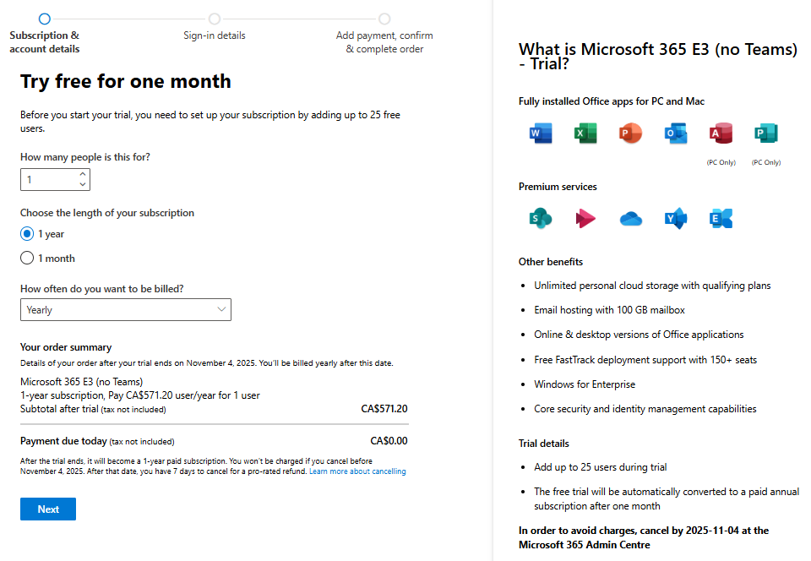
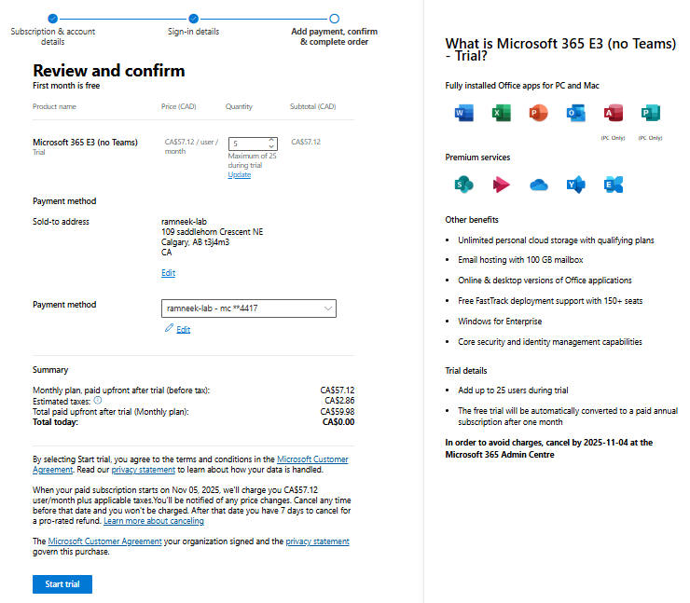
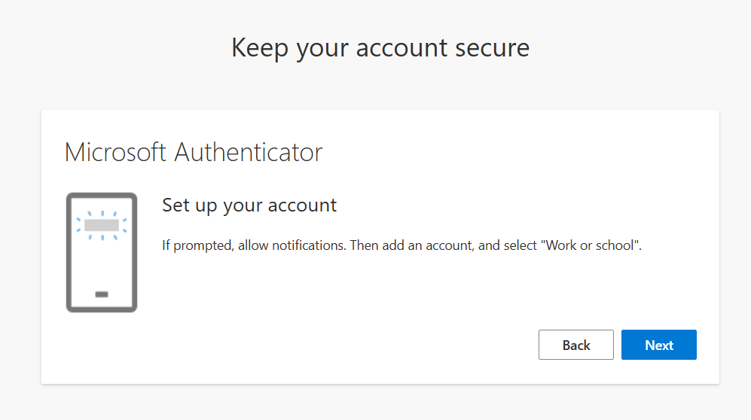
Complete the Microsoft authenticator steps to add MF.
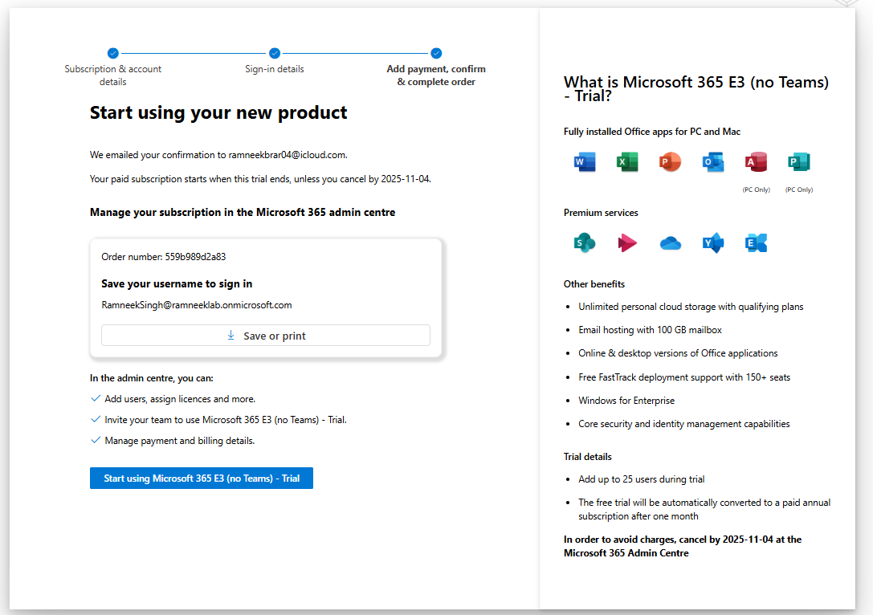
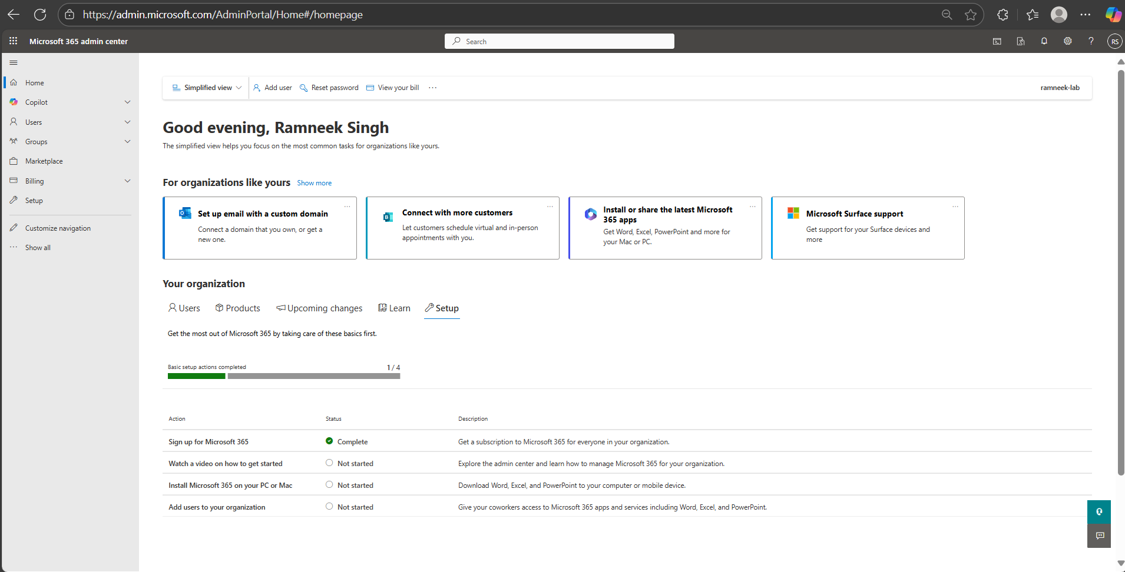

1.2 Accessing the Admin Center
- Go to https://admin.microsoft.com and sign in with your new account.
- Explore the dashboard:
  - Users → create and manage users
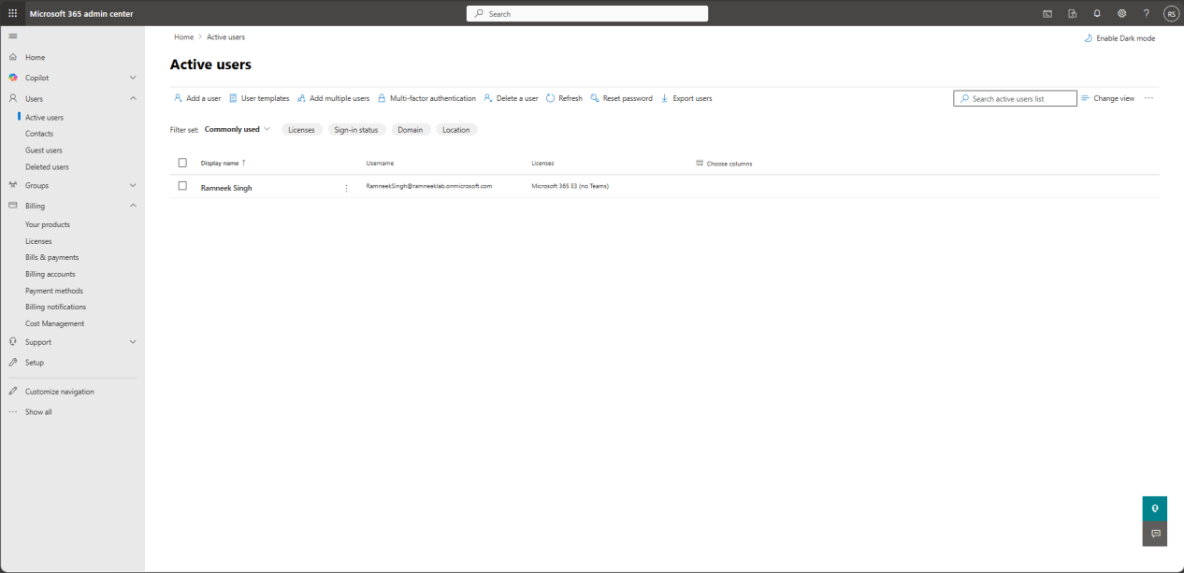
  - Groups → security and distribution groups
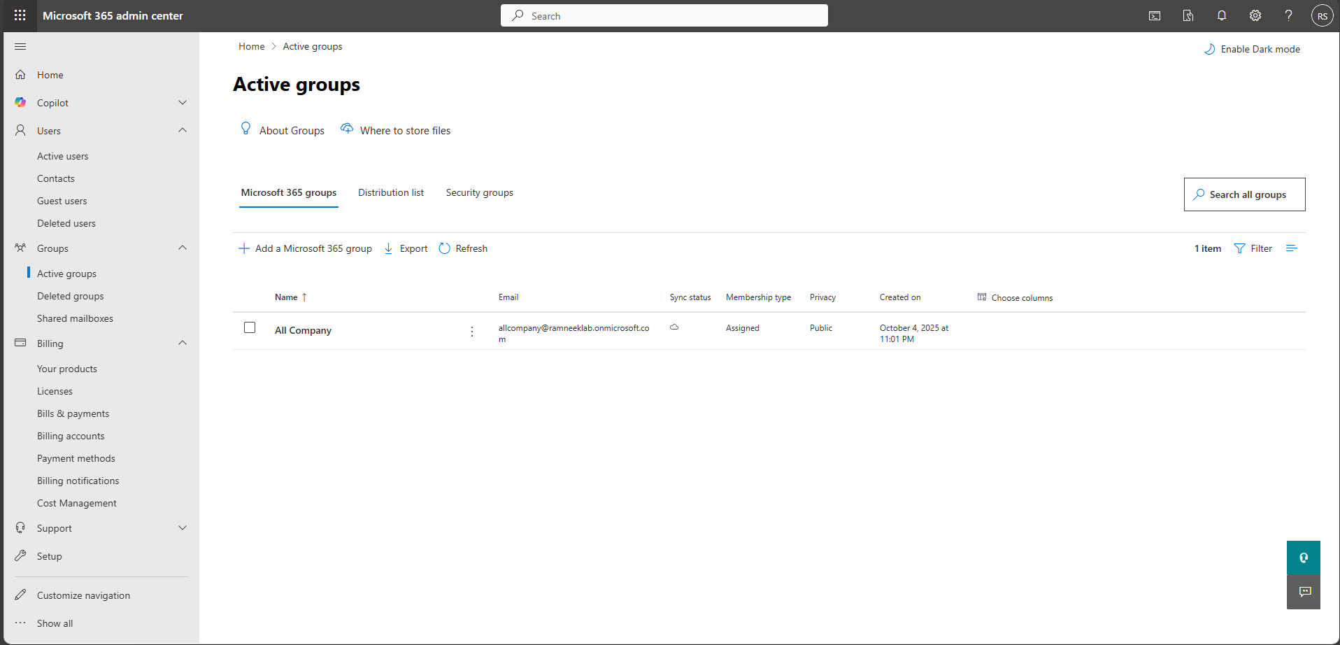
  - Billing & Licenses → check your active licenses
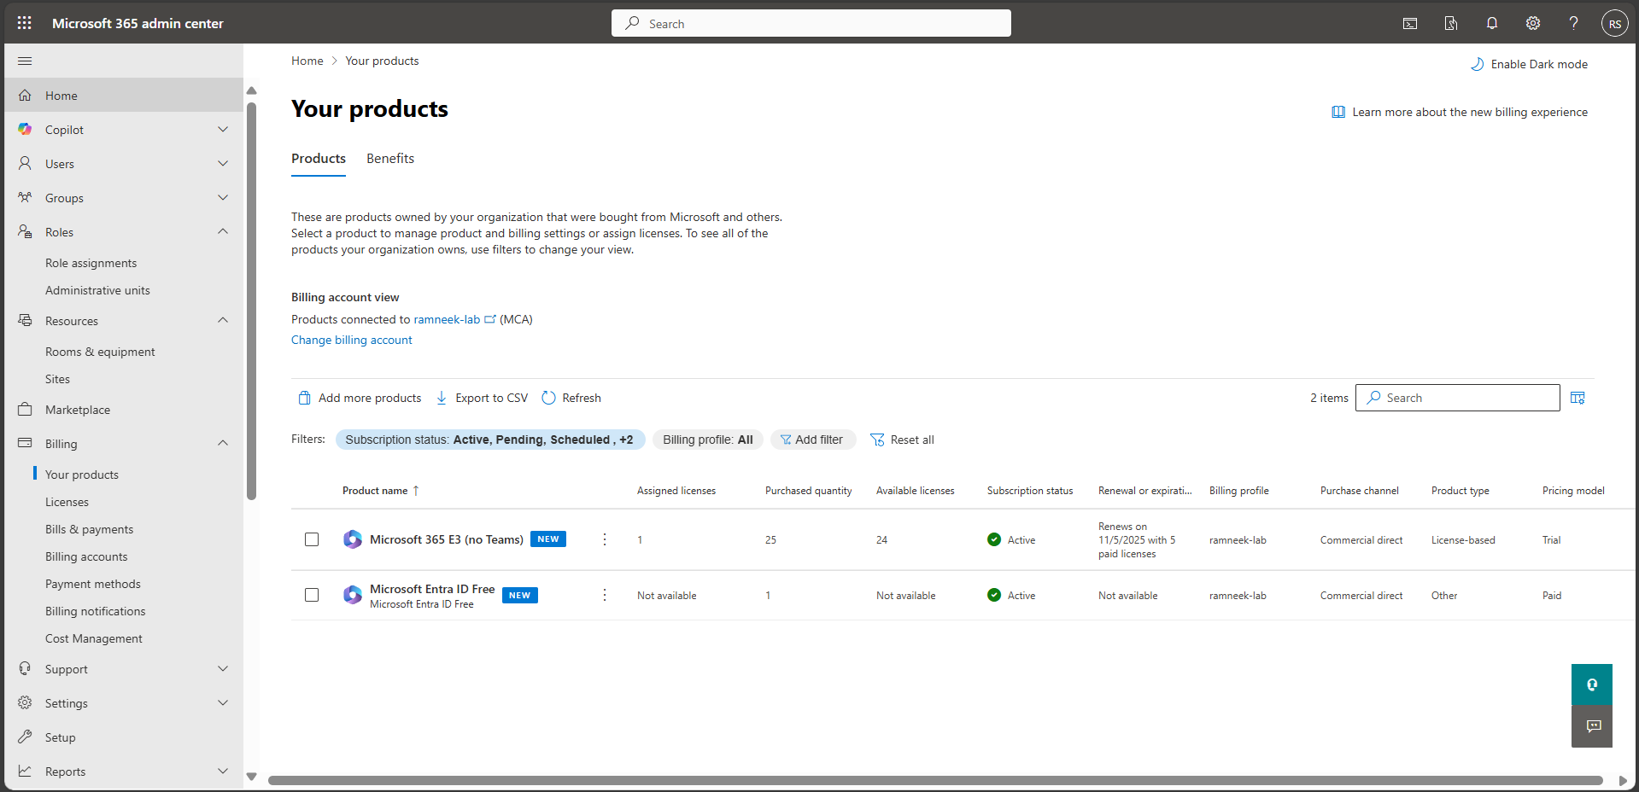

1.3 Domain Setup (Guided Setup)
To make the environment closer to a real organization, the guided setup helps configure your domain and initial settings:
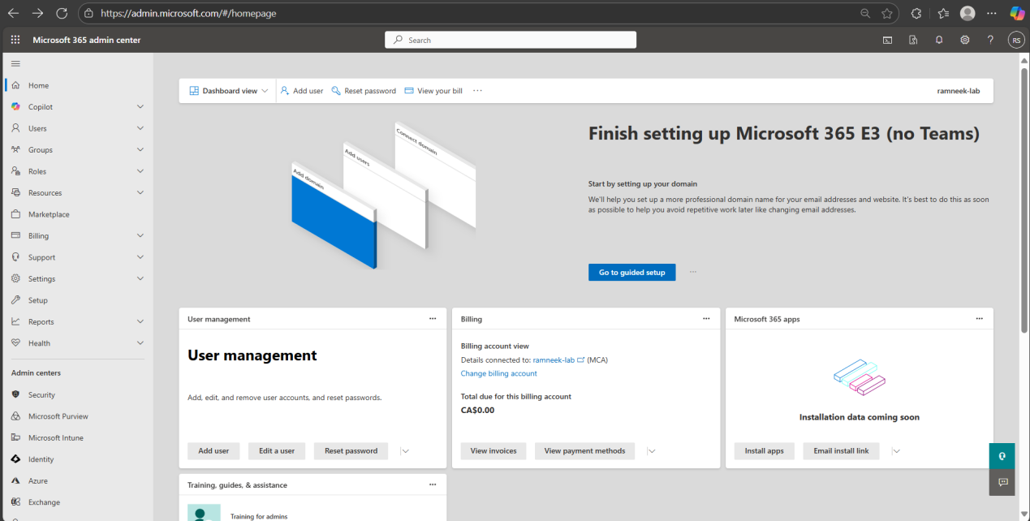
- When prompted in the guided setup, choose to set up a domain. You can use the default ramneeklab.onmicrosoft.com or add a custom domain if you own one.
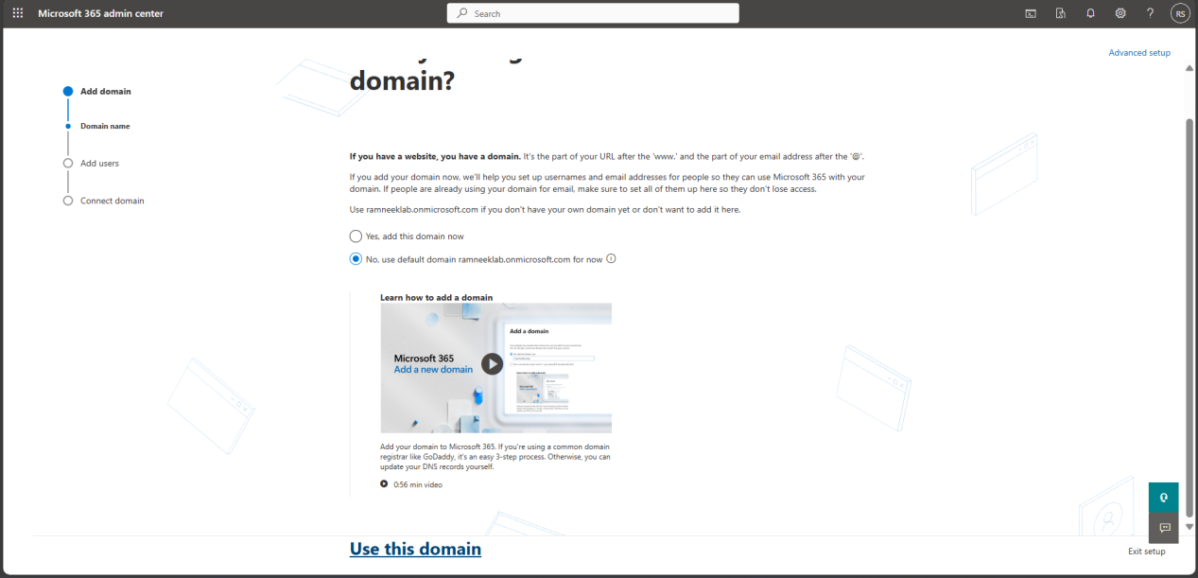
- Add initial users if prompted. For your lab, add 2 random users to simulate employees. These can be simple test accounts like:
- user1@ramneeklab.onmicrosoft.com
- user2@ramneeklab.onmicrosoft.com
Assign them the Microsoft 365 E3 trial license and a temporary password. You can edit or expand these accounts later when building your full lab. Licenses will be added to the Users automatically.
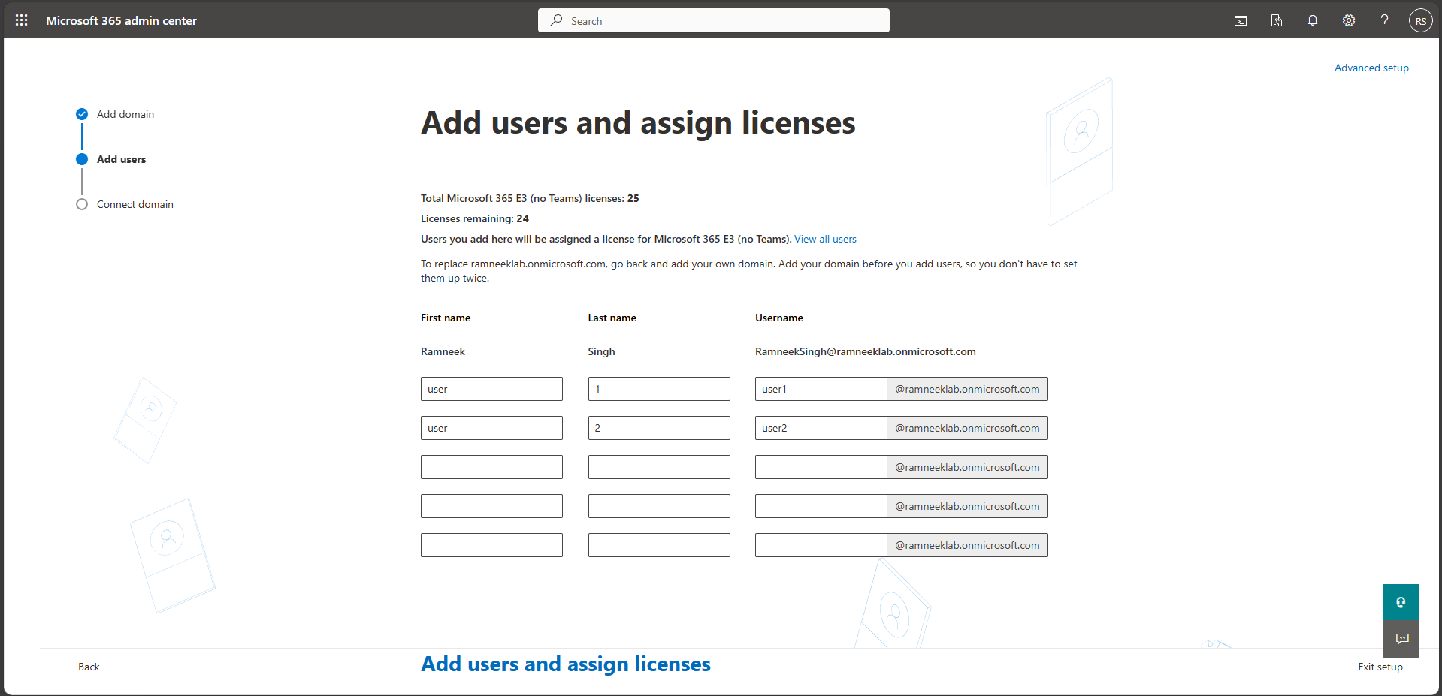
- Finish the guided setup to have your tenant fully configured and ready for administration tasks.
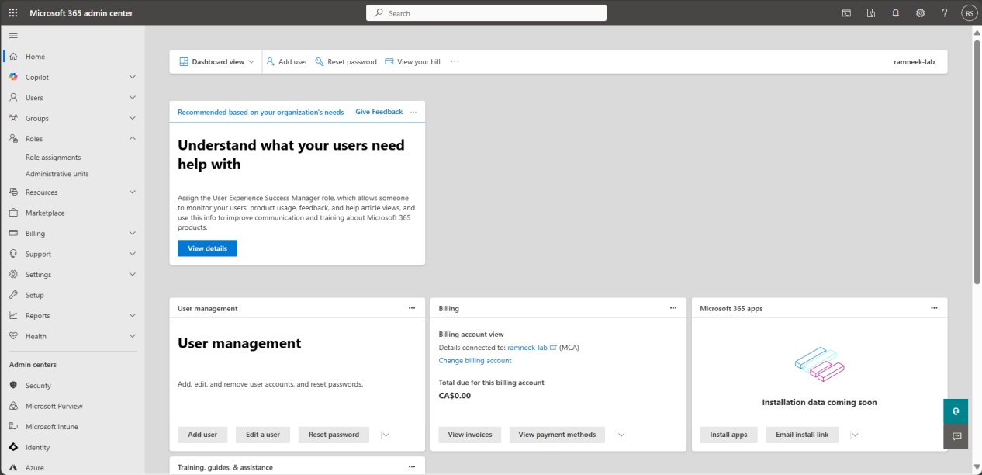
- Note: Doing the guided setup ensures your tenant has a configured domain, initial users, and MFA enabled, which mirrors a real-world enterprise deployment.

- Note: The environment setup has been successfully completed. A Microsoft 365 E3 trial tenant (ramneeklab.onmicrosoft.com) has been created, including the underlying Entra ID Free instance. The global admin account (ramneeksingh@ramneeklab.onmicrosoft.com) has been verified, and multi-factor authentication (MFA) has been configured via Microsoft Authenticator. The guided setup added 2 initial users, and licenses were automatically assigned. The tenant is now fully configured and ready for administration tasks, including creating additional users, managing groups, and performing day-to-day help desk operations.

Part 2: User and Group Management
This section builds on your configured E3 trial tenant (ramneeklab.onmicrosoft.com) to create and manage users, assign licenses/roles, and set up groups for role-based access. These tasks simulate common helpdesk responsibilities like onboarding new employees, organizing departments via groups, and ensuring secure access. We'll add 3–5 test users (e.g., for HR, IT, Sales departments), assign E3 licenses, create security groups for permissions, and a Microsoft 365 group for collaboration. Document each step with screenshots to showcase your admin skills.

2.1 Creating Additional Test Users
Expand your initial 2 users by adding more to simulate a small organization (total 5–7 users). This practices user lifecycle management.
- In the Microsoft 365 Admin Center, navigate to Users → Active users.
- Click multiple Add users (top menu).
- A table-style entry form will appear. Fill in user details for each row:
  - hr.manager@ramneeklab.onmicrosoft.com (HR dept)
  - it.support@ramneeklab.onmicrosoft.com (IT dept)
  - sales.rep@ramneeklab.onmicrosoft.com (Sales dept)
  - test.enduser@ramneeklab.onmicrosoft.com (General user)
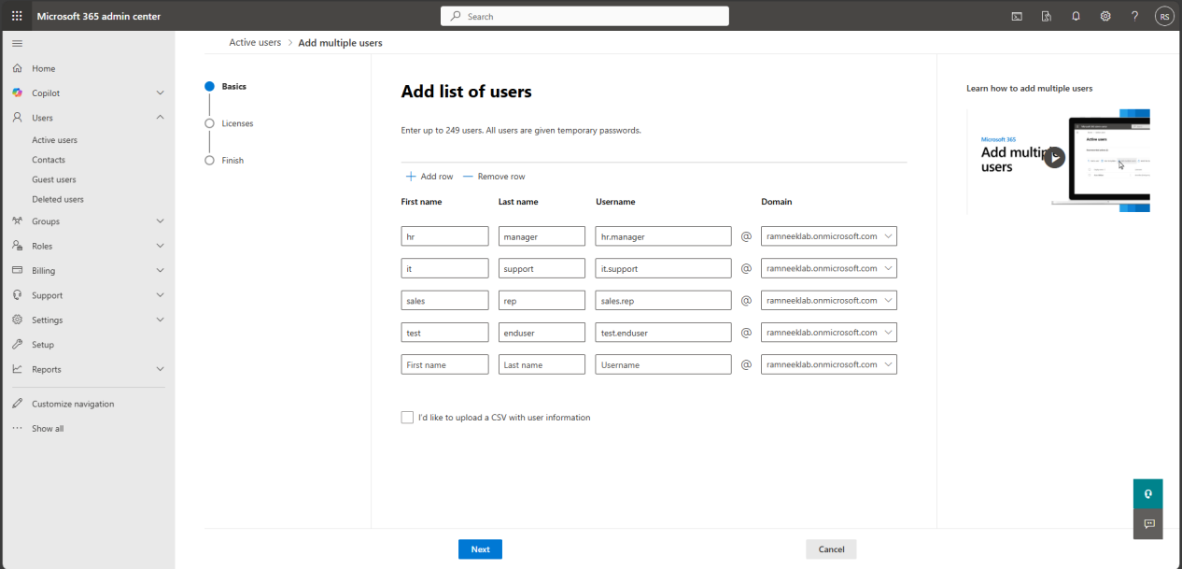
- Note: You can also use the CSV method by downloading the provided template, adding users in the spreadsheet, and then uploading it back. However, for a small lab environment, the built-in table entry is simpler and faster.
- Add the licenses to all the users created and leave the apps at default. By default, the user will have access to all the apps included in the Microsoft 365 E3 Subscription.
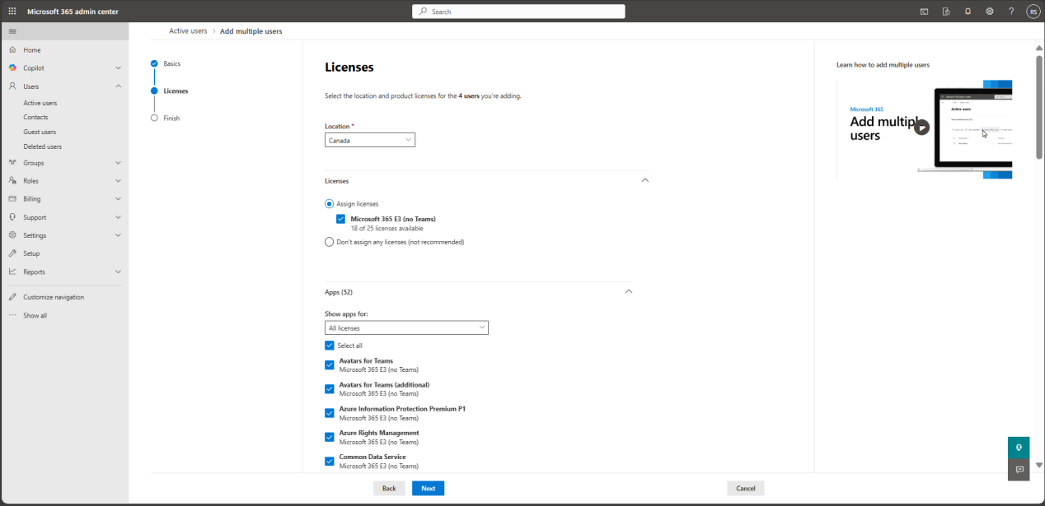
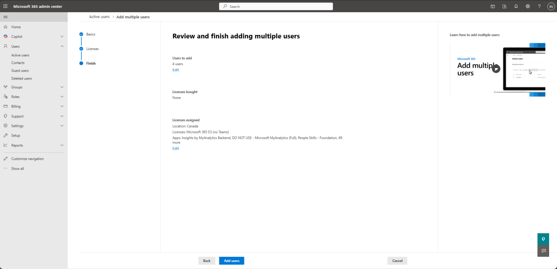
- Click Next, then make sure to to download user details to file then click close.
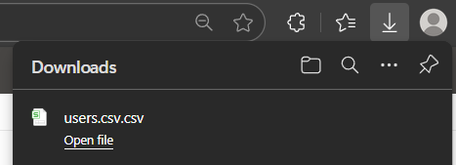
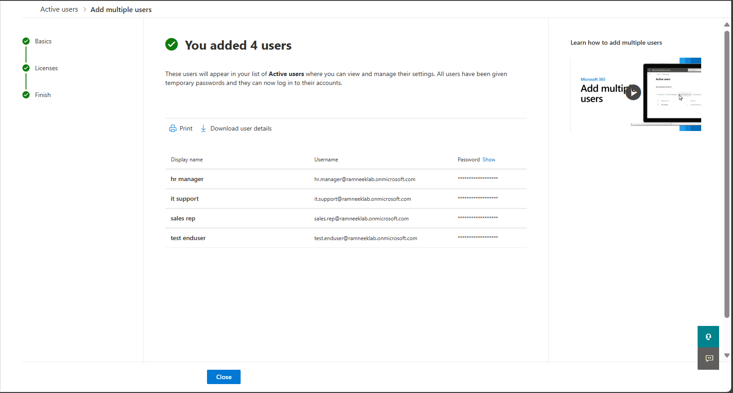
- Verify Addes users.
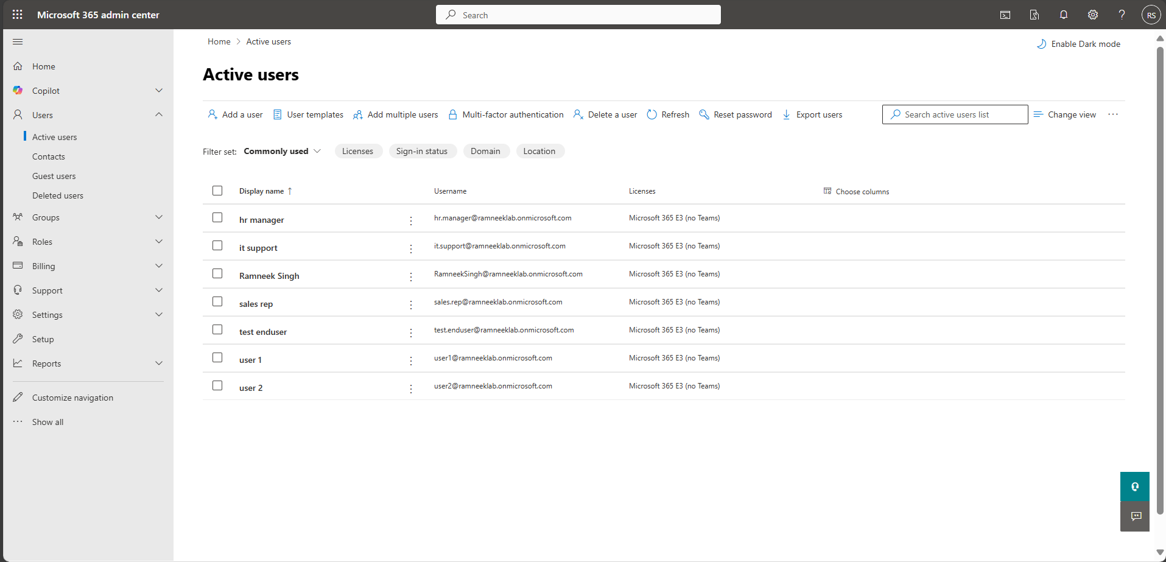

2.2 Assigning Licenses and Roles
Once additional users are created, verify they have the proper licenses and assign roles to simulate helpdesk delegation.
- Verify Licenses
  - In the Microsoft 365 Admin Center, go to Billing → Licenses.
  - Confirm that the Microsoft 365 E3 licenses are assigned to all your users.
  - If any user is missing a license, click on the license count, select the user, and assign the license.
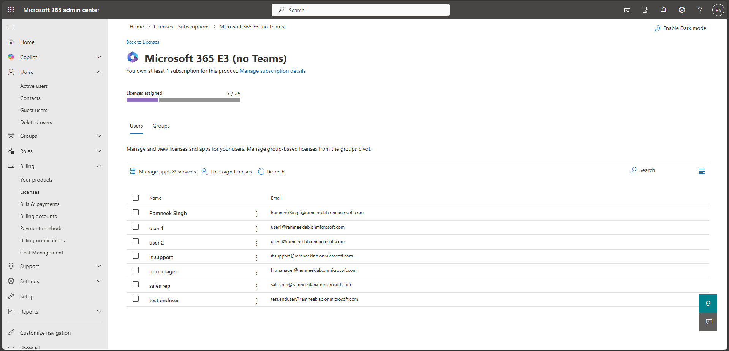
- Assign Roles
  - Go to Users → Active users and select it.support@ramneeklab.onmicrosoft.com.
  - Open the Manage roles tab.
  - Search for Helpdesk Administrator and assign this role.
  - This allows it.support to reset passwords and manage basic user tasks without having global admin rights.
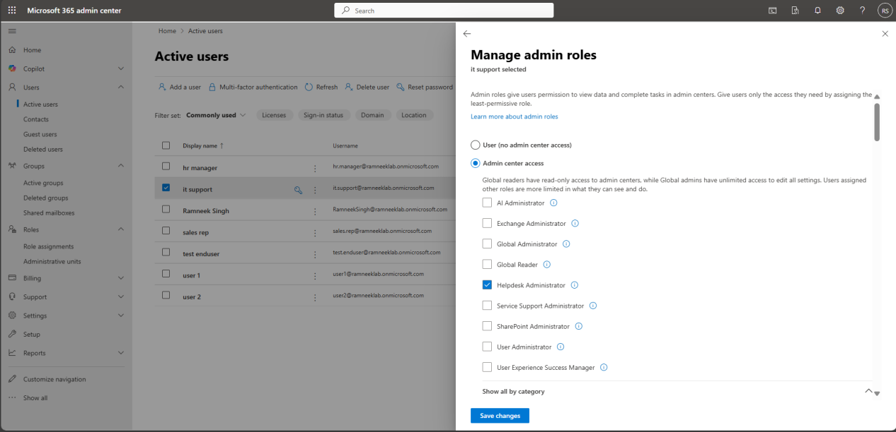
- Verification
  - Still under Users → Active users, select it.support and check the Assigned roles tab.
  - Confirm that “Helpdesk Administrator” is listed as their active role.

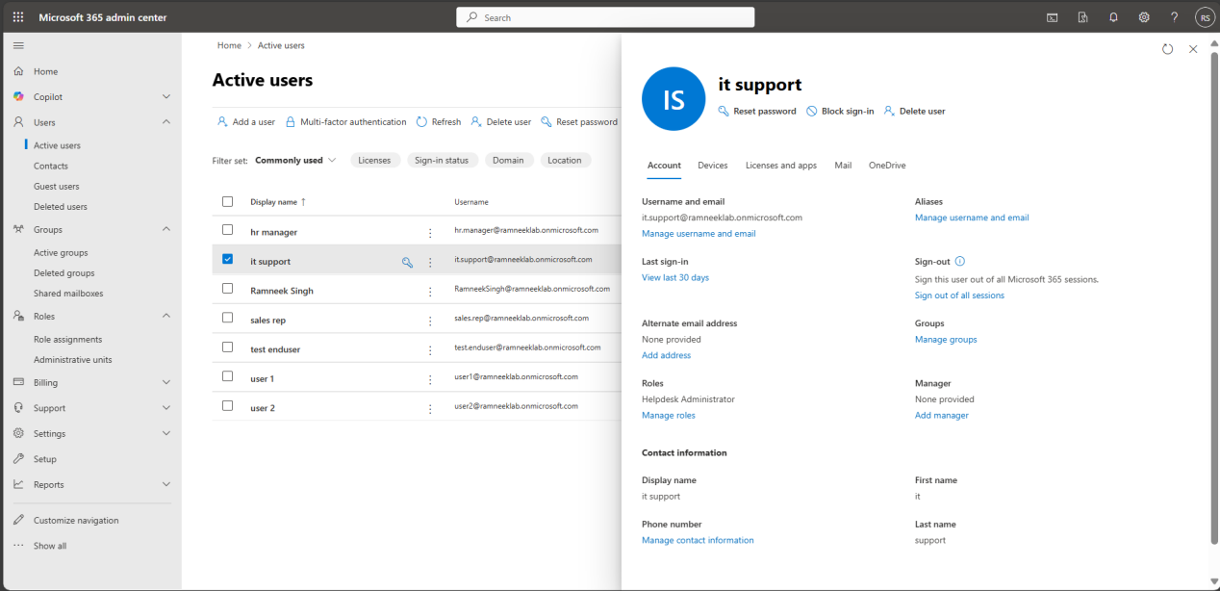

2.3 Creating and Managing Security Groups
Mail-enabled security groups combine security/permissions management with an email address so members can receive messages sent to the group. This is useful for simulating department communication while controlling access to resources.
- Go to Groups → Active groups in the Microsoft 365 Admin Center.
- Go to the Security Groups Tab and then choose Mail-Enabled Security as the group type.
- Fill in the group details:
  - Display name: e.g., HR_Security_Group
  - Description: “HR department access and communication group”
  - Add your global admin account as Owner of the group (ramneeksingh@ramneeklab.onmicrosoft.com)
  - Add the hr manager user as member of the group
  - Email address: e.g., hr@ramneeklab.onmicrosoft.com
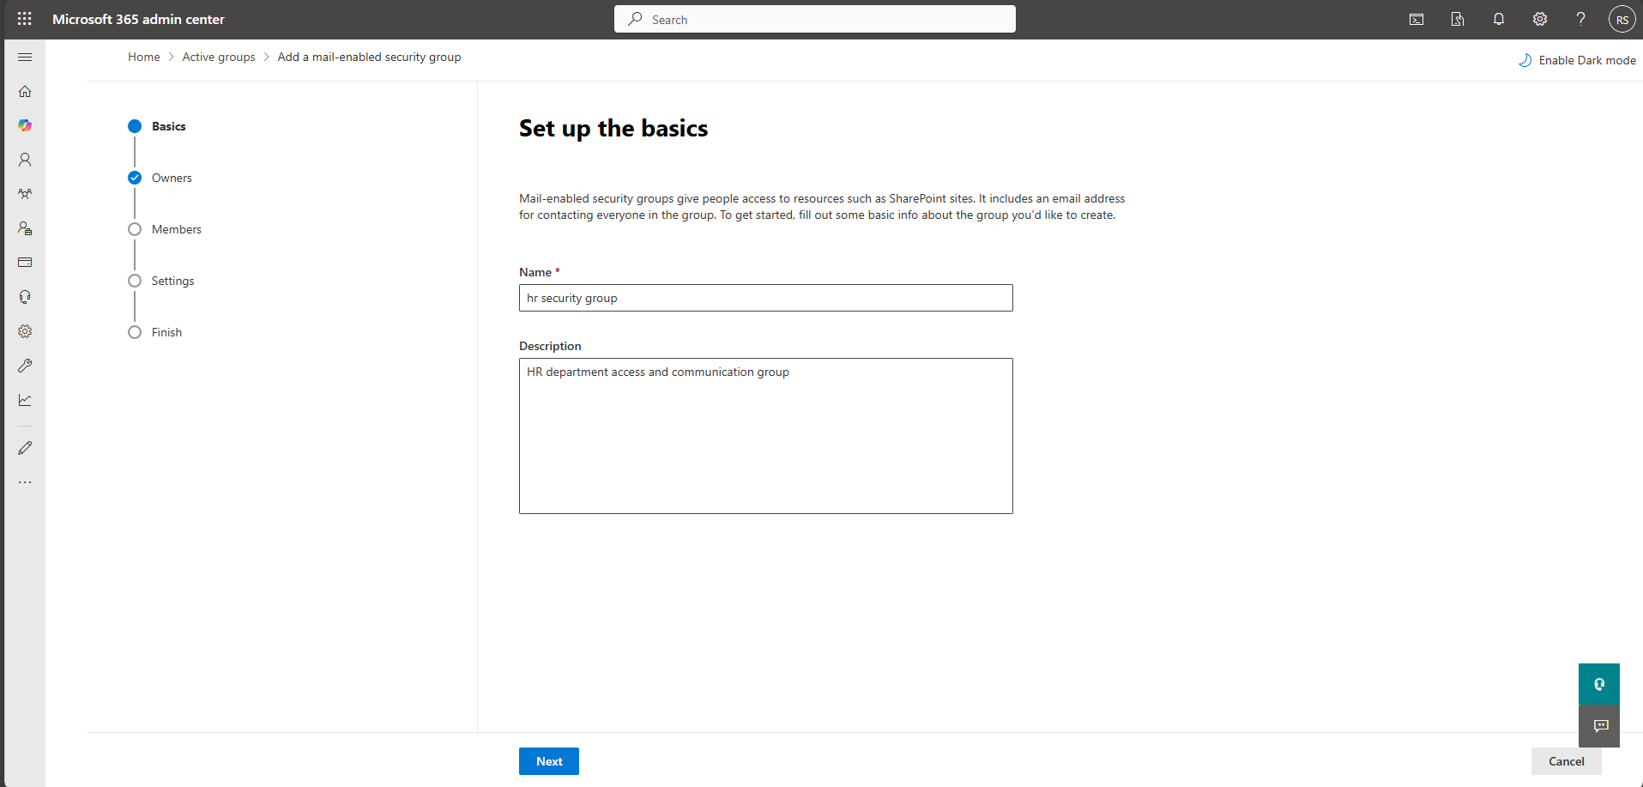
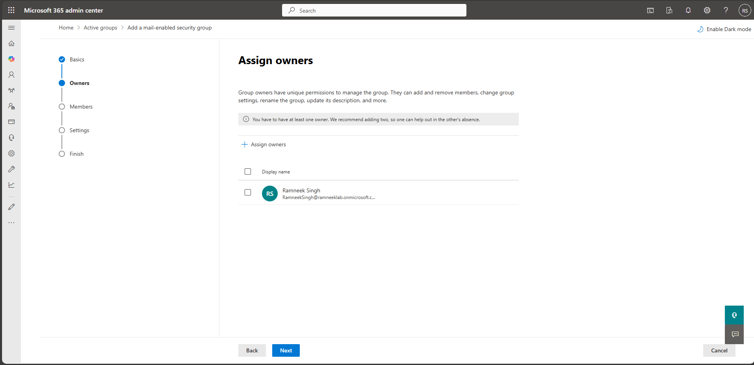
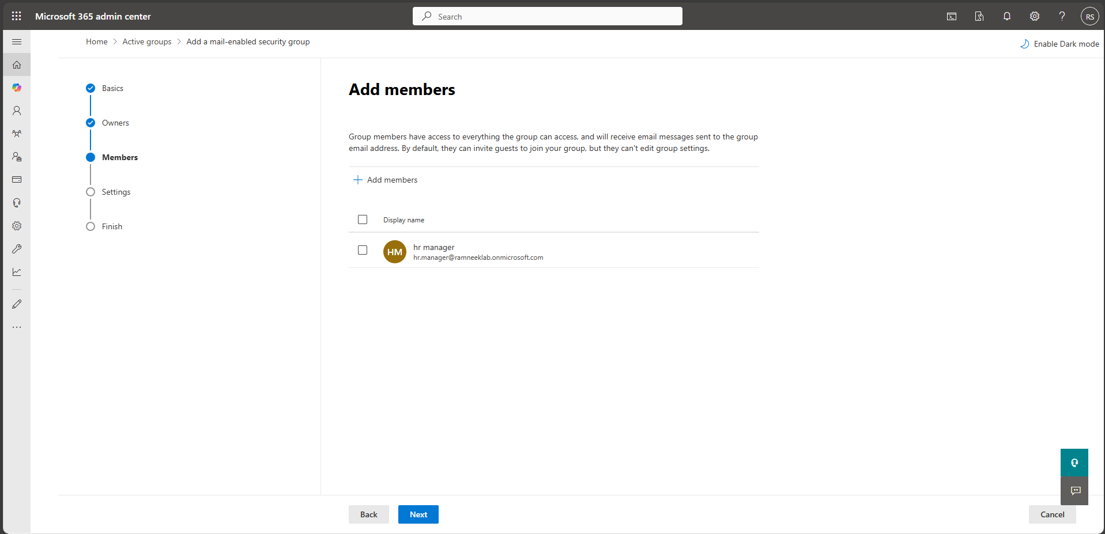
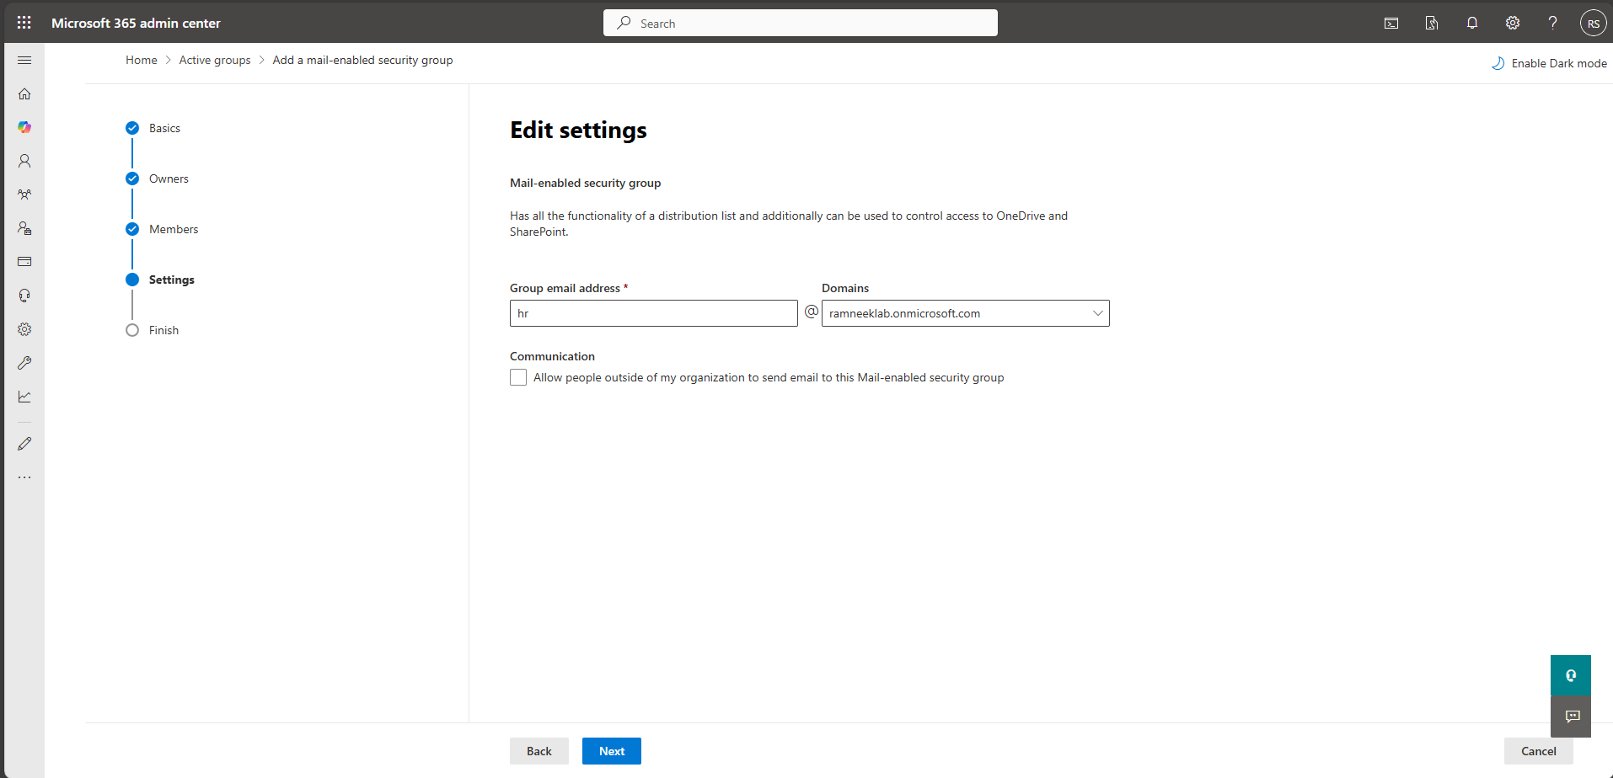
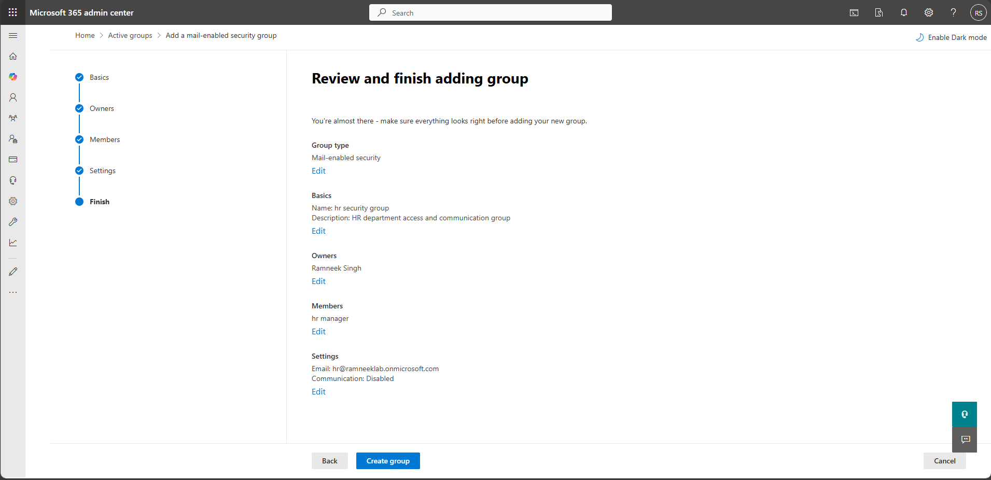
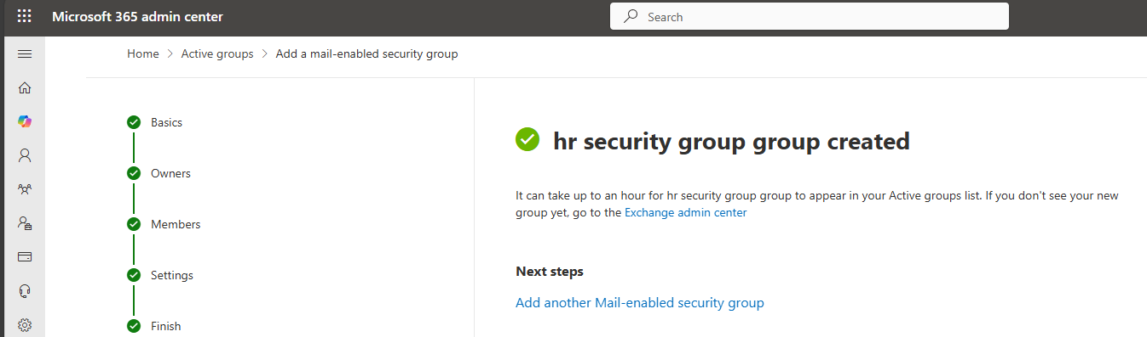
- Repeat steps 3–4 for the sales groups:
  - Sales_Security_Group → member: sales.rep@..., email: sales@ramneeklab.onmicrosoft.com
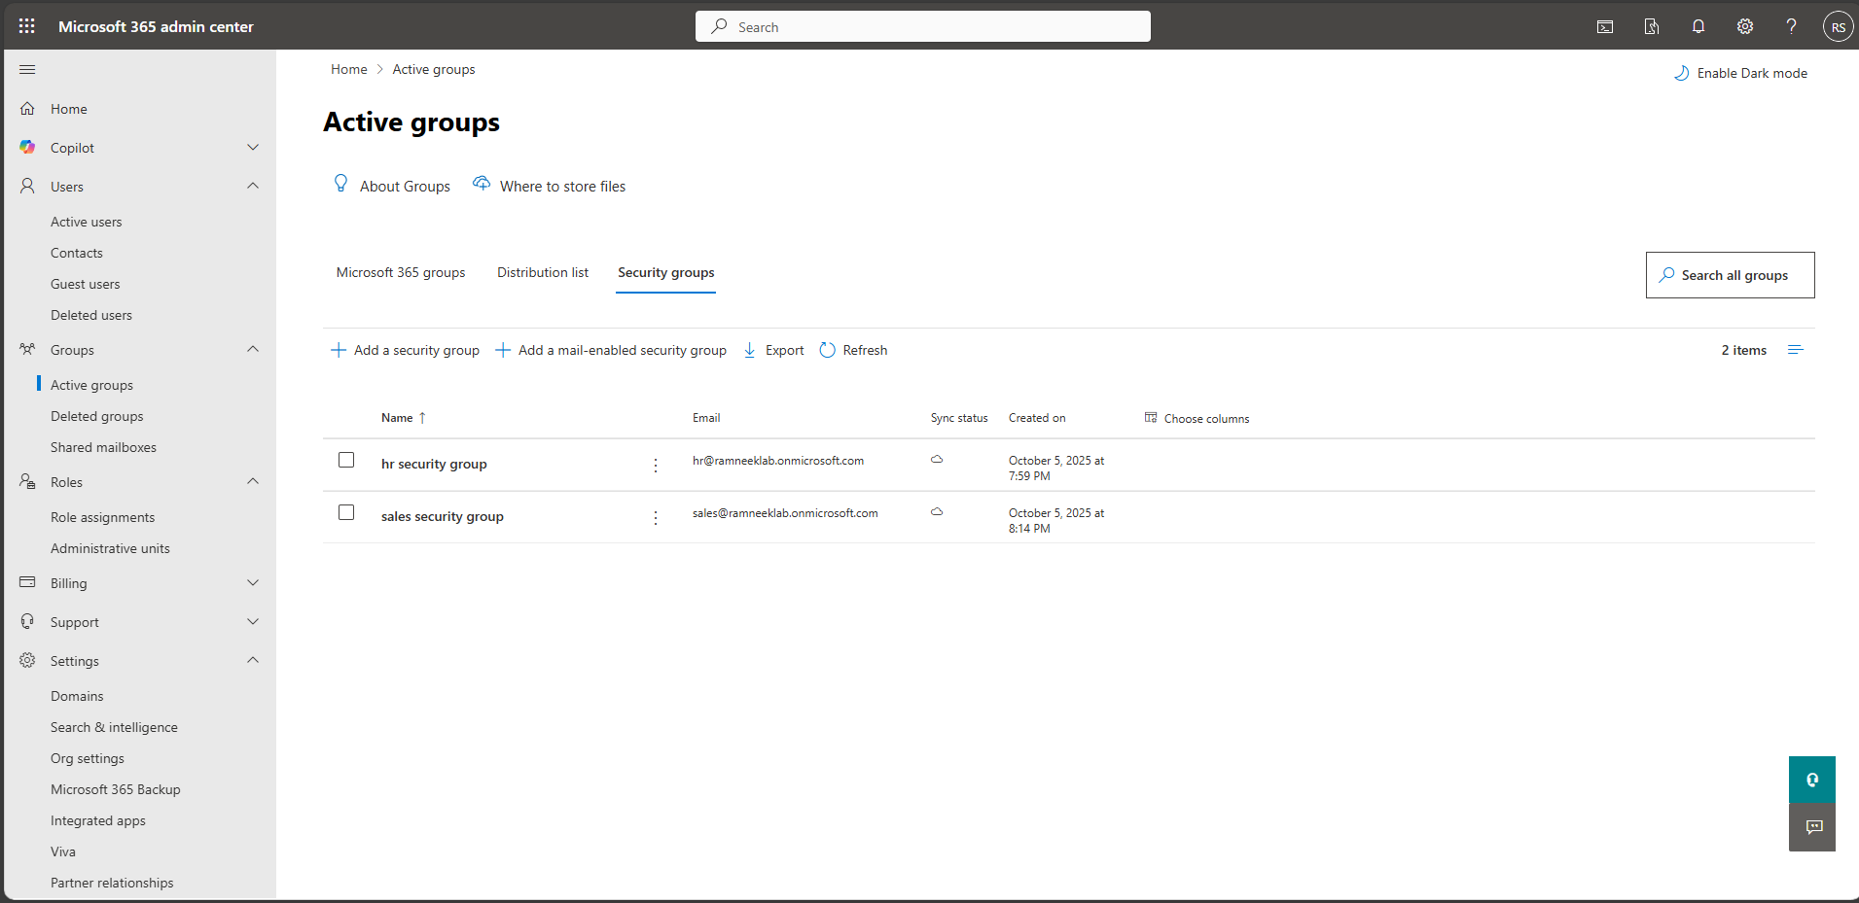
- Create a regular security group for IT security Group so that an admin role can be assigned to it. Make sure to check the option: “Azure AD roles can be assigned to this group”
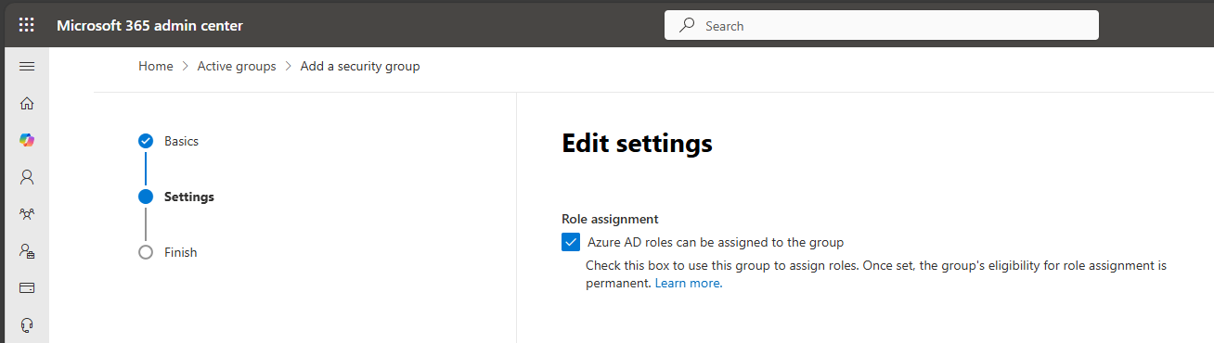
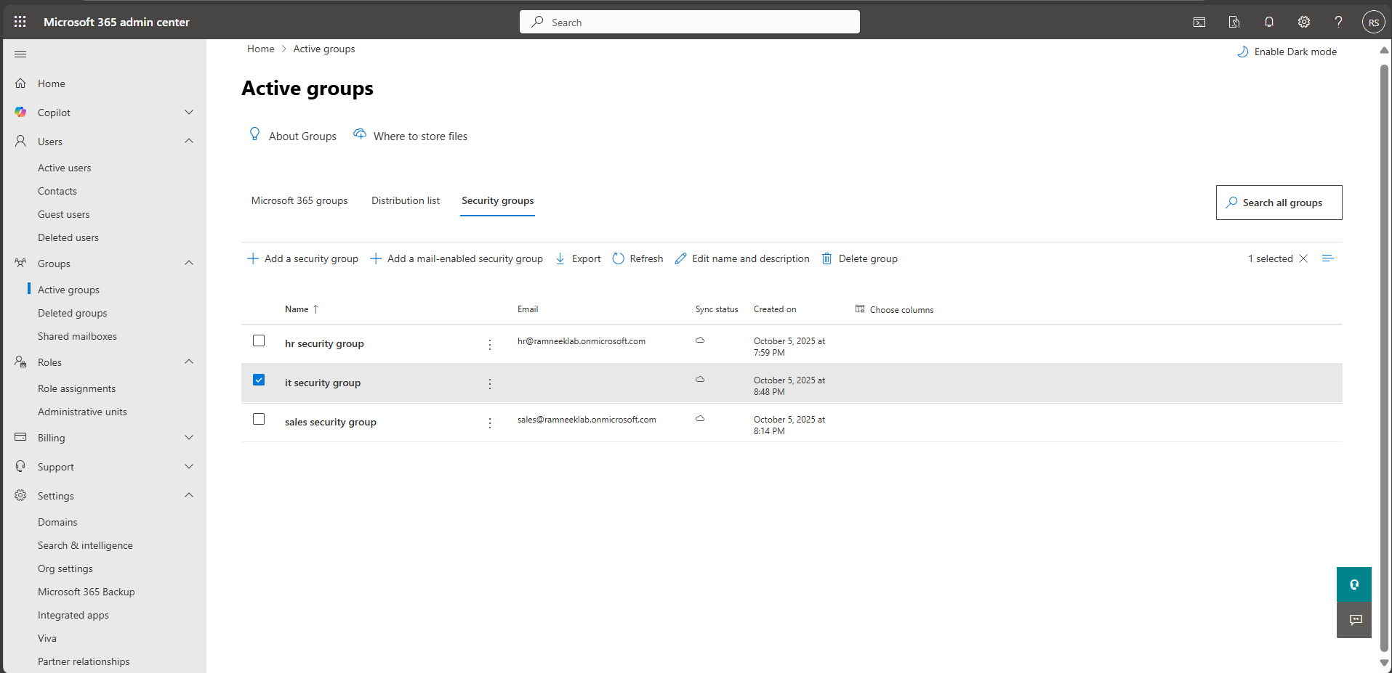
- Add members and owner manually by clicking on the group and selecting the members tab and clicking manage owners and owners.
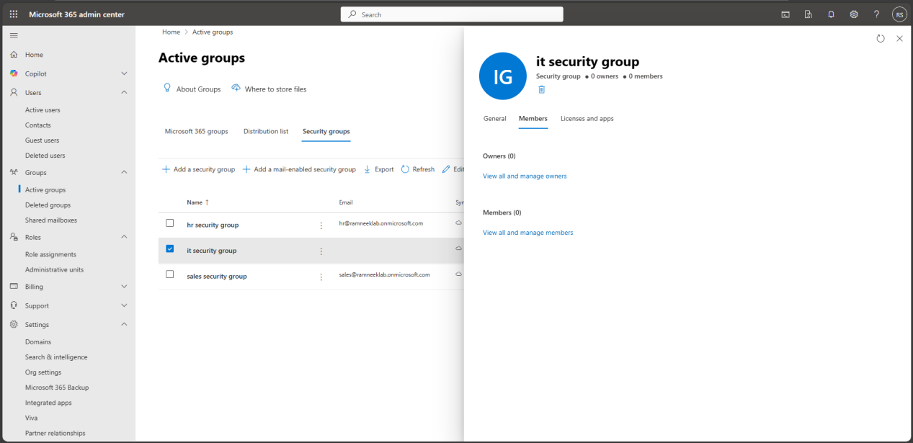
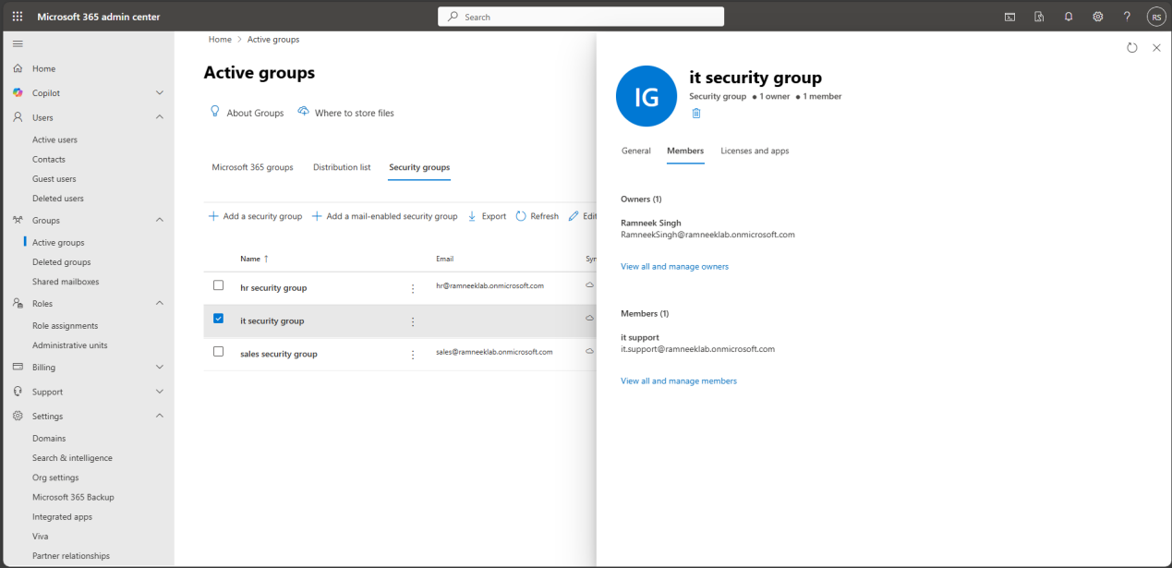
- Assign the helpdesk admin Role to the IT Security Group by clicking on the group and then selecting manage roles.
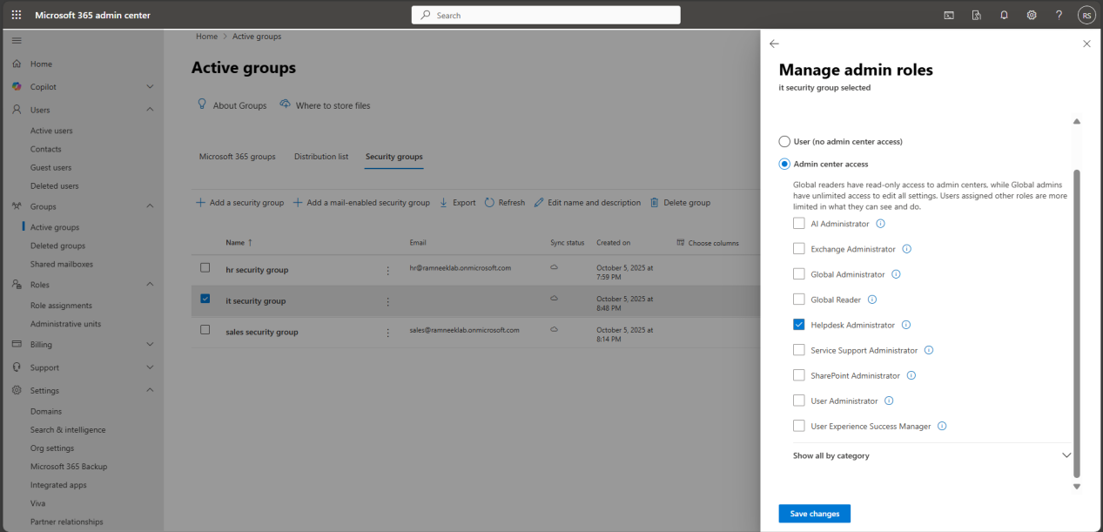

Part 3: Device Enrollment (Entra ID Join)
This section demonstrates enrolling a Windows 11 device into your Entra ID tenant (ramneeklab.onmicrosoft.com) to simulate device management scenarios typically handled by a helpdesk or IT admin. Enrollment allows you to apply policies, manage devices, and simulate real-world onboarding tasks in an enterprise.

3.1 Preparing Windows 11
For this part of the lab, you need a Windows 11 device to simulate an employee workstation joining your Microsoft 365/Entra ID environment. You have two options:
- Option 1: Local VM
  - Use Hyper-V, VMware, or VirtualBox to create a Windows 11 VM on your own computer.
  - Benefits: Full control, offline setup, snapshots for easy rollback, no extra cost.
  - Recommended for small labs or testing device join scenarios.
- Option 2: Cloud VM
  - Use Azure Virtual Machines (Windows 11 Enterprise) with a temporary subscription or free trial.
  - Benefits: No local resource usage, can simulate remote users, built-in network connectivity.
  - Slightly more complex and may incur cost if trial limits are exceeded.
- Note: The lab will not cover step-by-step instructions for creating local or cloud VMs. This guide assumes you already have a Windows 11 device or VM prepared for enrollment.

3.2 Joining the VM to Entra ID (M365 Join)
- Enable Automatic Intune Enrollment
Before joining your Windows 11 VM, make sure that devices automatically enroll in Intune when joined to Entra ID.
  - Go to the Microsoft Intune Admin Center (https://intune.microsoft.com) → Devices → Enroll devices → Automatic Enrollment.
  - Under MDM user scope, select All (or a specific group that includes your test users, such as IT and Sales).
  - Click Save. This ensures any device joined to Entra ID by a user in that scope will automatically register with Intune for management.
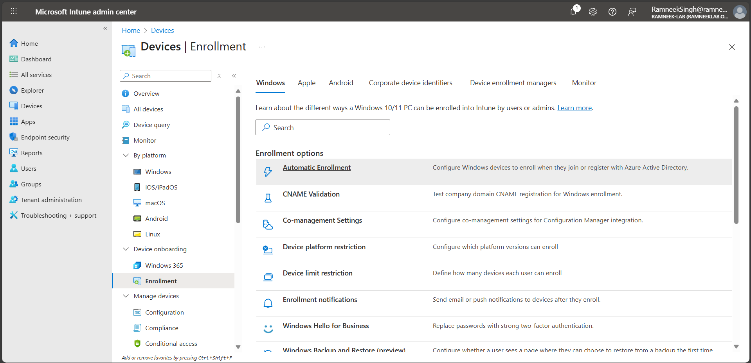
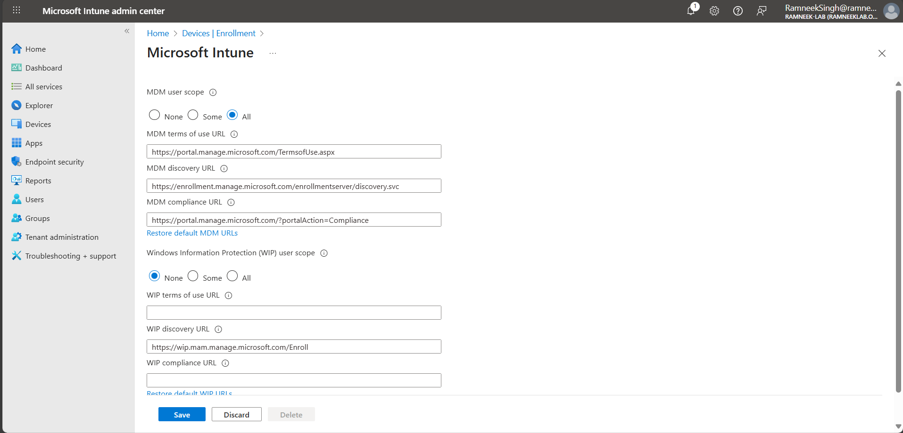
- Sign in as the local admin → Settings → Accounts → Access work or school → Connect.
- Select Join this device to Azure Active Directory.
- Enter your Microsoft 365 account (e.g., it.support@ramneeklab.onmicrosoft.com or the non-admin test user). Complete MFA if prompted.
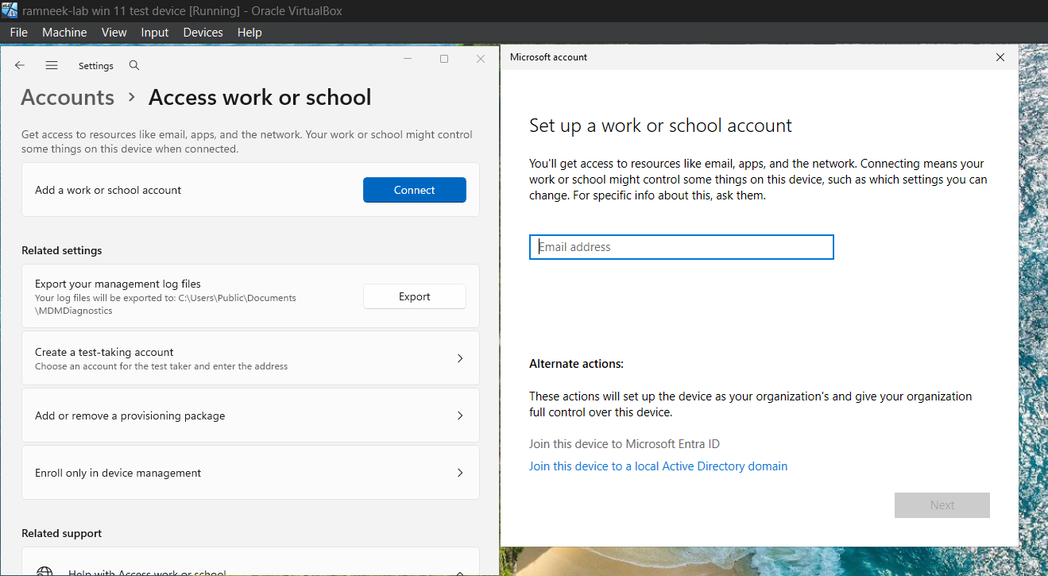
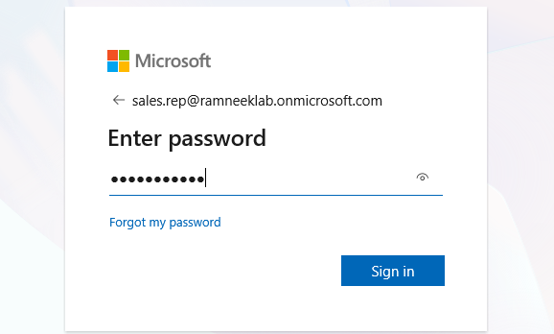
- Note: The password is in the CSV file we downloaded when we created the users.
- Click Join.
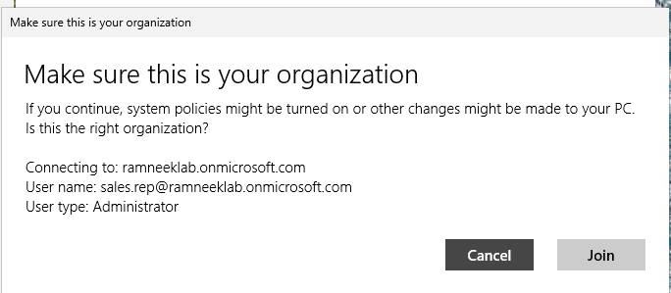
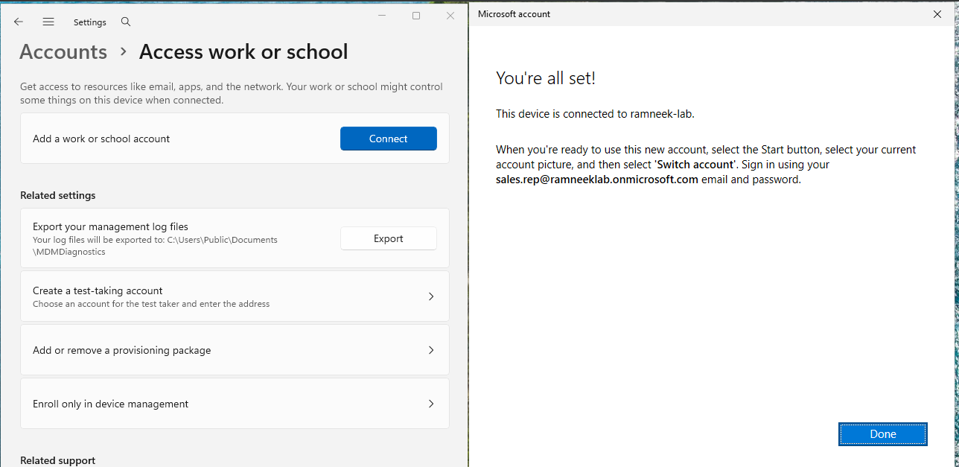
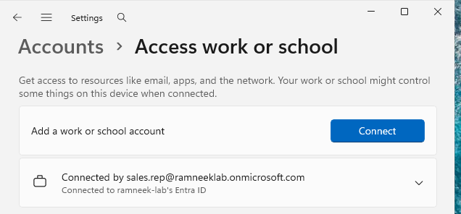
- Sign out and Sign in as the Sales Rep User.
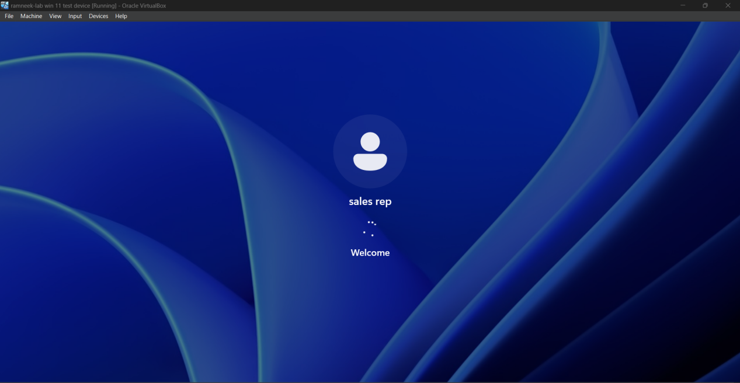
- Complete the MFA Setup Requirements.
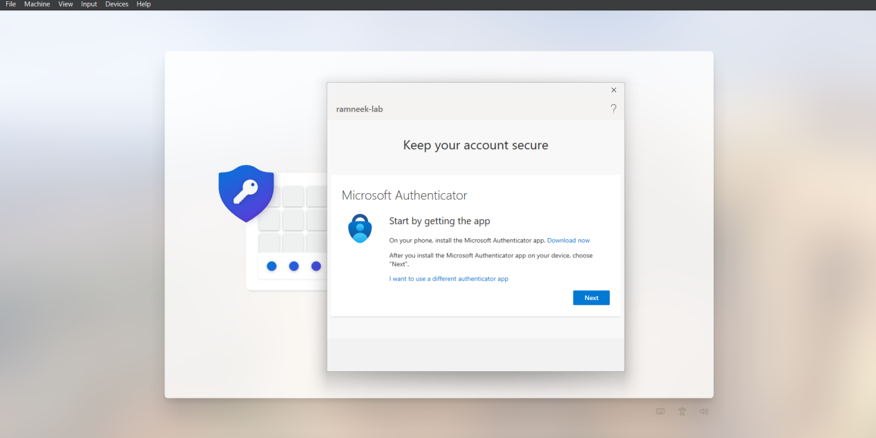
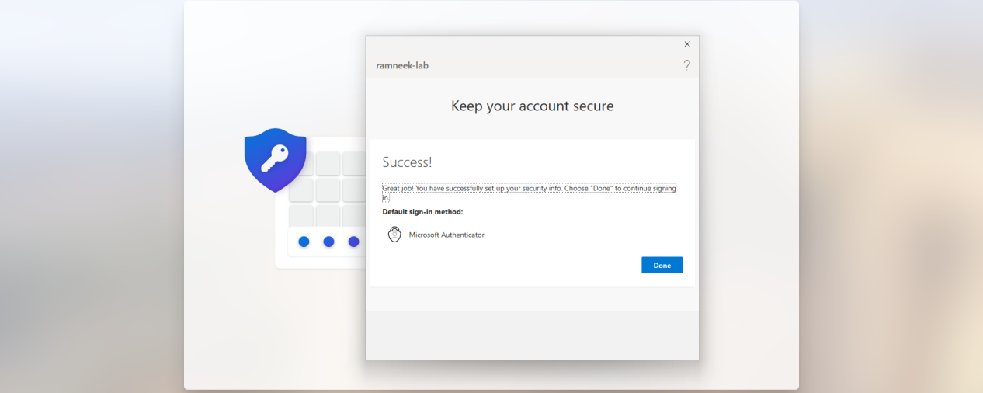
- Add PIN for Easier Access
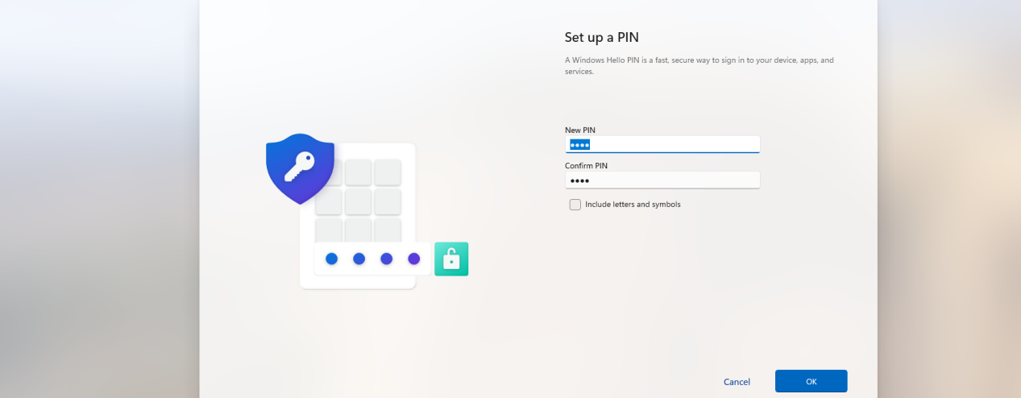
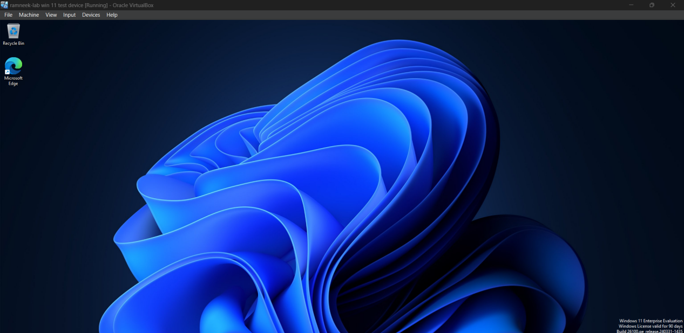

3.3 Verification
After joining the device to Entra ID, confirm that the enrollment was successful and the device is recognized by the tenant.
- On the Windows 11 VM:
  - Go to Settings → Accounts → Access work or school.
  - Verify that the device shows as Connected to Entra ID with your user listed.
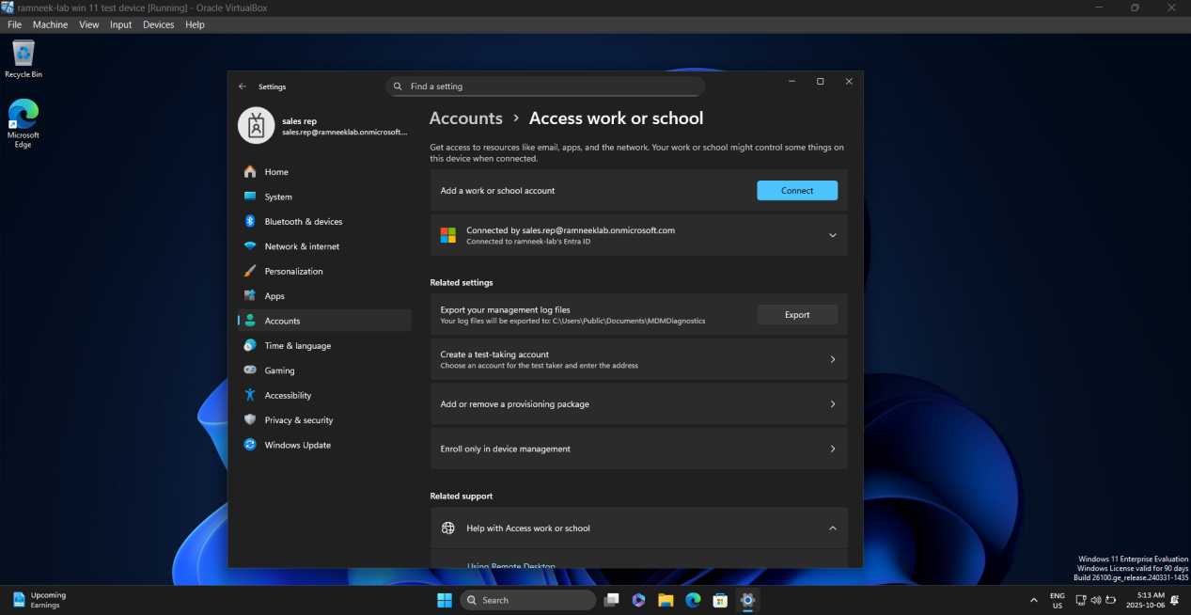
- Check in Entra ID / Microsoft 365 Admin:
  - Go to the Entra ID Admin Center (https://entra.microsoft.com) → Devices → All devices.
  - Confirm that the Windows 11 VM appears in the device list, showing the correct device name, user, and join type (M365 join).
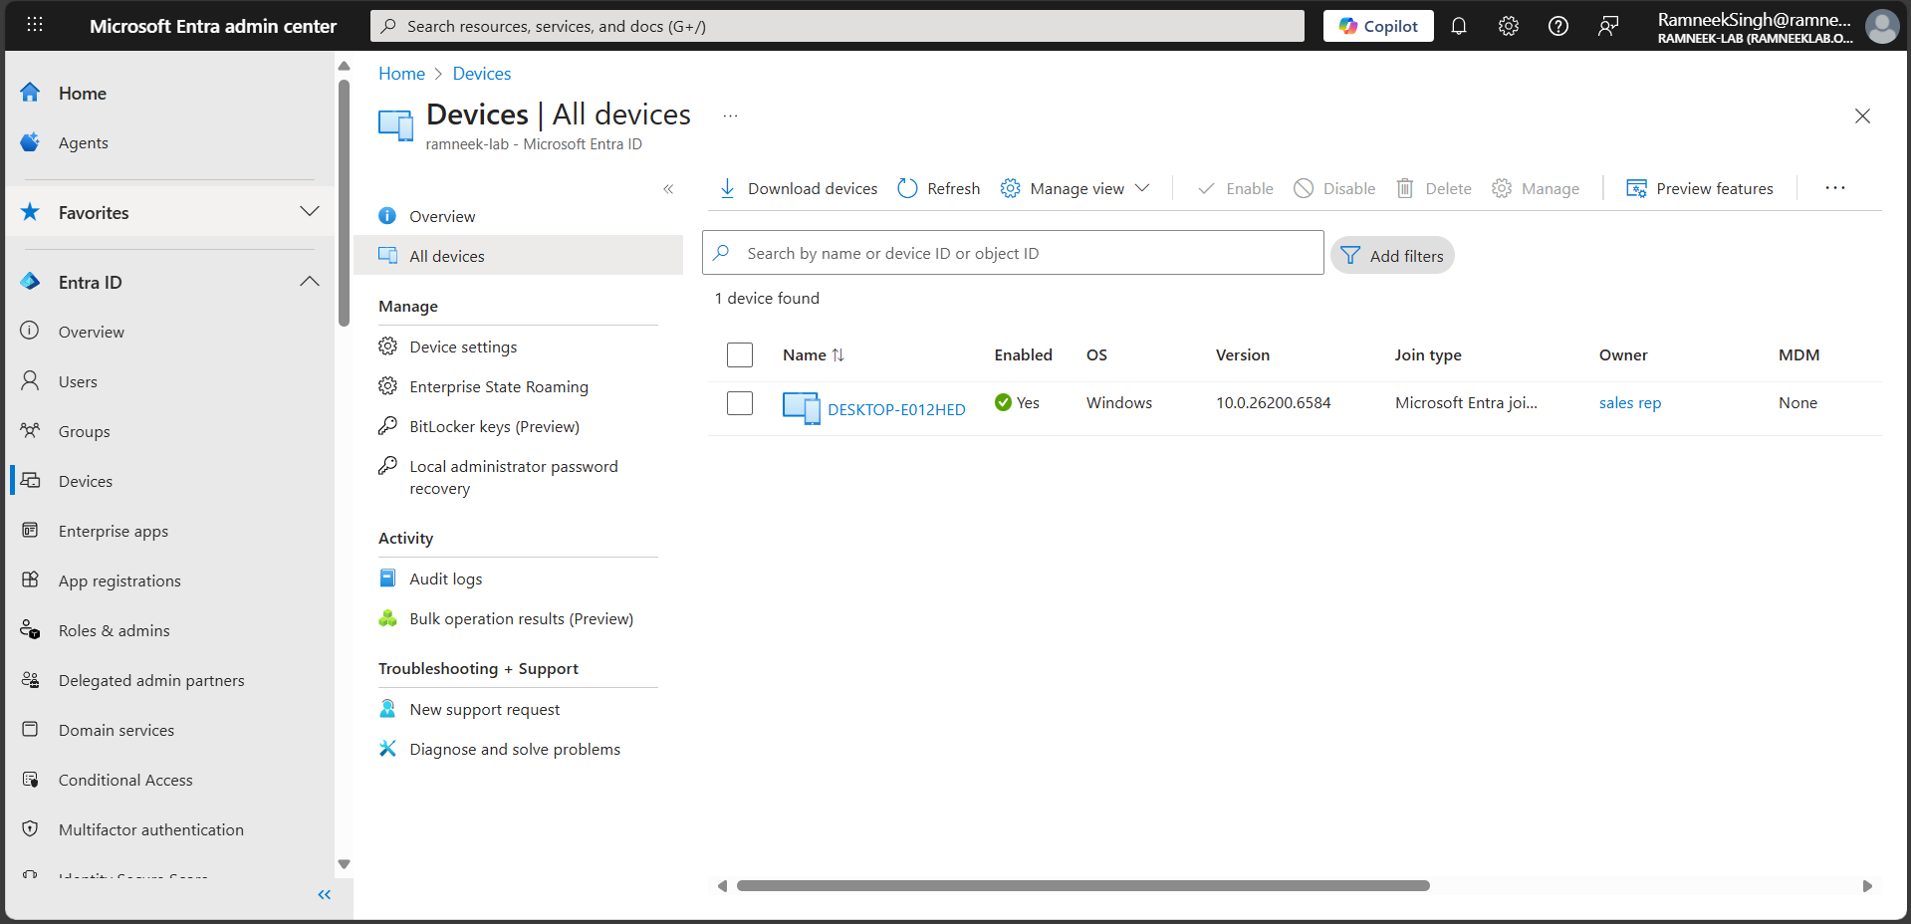
- Check device compliance and management status
  - If Intune is configured, the device should also appear under Endpoint Manager → Devices with compliance and enrollment status.
  - For this lab, simply confirming that the device is visible in Entra ID and associated with the correct user is sufficient.
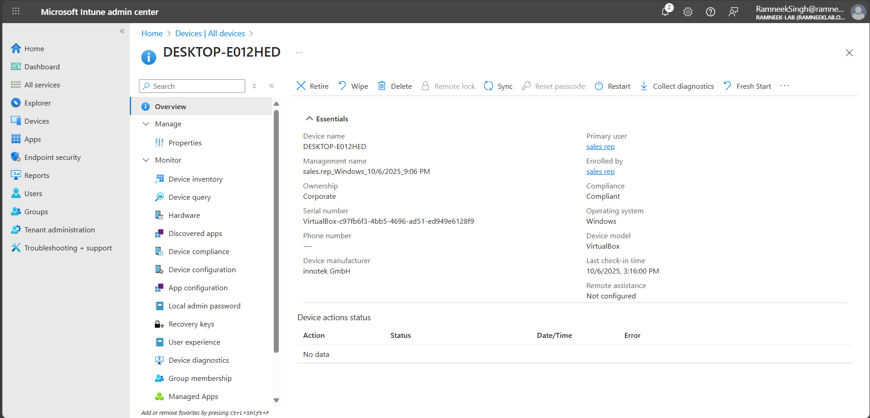

Part 4: Intune Device Compliance and Configuration Policies
This section demonstrates how to define and apply device compliance rules and configuration settings using Microsoft Intune. These policies help enforce security standards and automate configuration across enrolled Windows 11 devices.

4.1 Creating a Device Compliance Policy (Windows 10/11)
Compliance policies define what conditions a device must meet to be considered secure and compliant with company standards.
- Go to Microsoft Intune Admin Center (https://intune.microsoft.com) → Devices → Compliance policies → Create policy.
- Choose Platform: Windows 10 and later → Create.
- Enter details:
  - Name: Windows 11 Compliance Policy
  - Description: “Ensures devices meet basic security standards.”
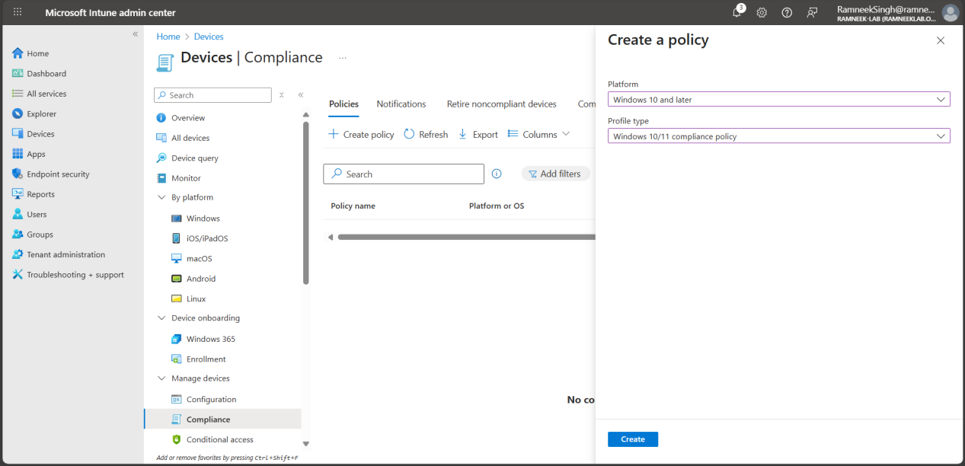
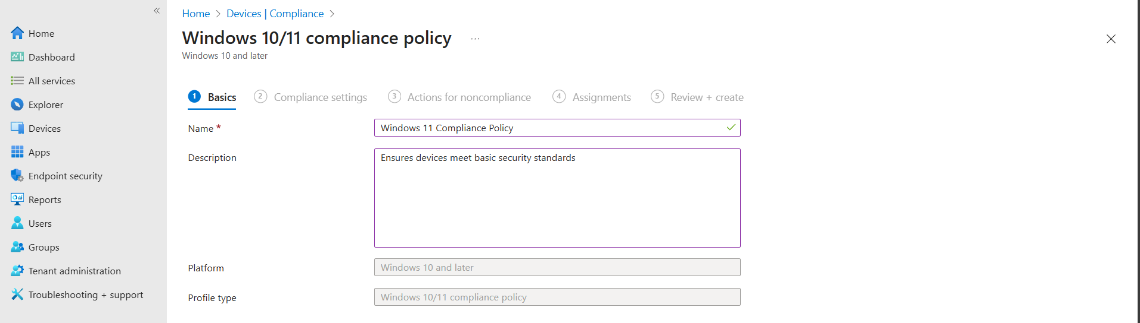
- Configure compliance settings:
  - Firewall: Require
  - Trusted Platform Module (TPM): Require
  - Antivirus: Require
  - Antispyware: Require
  - Microsoft Defender Antimalware: Require
  - Microsoft Defender Antimalware security intelligence up-to-date: Require
  - Real-time protection: Require
  - Require the device to be at or under the machine risk score: Low
Leave all other options Not configured, since this lab focuses on demonstrating essential compliance rules only.
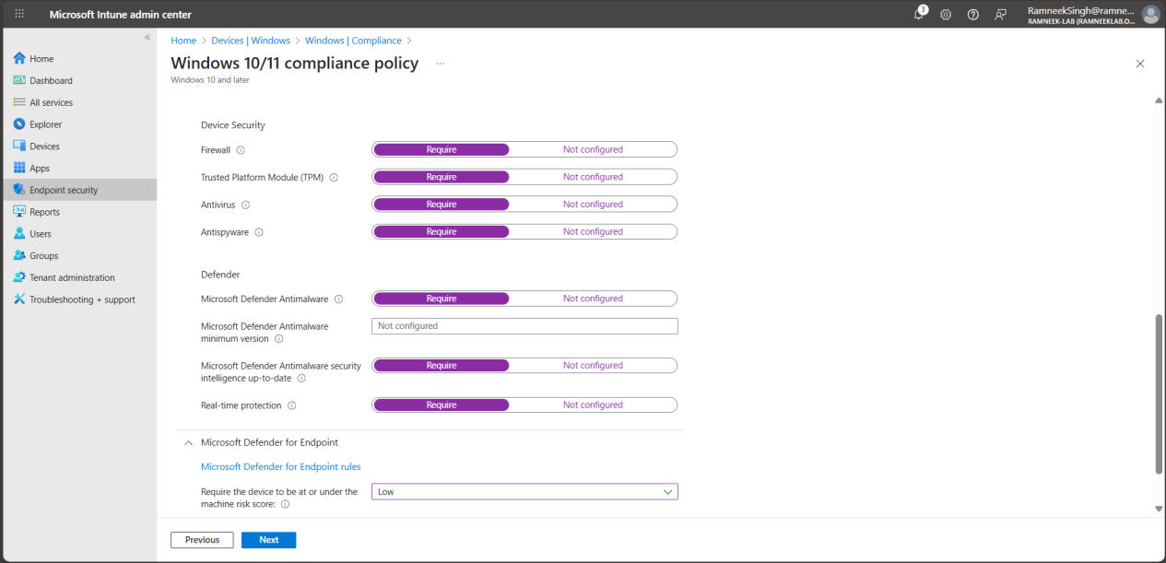
- Click Next, then configure Actions for noncompliance → leave default (“Mark device noncompliant”).
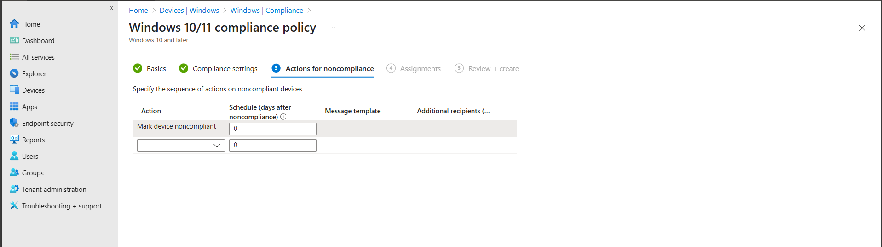
- Assign the policy to All Devices
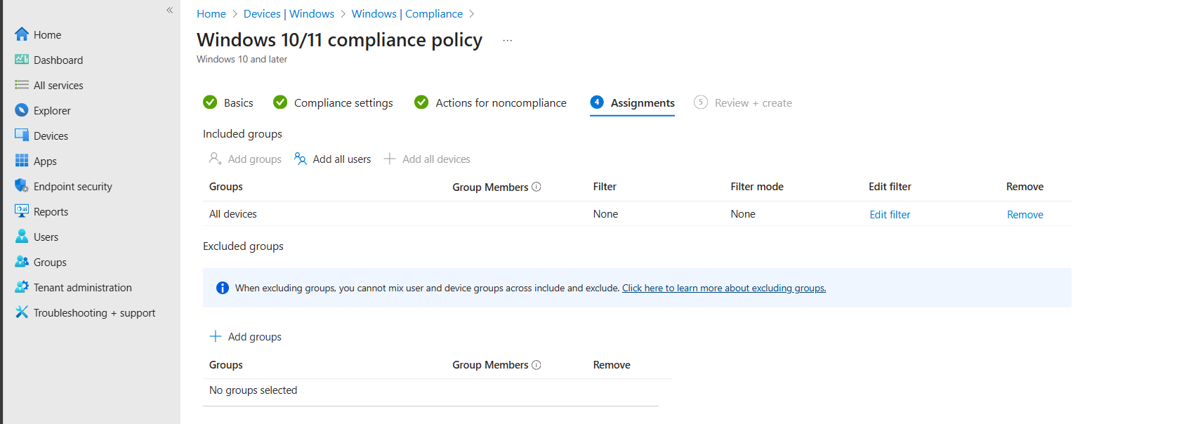
- Click Create to save and deploy the policy.
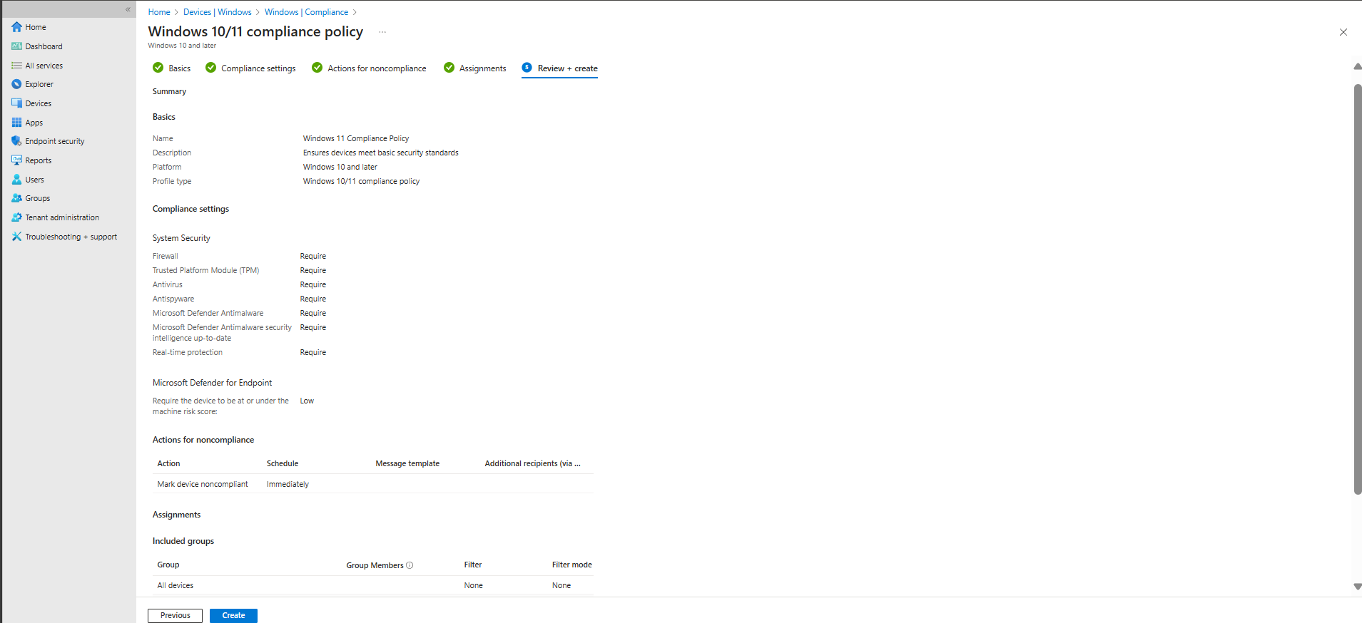
- Note: The compliance policy setting for “machine risk score” depends on Microsoft Defender for Endpoint (MDE). While other security requirements (firewall, antivirus, TPM, Defender version, etc.) are enforced via Intune, the risk-based check will not evaluate correctly until the device is onboarded to MDE. In this lab, you can either:
- Onboard the device to MDE to fully enforce all compliance checks, or
- Leave the risk-based setting untested while other security settings remain enforced.
- To fully enforce compliance policies that rely on machine risk score, the device must be onboarded to MDE:
- Follow the following Steps:
  - Go to Endpoinit Security -> Click on MDE (Setup) and follow the instructions
  - Open MDE Admin Console and go to settings and enable the following Setting:
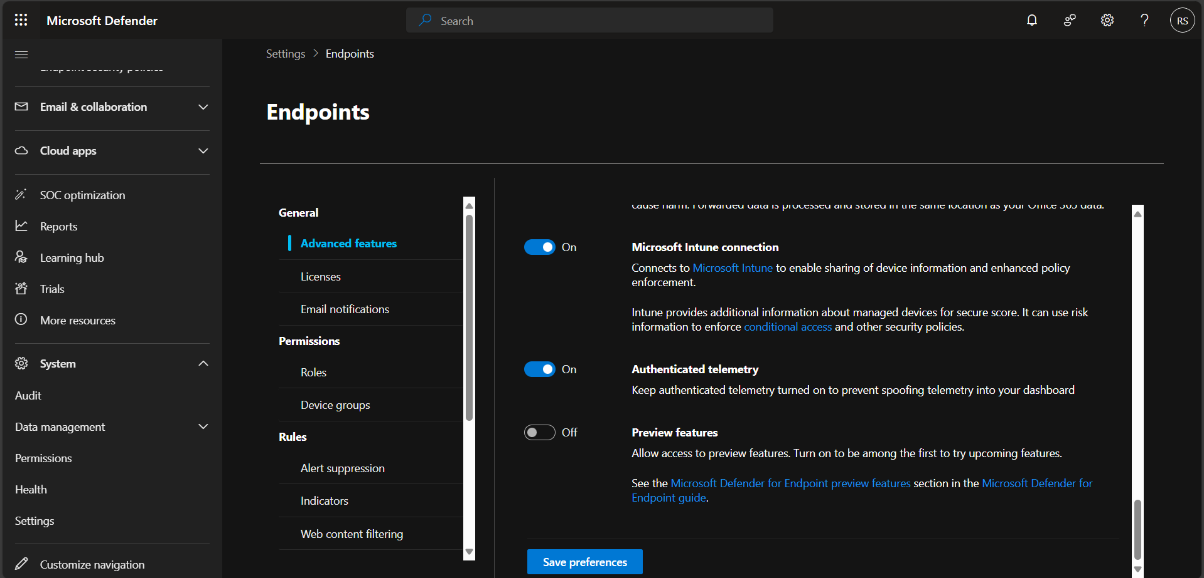
  - Go to Endpoint security | Microsoft Defender for Endpoint and enable the following settings then refresh and save:
    - After this step Intune and MDE should be connected to each other
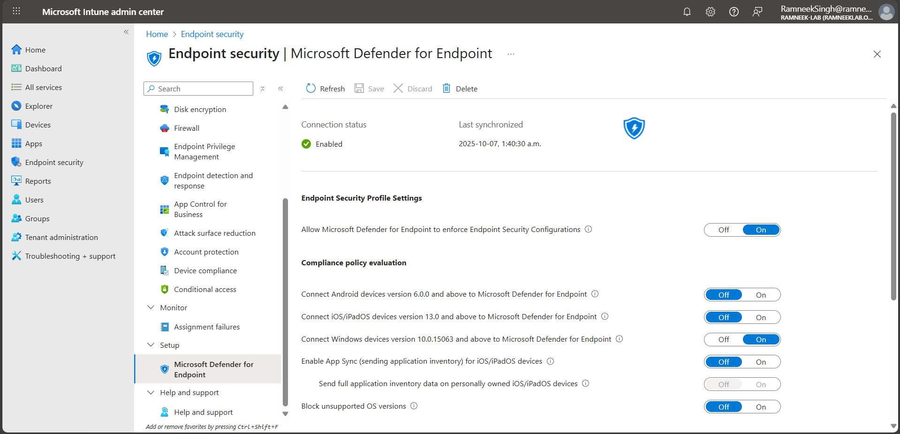
  - The next step is to onboard the Device to MDE, to do this you must deploy a preconfigured policy to the device. Go to Endpoint security | Endpoint detection and response and click deploy pre configure policy and follow the steps
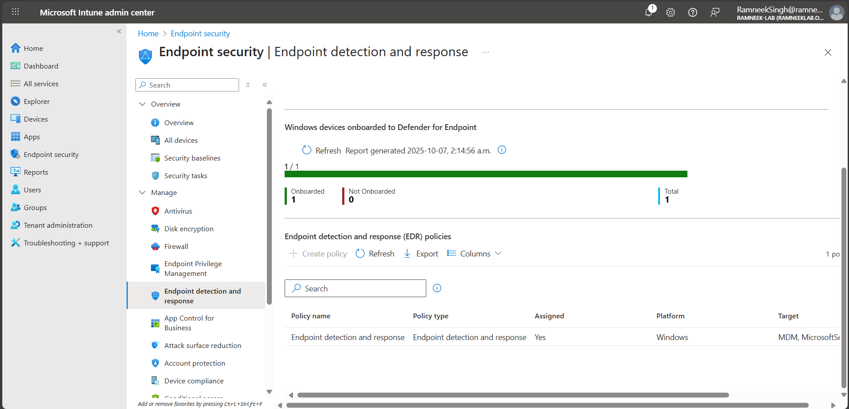
  - After these steps the device should be on-boarded to MDE and be able to verify this in Intune and MDE. Be patient and wait for the changes to take effect, this may take a while.
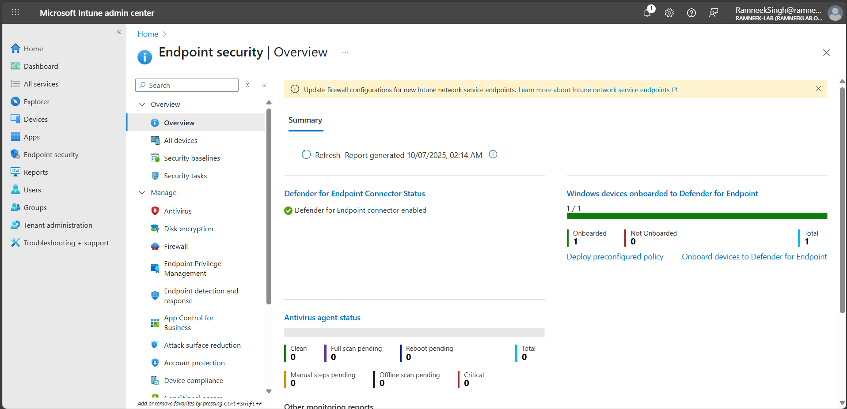
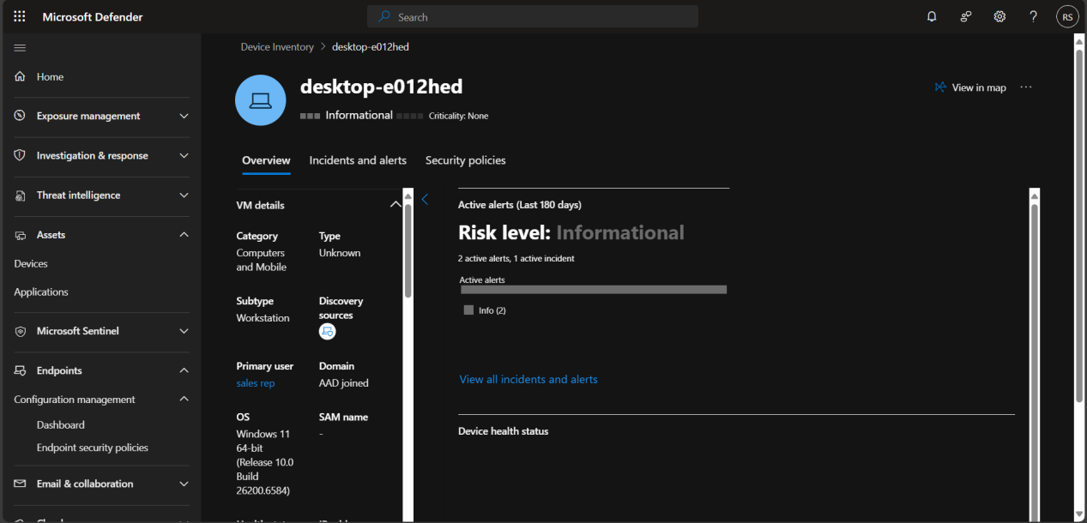
- Note we will tinker with MDE security policies later. In this step it was important that we on-board the device to MDE so that the compliance policies would work.

4.2 Configuration Policies
Configuration policies allow you to actively manage and enforce device settings on enrolled Windows 10/11 devices. Unlike compliance policies, which only check for requirements, configuration profiles push settings to devices—similar to Group Policy Objects in on-prem AD. This section demonstrates creating and assigning a basic configuration policy for security and system settings.
- Sign in to Microsoft Intune Admin Center
  - Go to https://endpoint.microsoft.com and sign in with your global admin account.
- Create a New Configuration Profile
  - Navigate to Devices → Windows → Configuration profiles → Create policy.
  - Set the following:
    - Platform: Windows 10 and later
    - Profile type: Settings catalog
  - Click Create.
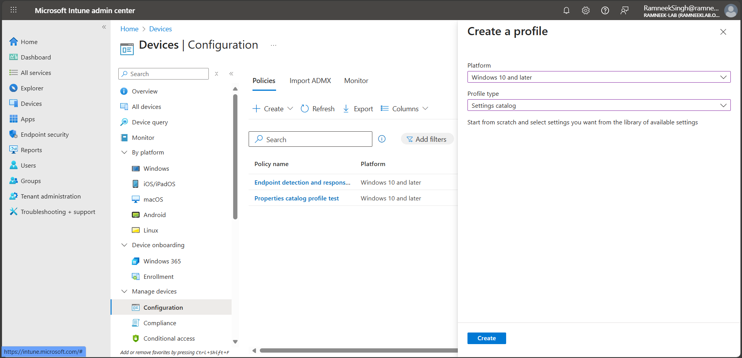
- Basics
  - Enter a name for the profile, e.g., Windows 11 Security Settings.
  - Add a short description, e.g., “Basic security configuration for lab devices.”
  - Click Next.
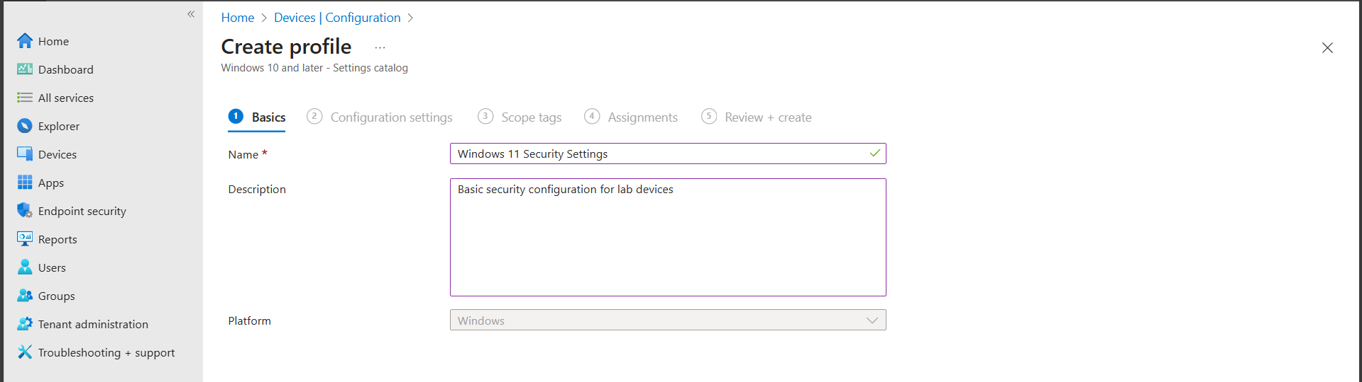
- Add Settings
  - Click Add settings. This opens the catalog.
  - Select important security-related settings for this lab, for example:
    - Administrative Templates → Control Panel → Prohibit access to Control Panel and PC settings (User): Enabled
    - Windows Components → Microsoft Defender Antivirus → Security Intelligence Updates → Initiate security intelligence update on startup: Enabled
    - Windows Components → Microsoft Defender Antivirus → Security Intelligence Updates → Turn on scan after security intelligence update: Enabled
    - Device Lock → Account Lockout Policy: Configured as per lab requirement
    - Windows Update For Business → Allow Auto Update: Enabled (automatic install and restart, applied during maintenance windows on non-battery, non-metered networks)
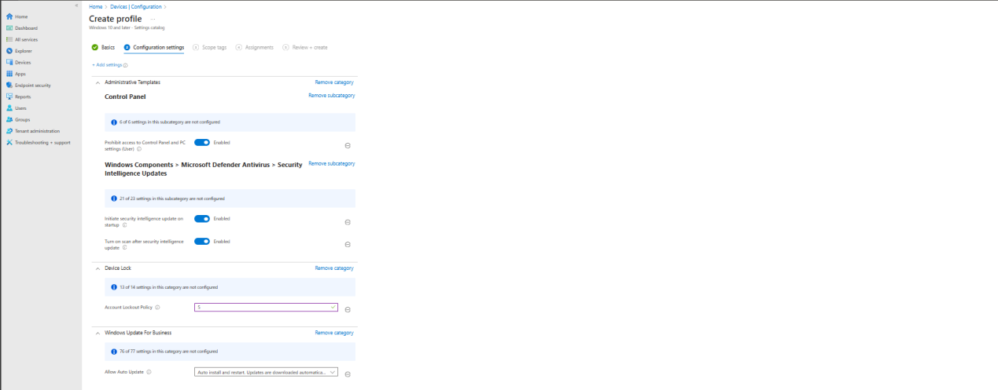
  - Click Next when done.
- Note: These are just some basic settings for demonstration. In enterprise environments, configuration profiles are usually more comprehensive and cover many security, management, and compliance controls. Each setting here helps enforce security or standardization: restricting Control Panel prevents unwanted changes, Defender updates and scans protect against malware, account lockout policies reduce unauthorized access risk, and automatic updates keep devices patched.
- Assign the Profile
  - On the Assignments page, select the all devices and all users.
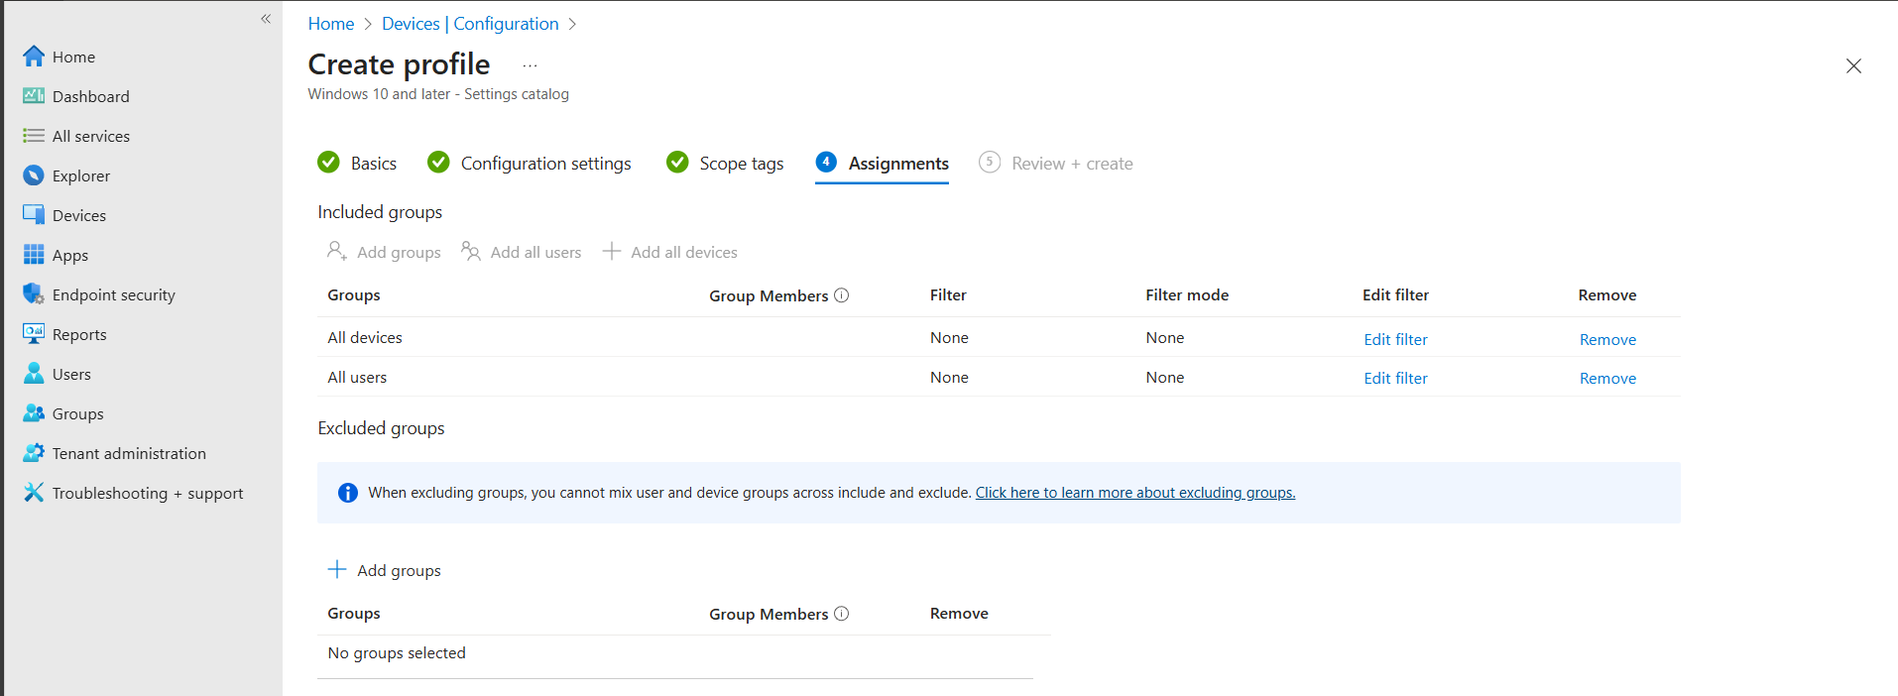
- Review and Create
  - Review your settings, then click Create. The policy is now active.
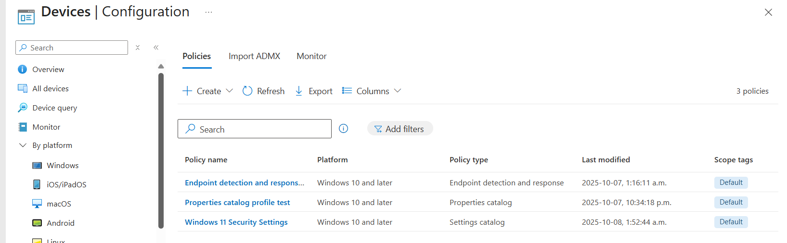
- Verification
  - On the enrolled Windows 11 VM, open Settings → Accounts → Access work or school → Info, then click Sync to force policy application.
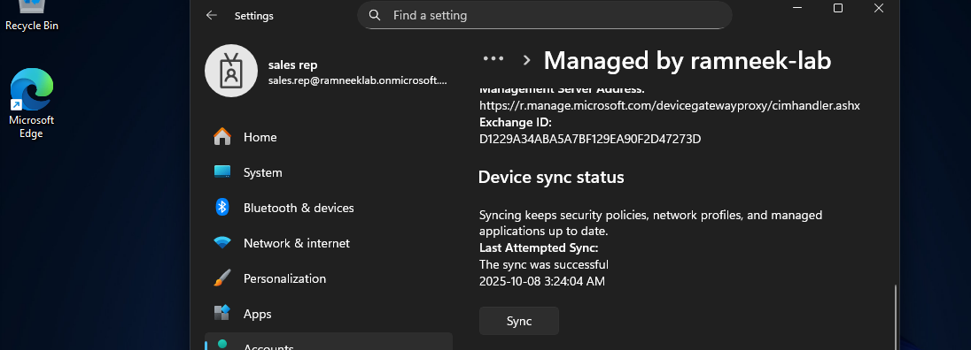
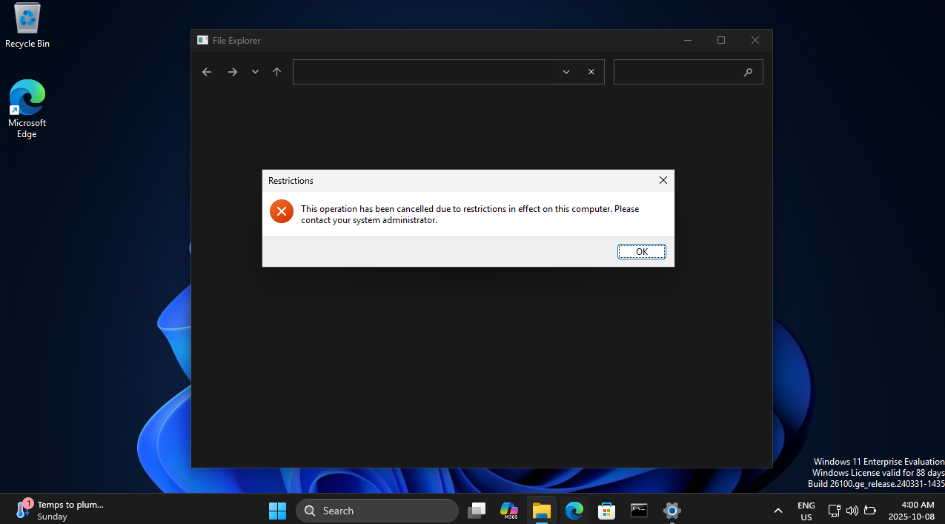
- Note: Configuration profiles can take a few minutes to propagate. You can combine multiple profiles for different purposes, such as security, system settings, and device restrictions. In the Screenshot above we can observe that we cannot access the control panel due to the newly configured profile assigned to the device.

4.3 Microsoft Defender for Endpoint (MDE) Security Policies
Microsoft Defender for Endpoint (MDE) is Microsoft’s enterprise-grade endpoint protection platform. When connected with Intune, it allows administrators to apply and enforce unified threat protection settings across all managed Windows devices.
In this section, we will enable Defender integration, configure basic endpoint security policies, and assign them to all enrolled devices for continuous monitoring and protection.
- Create an Endpoint Security Policy
  - In Endpoint security, select Antivirus → Create Policy.
  - Configure the following settings for demonstration:
  - Platform: Windows 10 and later
  - Profile type: Microsoft Defender Antivirus
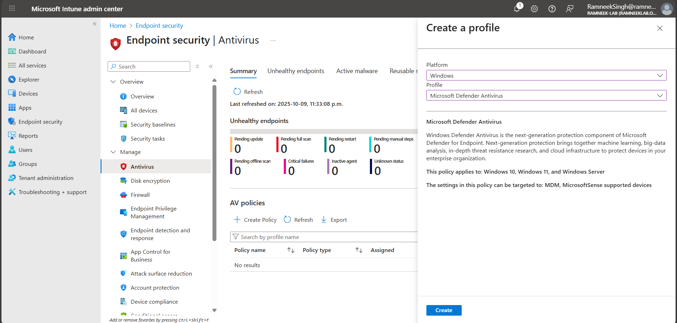
  - Under Configuration settings, enable:
  - PUA Protection: Enabled
Helps detect and block potentially unwanted applications such as adware, toolbars, or bundled installers that can affect system performance or security.
  - Real-Time Scan Direction: Monitor all files
Ensures Defender scans both incoming and outgoing files, detecting threats during file access or modification.
  - Scan Parameter: Quick Scan
Sets Defender to perform a daily quick scan instead of a full system scan, optimizing performance while maintaining protection.
  - Schedule Quick Scan Time: 120
Schedules the quick scan for 2:00 AM daily, a time when systems are typically idle.
  - Schedule Scan Day: Sunday
Defines the day for the weekly scheduled scan.
  - Schedule Scan Time: 120
Runs the weekly scan at 2:00 AM on the configured day.
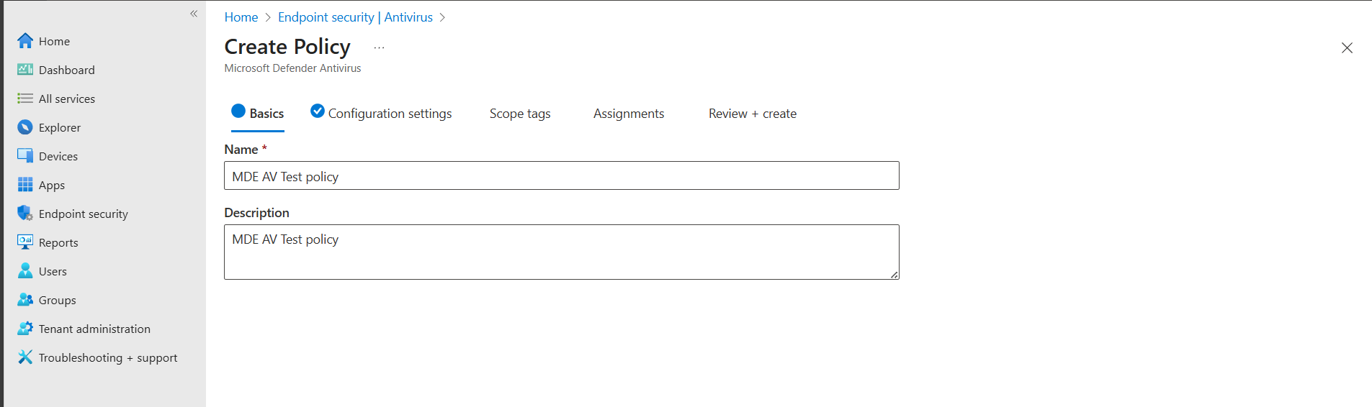
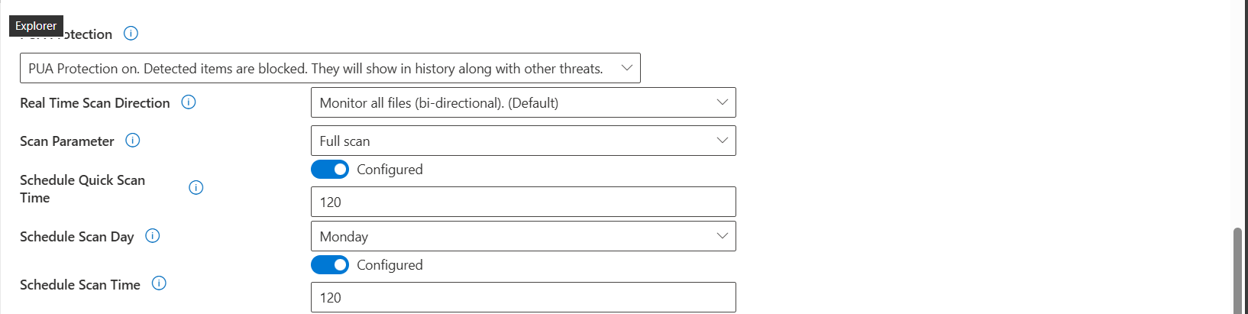
  - Click Next → assign to All devices → Next → Create.
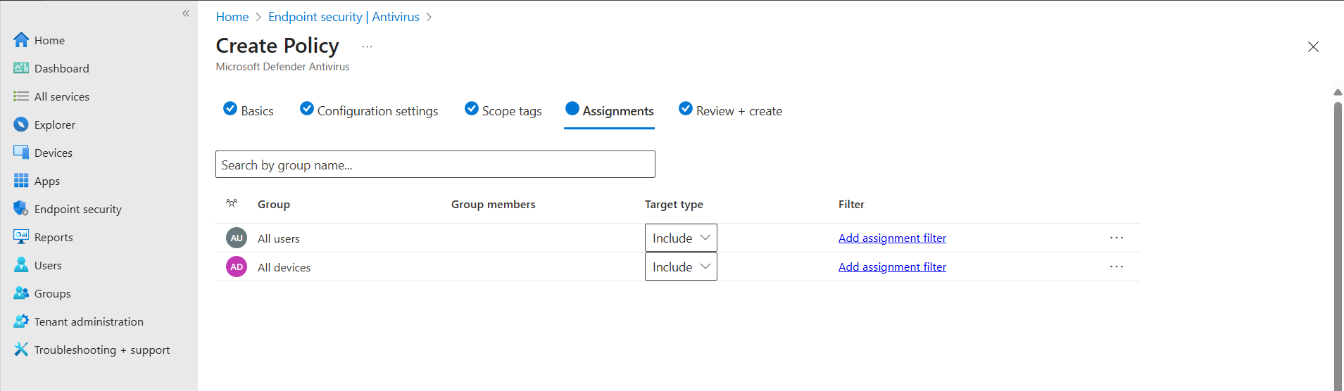
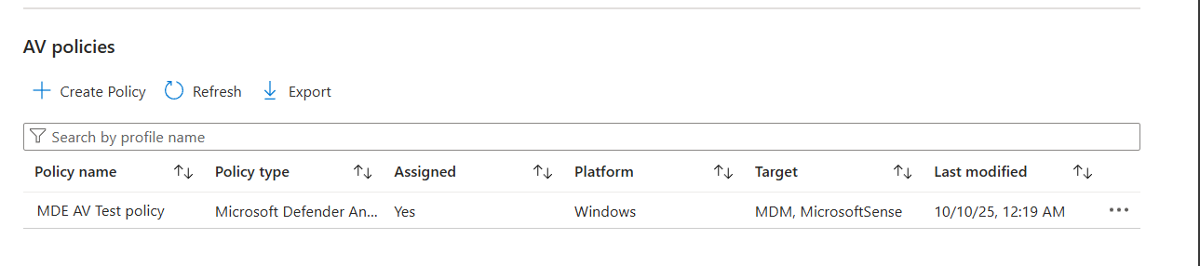
- Create an Attack Surface Reduction (ASR) Policy
  - Go to Endpoint security → Attack surface reduction → Create policy.
  - Choose Windows 10 and later → Attack surface reduction rules.
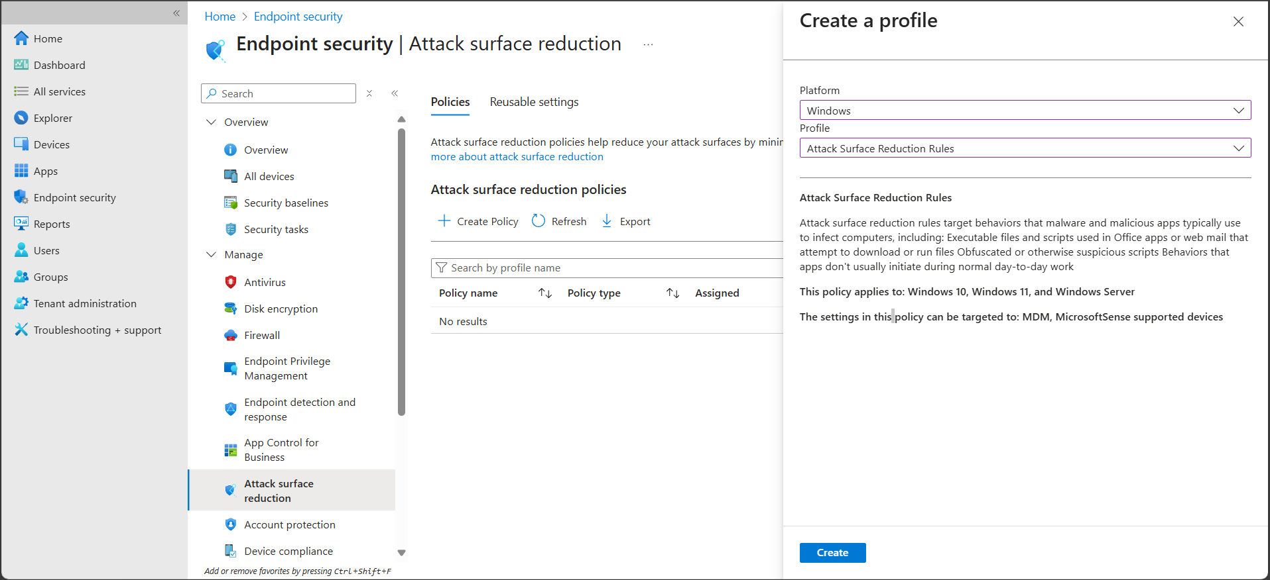
  - Enable rules such as:
  - Block executable content from email and webmail.
  - Block credential stealing from LSASS.
  - Use advanced protection against ransomware.
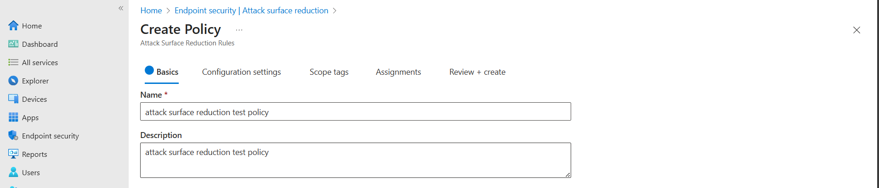
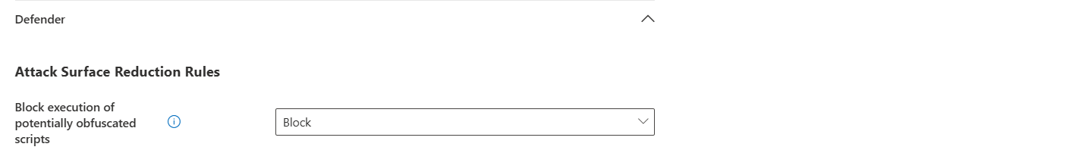
  - Assign the policy to All devices and click Create.
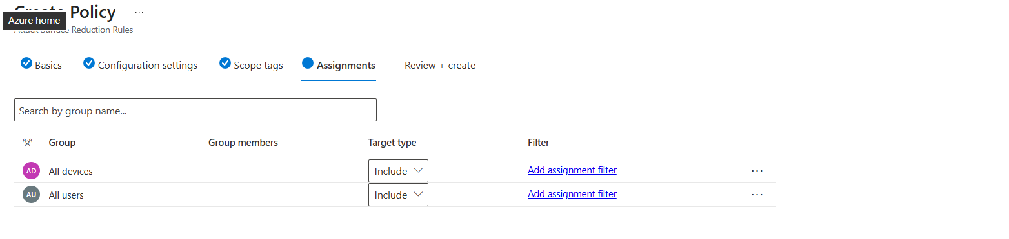
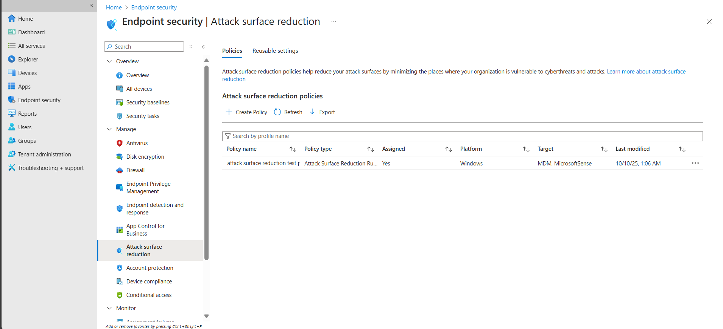
- (Recommended) Configure Firewall and Disk Encryption Policies
  - Navigate to Endpoint security → Firewall → Create Policy, set all network profiles (Domain, Private, Public) to Enabled.
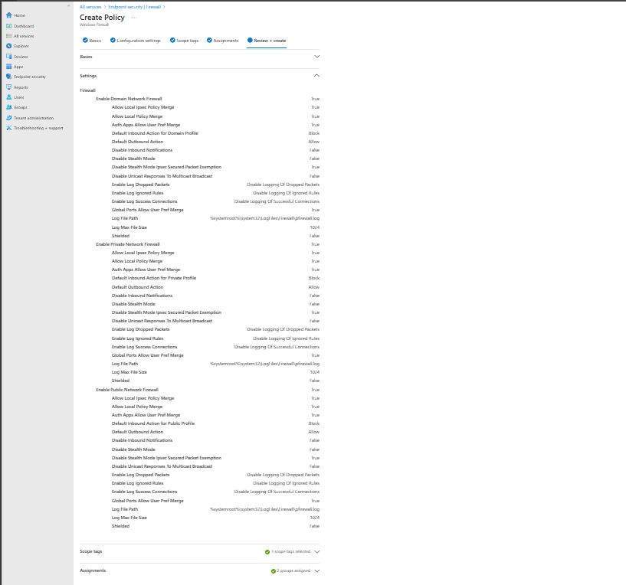
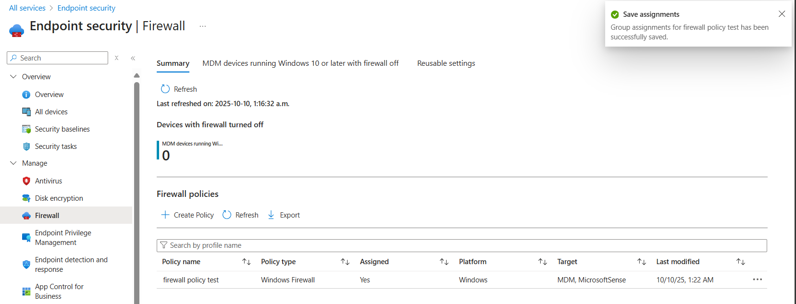
  - Navigate to Endpoint security → Disk encryption → Create Policy, enable BitLocker Drive Encryption for system and fixed drives.
These enforce baseline network and data-protection controls used in real enterprise deployments.
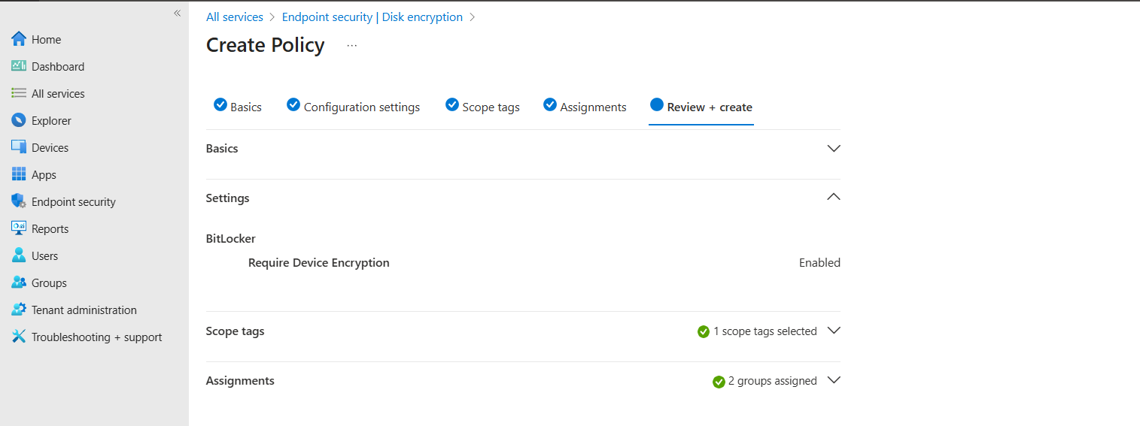
- Verify Policy Deployment
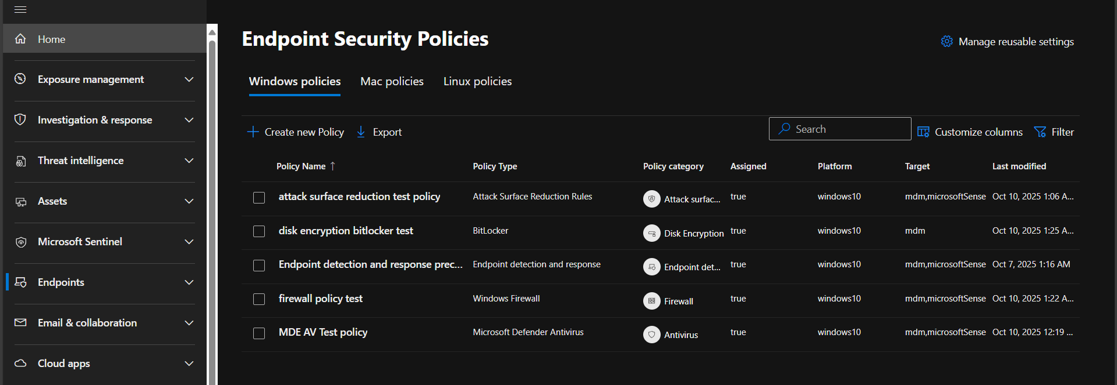

4.4 Conditional Access Policies
Conditional Access (CA) is a feature in Microsoft Entra ID that provides automated access control decisions based on specific conditions such as user, device compliance, location, or risk level. It’s how organizations balance security with user productivity enforcing MFA, blocking risky sign-ins, or requiring compliant devices before access.
- Turn off Security Defaults to be able to apply conditional access policies.
1. Access the Conditional Access Portal
  - Go to https://entra.microsoft.com
  - Navigate to Protection → Conditional Access → Policies
  - Click + New policy → Create new policy
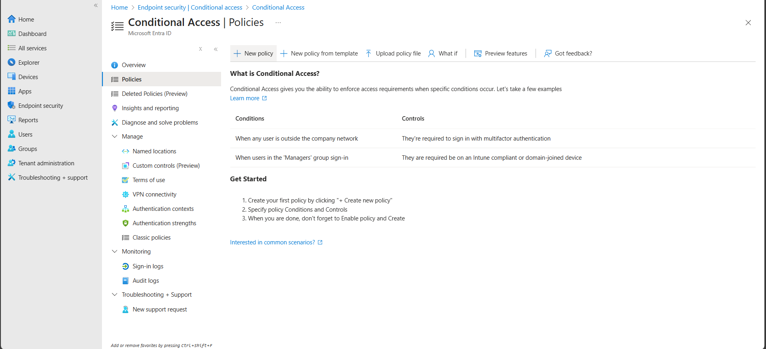
2. Basics
  - Name: Secure Access Policy
  - Description (optional): Enforces MFA and compliant device requirements for cloud apps.
3. Assignments
  - Users and Groups:
  - Select All users (or specific test users for your lab).
  - Note: Avoid locking yourself out — always exclude your Global Admin account when testing strict policies.
  - Cloud apps or actions:
  - Select All cloud apps (or just “Microsoft 365” to target Office apps).
4. Access Controls
  - Grant controls:
  - Choose Grant access
  - Then select:
    - Require multi-factor authentication
    - Require device to be marked as compliant

5. Enable Policy
  - Set Enable policy: On
  - Click Create
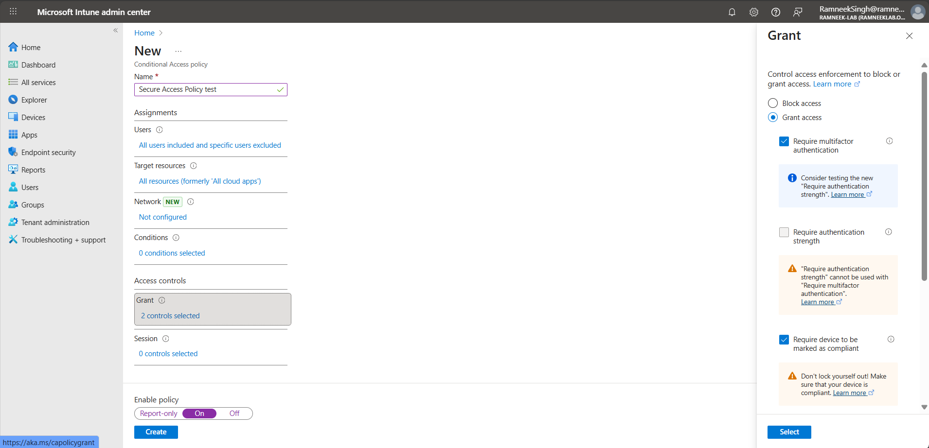
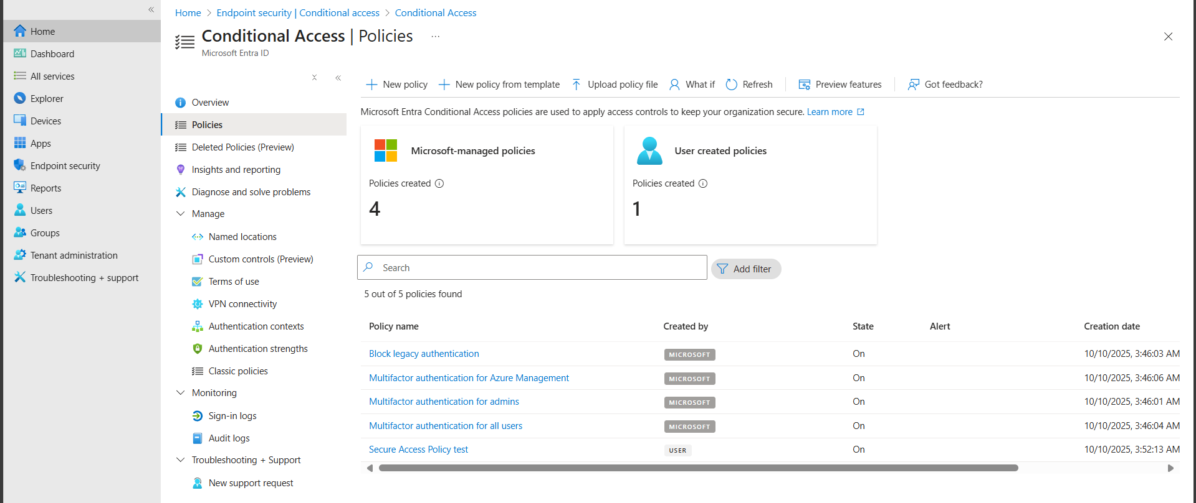

Part 5: Email Configuration and Management
This section focuses on Exchange Online within Microsoft 365, which handles all email and mailbox operations. You’ll learn how to create and manage different types of mailboxes, set permissions, apply retention and security policies, and configure mail flow rules to simulate enterprise email administration tasks.

Creating and Managing Mailboxes
- Navigate to the Exchange Admin Center (https://admin.exchange.microsoft.com) using your Global Admin account.
- Go to Recipients → Mailboxes → Add a mailbox.
- If you want to create a User Mailbox, first create the user in the Microsoft 365 Admin Center:
- Go to Users → Active users → Add a user.
- Assign an Exchange Online license to the user (e.g., hr.manager@ramneeklab.onmicrosoft.com).
- Once the user is created and licensed, their mailbox will automatically appear in the Exchange Admin Center.
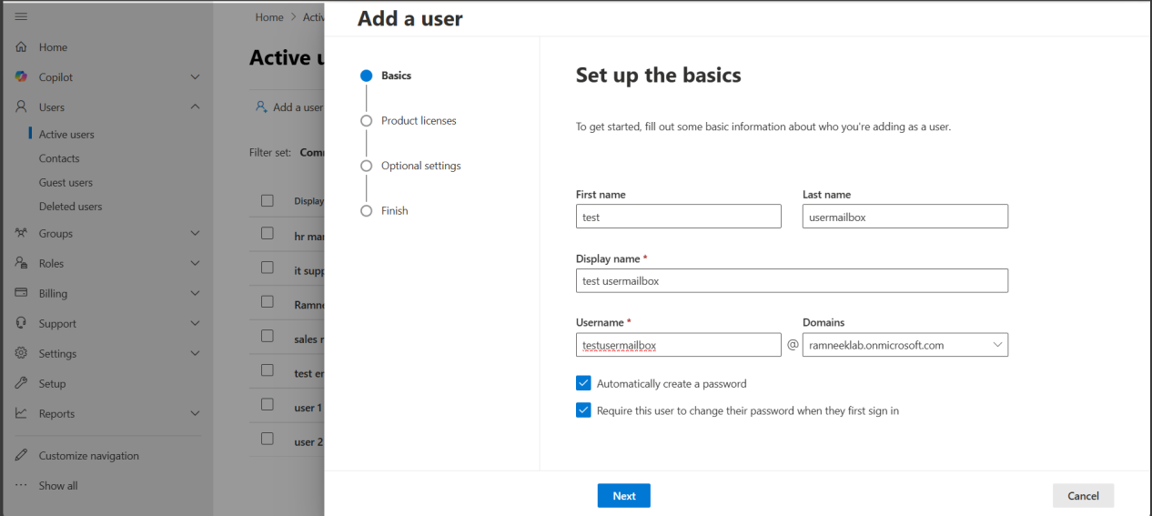
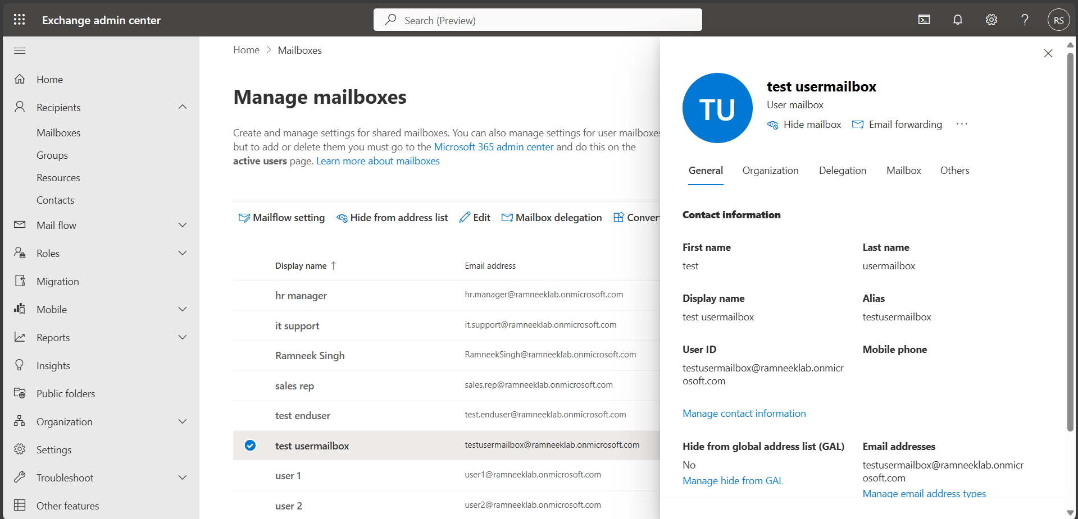
- If you want to create a Shared Mailbox, you can do it directly in the Exchange Admin Center under Recipients → Mailboxes → Add a mailbox → Shared mailbox, since shared mailboxes don’t require a licensed user.
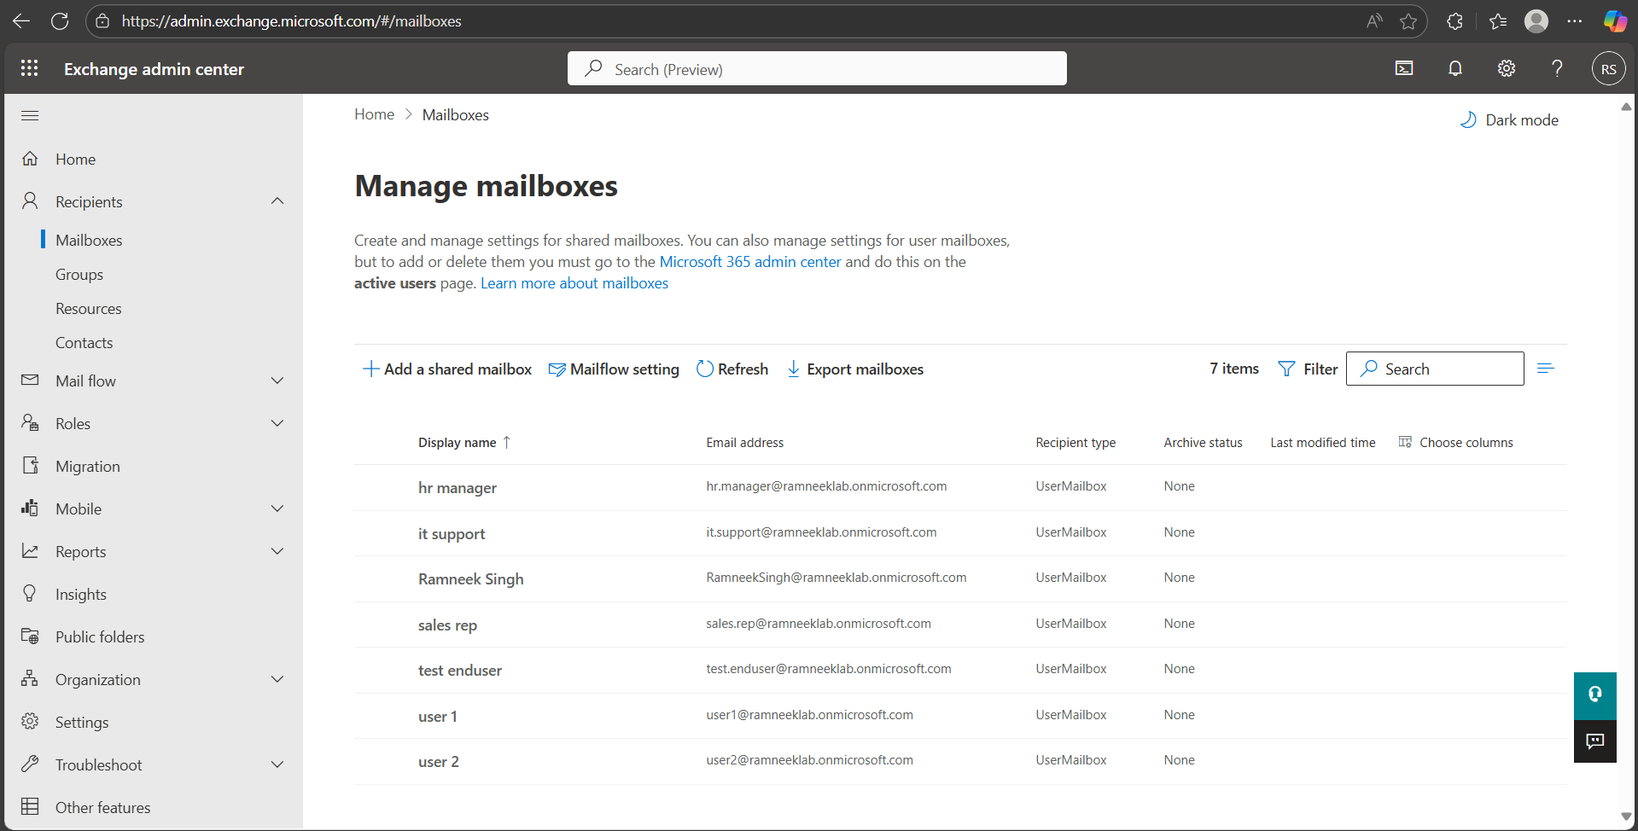
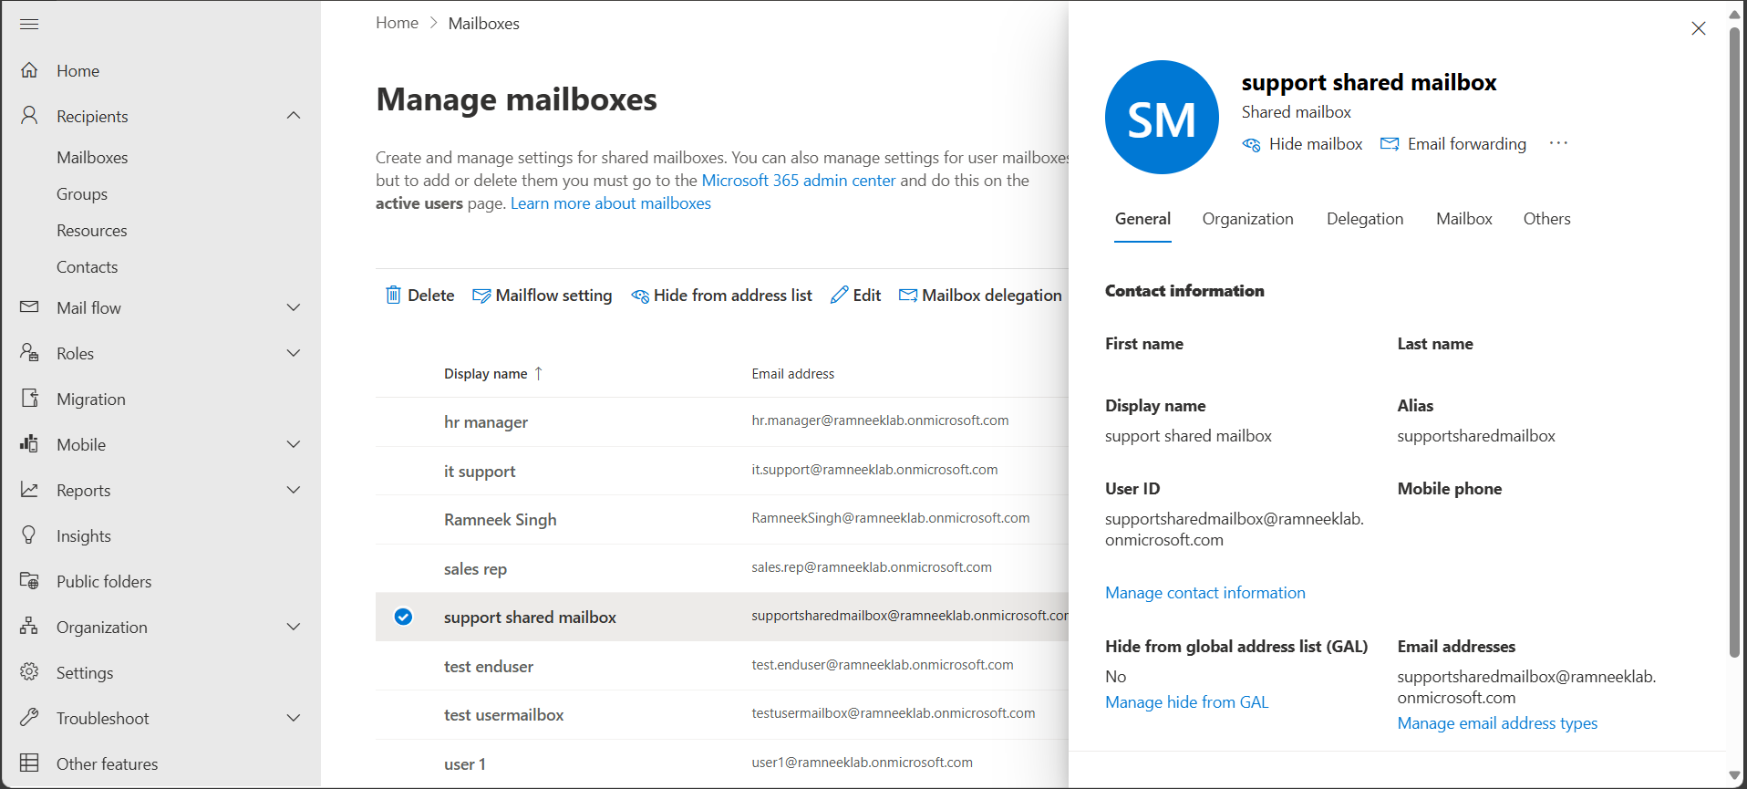
- To manage who can send email on behalf of the mailbox and who can read emails from this mailbox, click on the shared mailbox, then click on mailbox delegation and edit as needed.
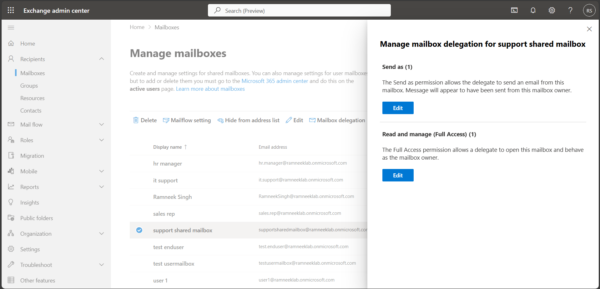
- Resource Mailbox Example:
- Go to Resources → Add room resource or equipment resource.
- Name: Meeting Room 1
- Type: Room
- Assign permissions as needed.
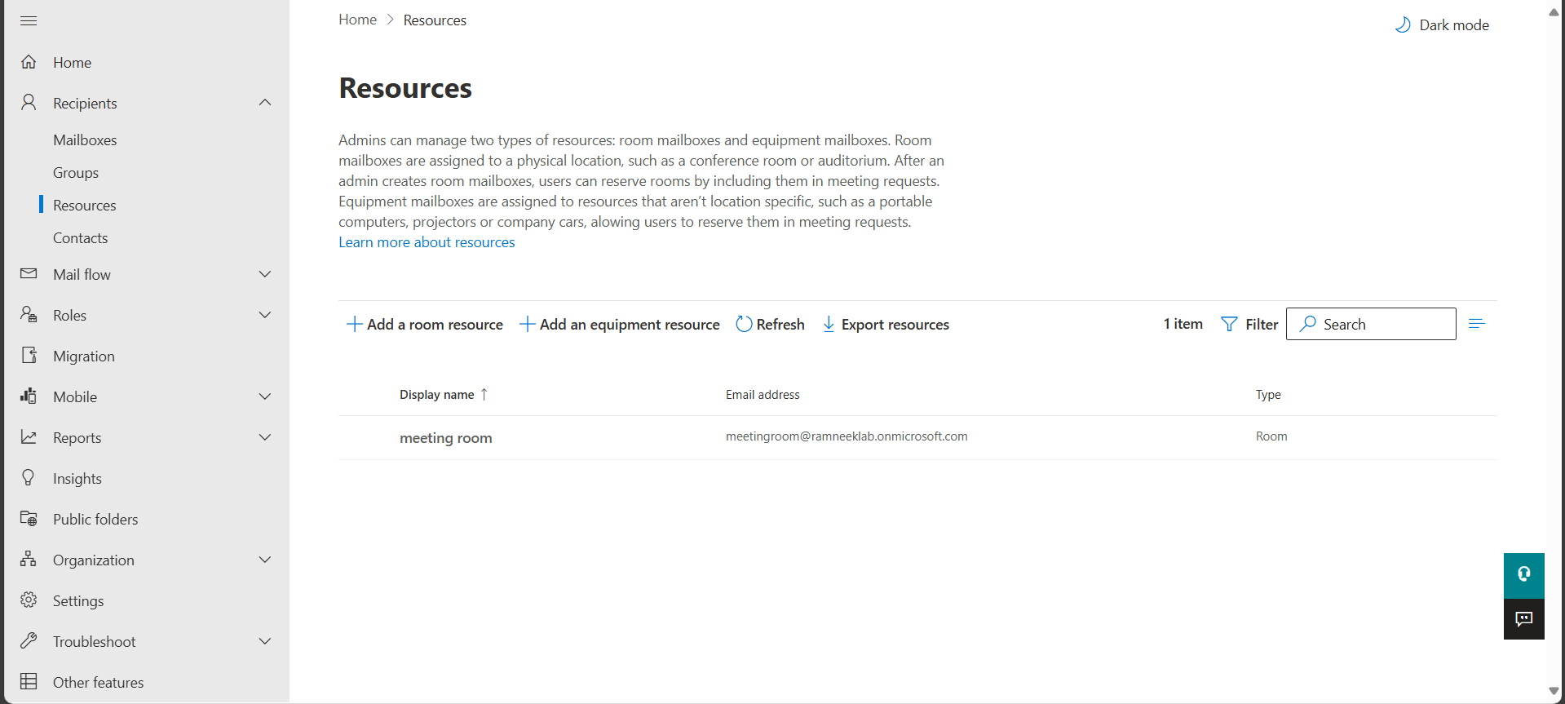

Mail Flow and Rules
Mail flow rules (transport rules) allow you to control email behavior for your organization.

- Navigate to Rules
- Go to Exchange Admin Center → Mail Flow → Rules.
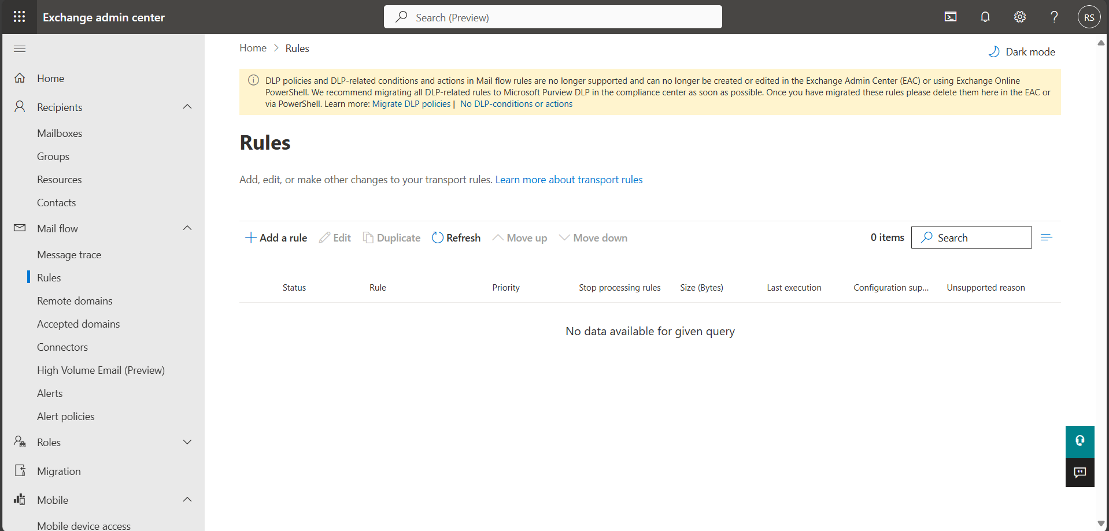
- Create a new mail flow rule
- Click Add (+) → Create a new rule.
- Example: Block external emails with executable attachments:
- Block any attachment that has executable content
- Do the following: Reject the message with explanation “Executable attachments are blocked.”
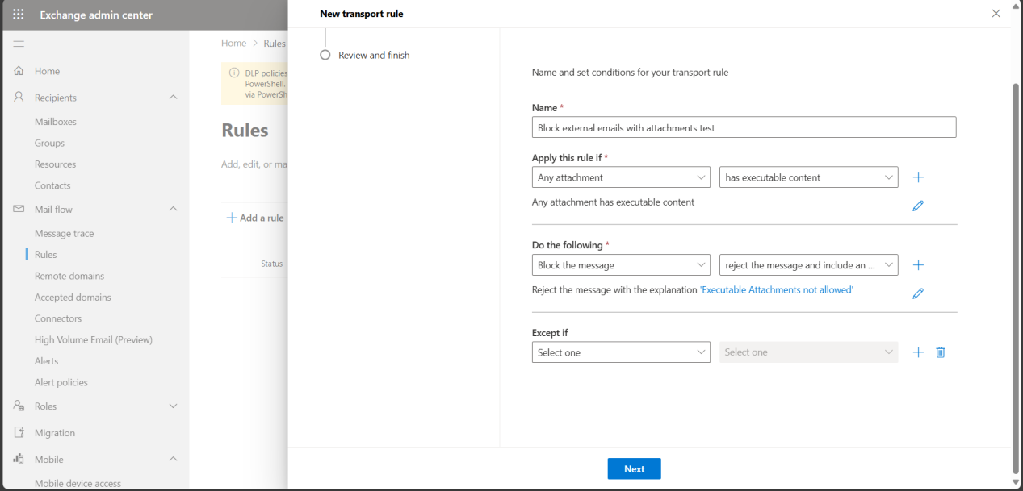
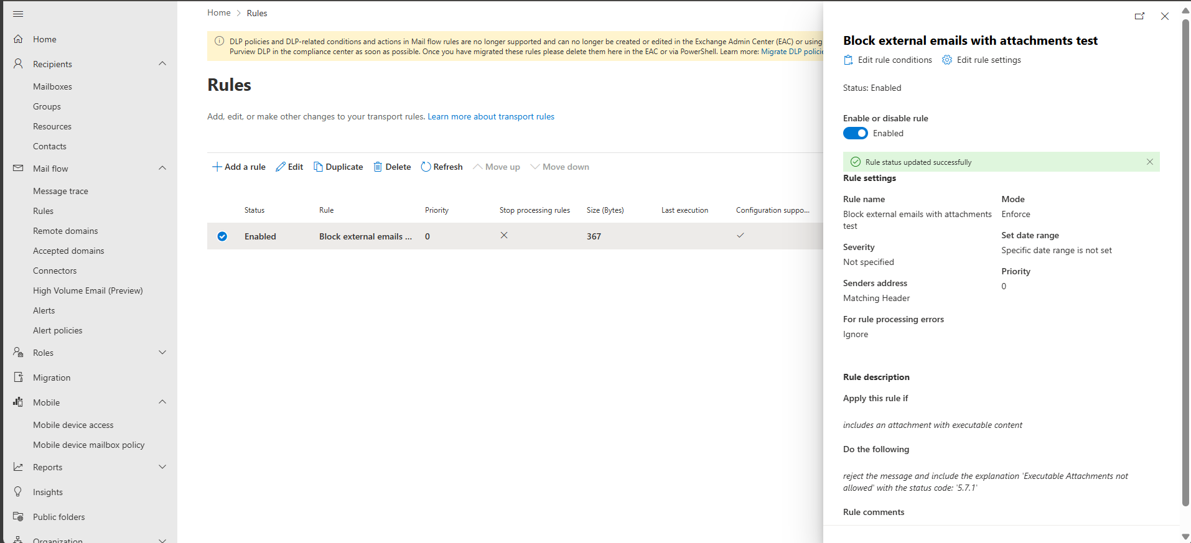
- Apply disclaimers
- Create a rule to append a company disclaimer to outgoing emails:
- Condition: Recipient is internal.
- Action: Append disclaimer text at the end of messages, e.g., “This email is intended only for authorized recipients of RamneekLab.”
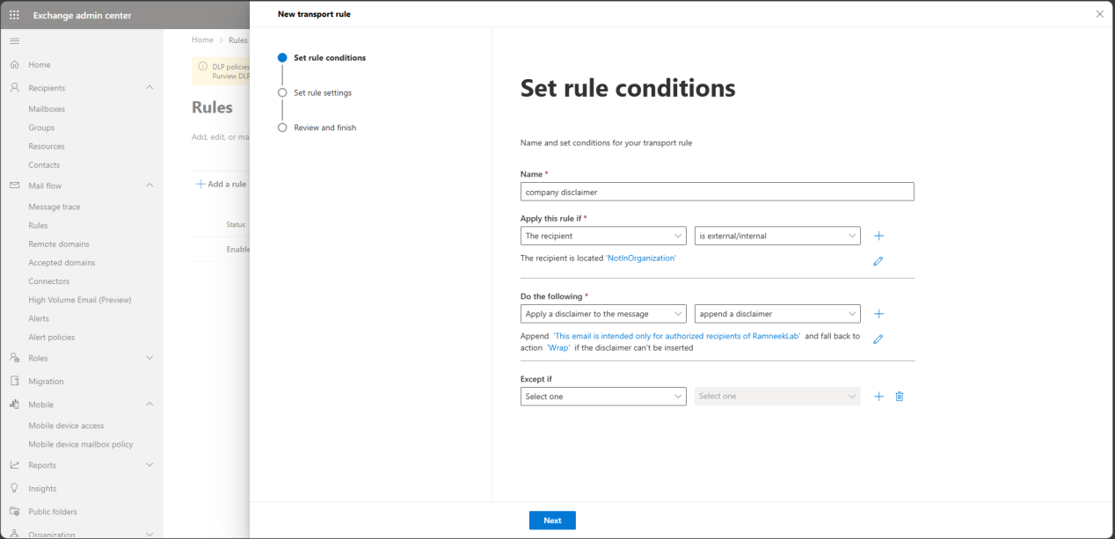
- Test rules
- Send test emails between internal and external accounts.
- Use Mail Flow → Message trace to verify delivery, rejection, or delays.
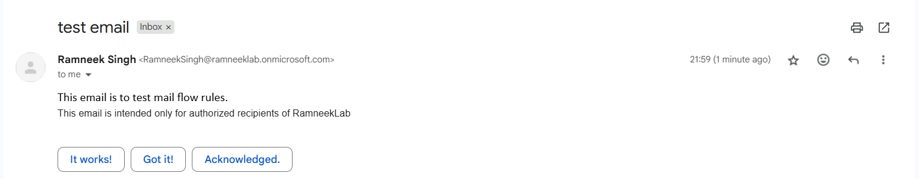
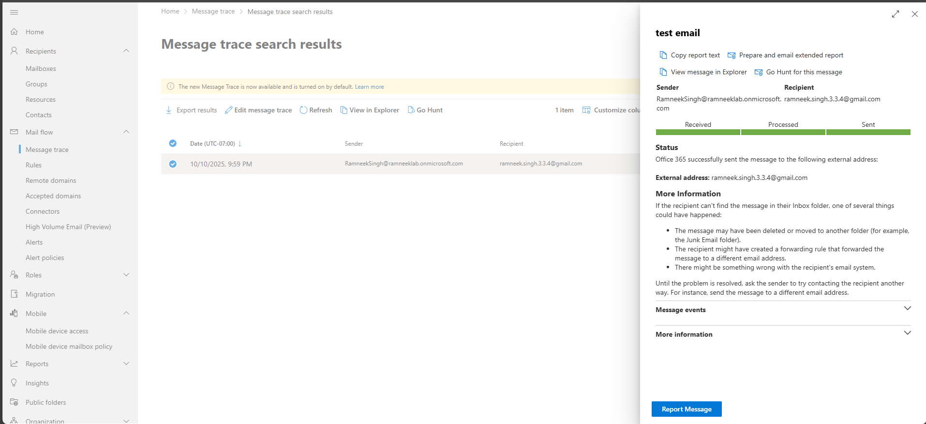

Email Security: Anti-Spam and Anti-Malware
- Anti-Spam and Anti-Malware Policies
- Go to Microsoft 365 Defender portal (https://security.microsoft.com) → Email & collaboration → Policies & rules → Threat policies.
- Review AtiAnti-Spam and Anti-Malware policies to protect mailboxes from phishing, junk mail, and malicious attachments.
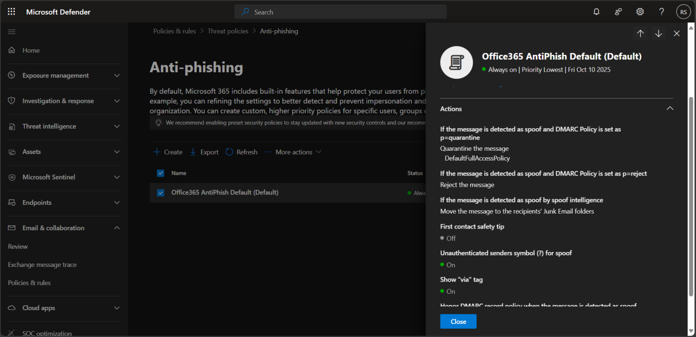
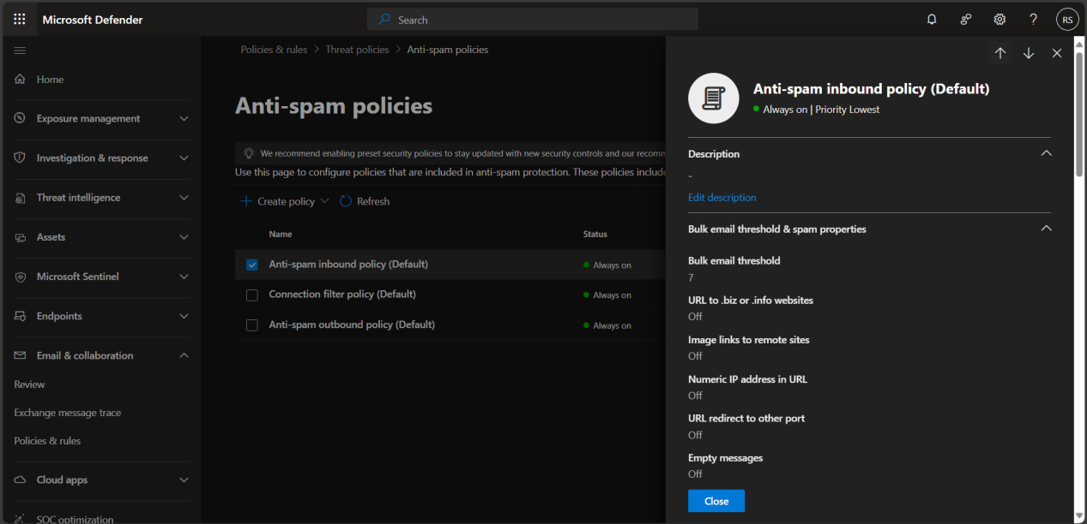
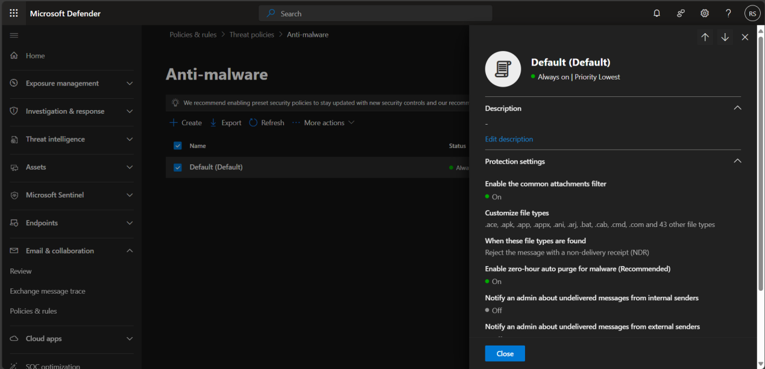
- Preset Security Policies
- In the Microsoft 365 Defender portal (https://security.microsoft.com) → Email & collaboration → Policies & rules → Threat policies, open Preset Security Policies.
- Enable Standard or Strict protection presets.
- These automatically apply recommended security settings for Anti-Phishing, Anti-Spam, and Anti-Malware to protect users from common threats without manual configuration.
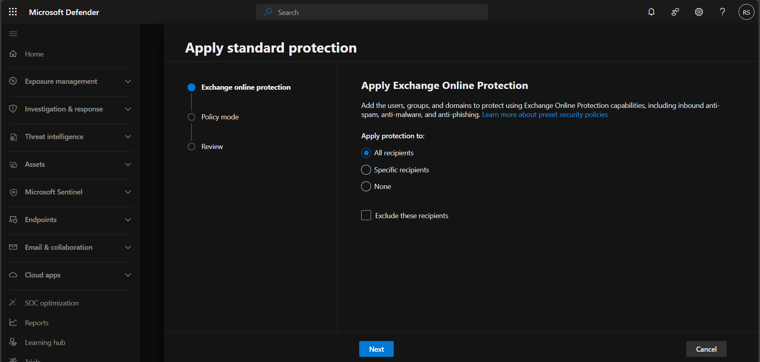
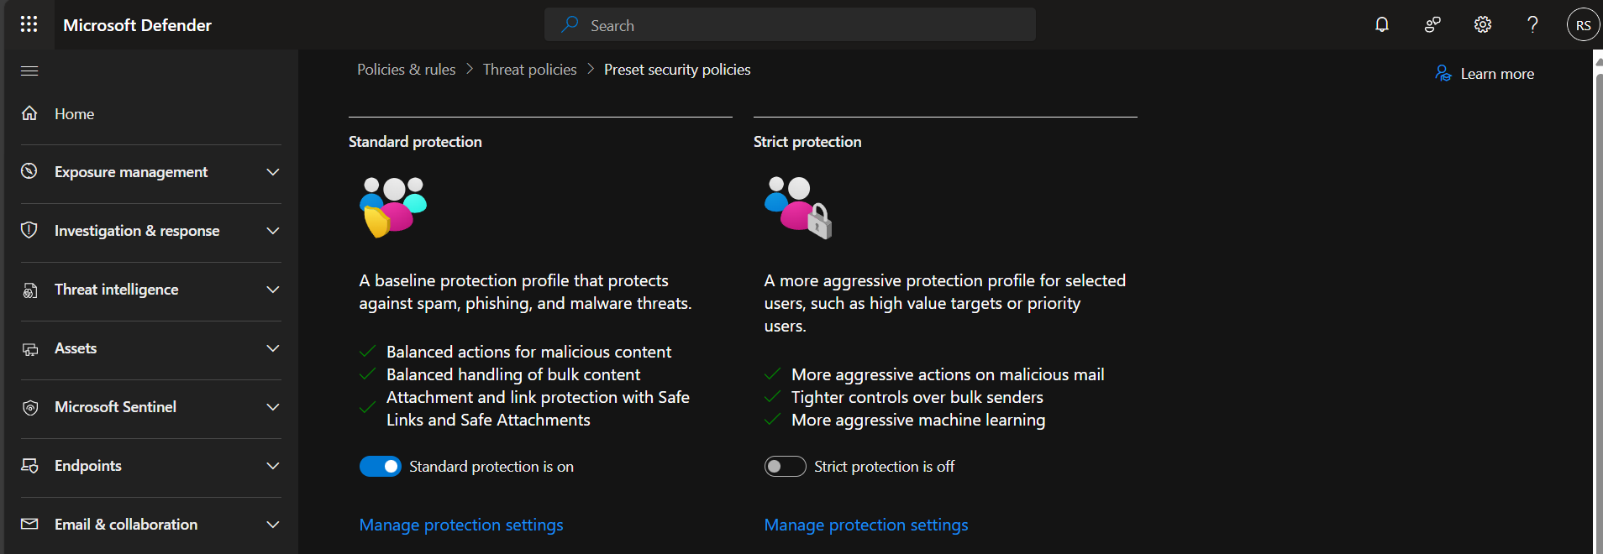
- Quarantine and Review
- Suspicious or harmful messages are automatically moved to Quarantine.
- Admins can review, release, or delete quarantined emails through the Defender portal.
- Users can also view and release their quarantined messages if permissions allow.
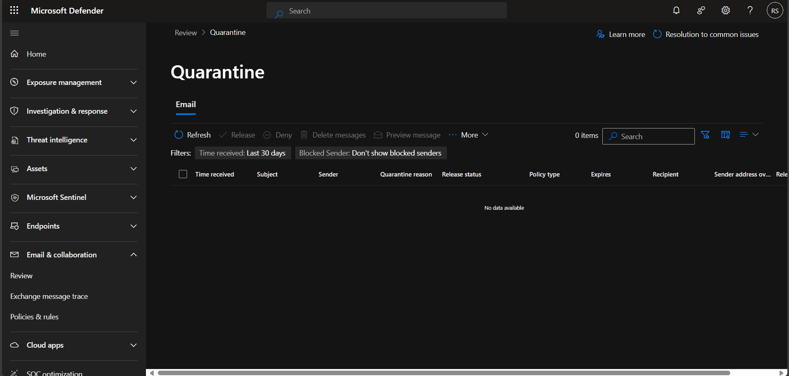

Part 6: Application Deployment and Management

6.1 Application Deployment and Management
This section demonstrates enterprise application deployment and control using Microsoft Intune. You’ll deploy apps, manage updates, and enforce policies for users and devices.
- Deploy Applications
- Win32 apps: Convert .exe or .msi apps to .intunewin format using the Intune Win32 Content Prep Tool. Upload in Intune → Apps → Windows → Add → Win32 app.
- Microsoft Store apps: Assign Store apps via Intune → Apps → Add → Microsoft Store app.
- Line-of-Business (LOB) apps: Deploy custom or internal company apps directly through Intune.
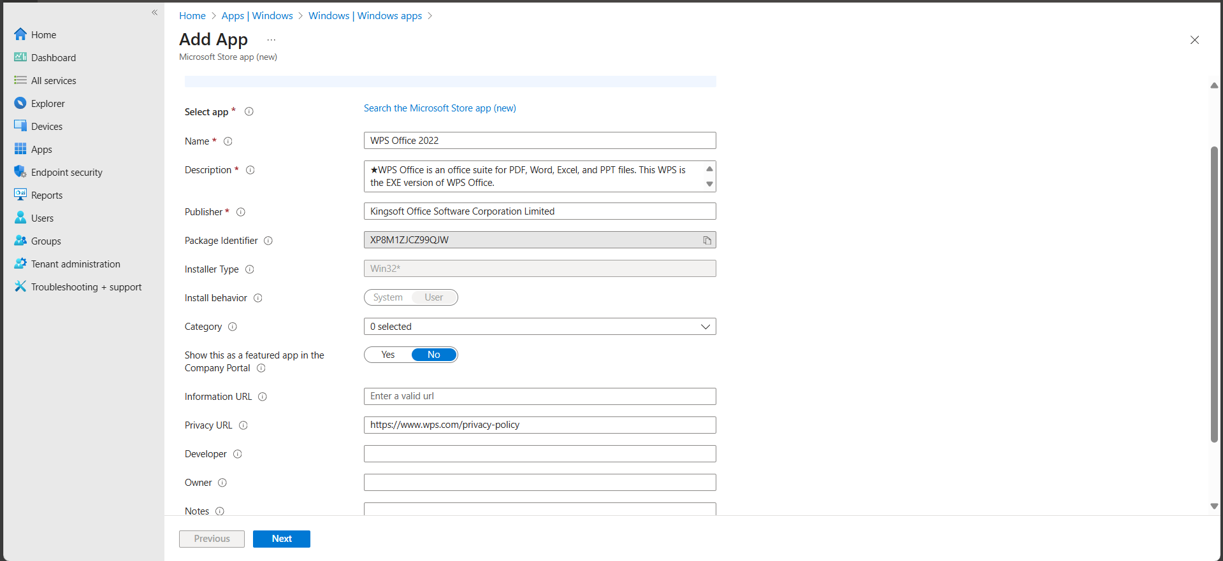
- Assign Applications
- Target users, devices, or groups for app deployment.
- Verify installation on enrolled Windows 11 test devices.
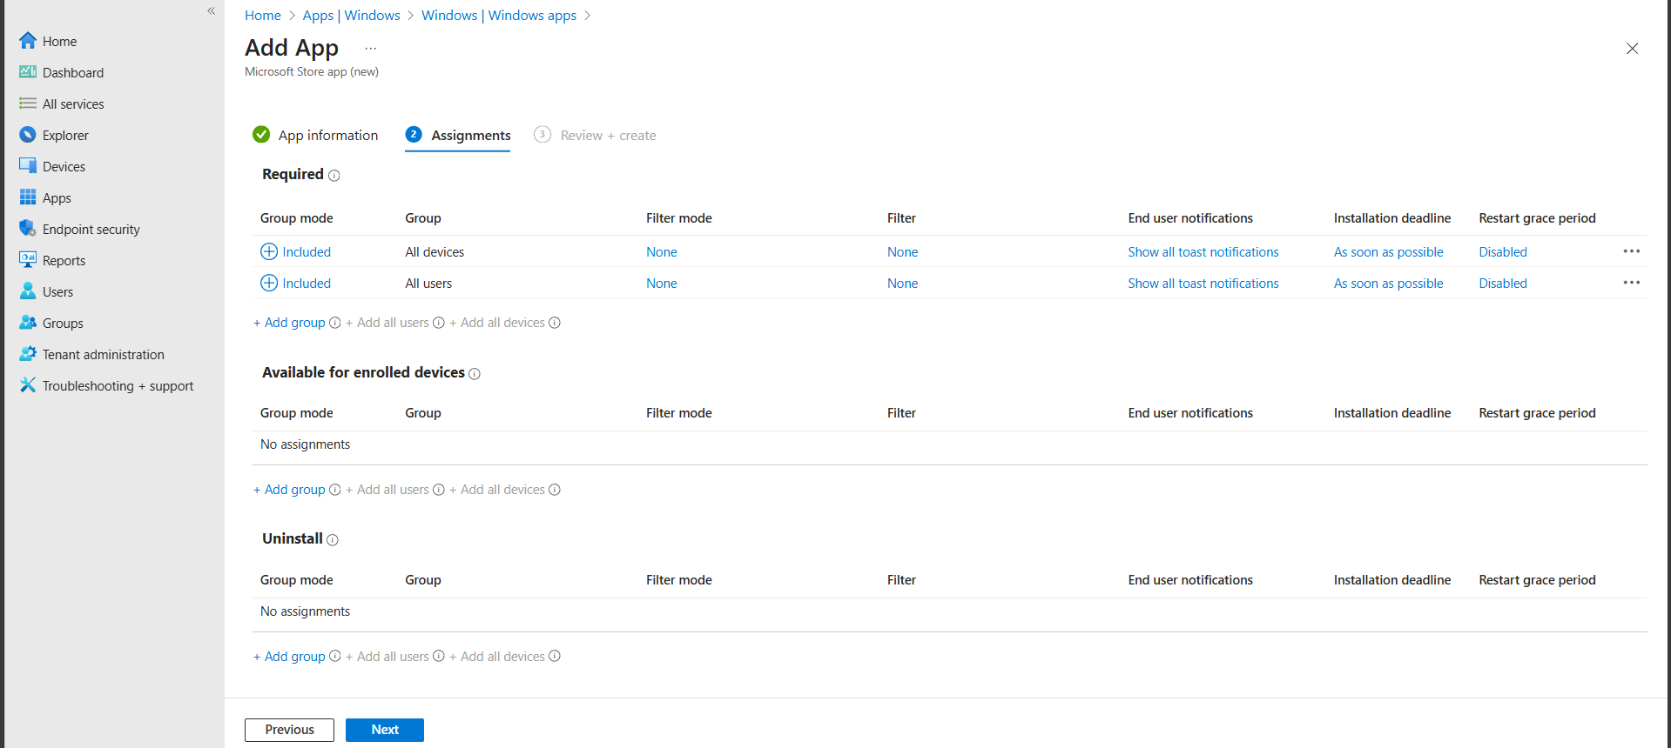
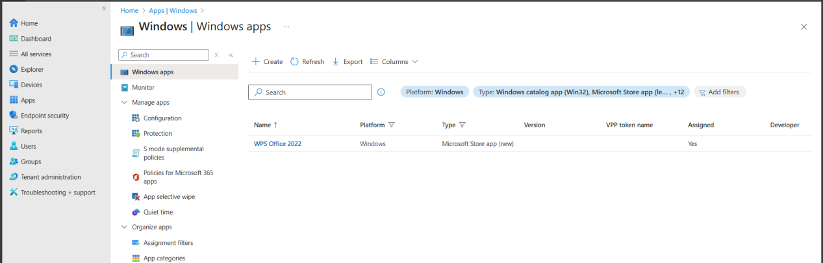
- Enforcing App Control (Managed Installer)
- In Intune Admin Center, go to Endpoint security → App control → Managed Installer.
- Click Create policy → Windows 10 and later → Managed Installer.
- Configure the policy:
    - Enable Managed Installer: On
    - Optional: specify exceptions or allow approved manual installs if needed for lab testing.
- Assign the policy to All devices (or the test device group).
- Click Create.
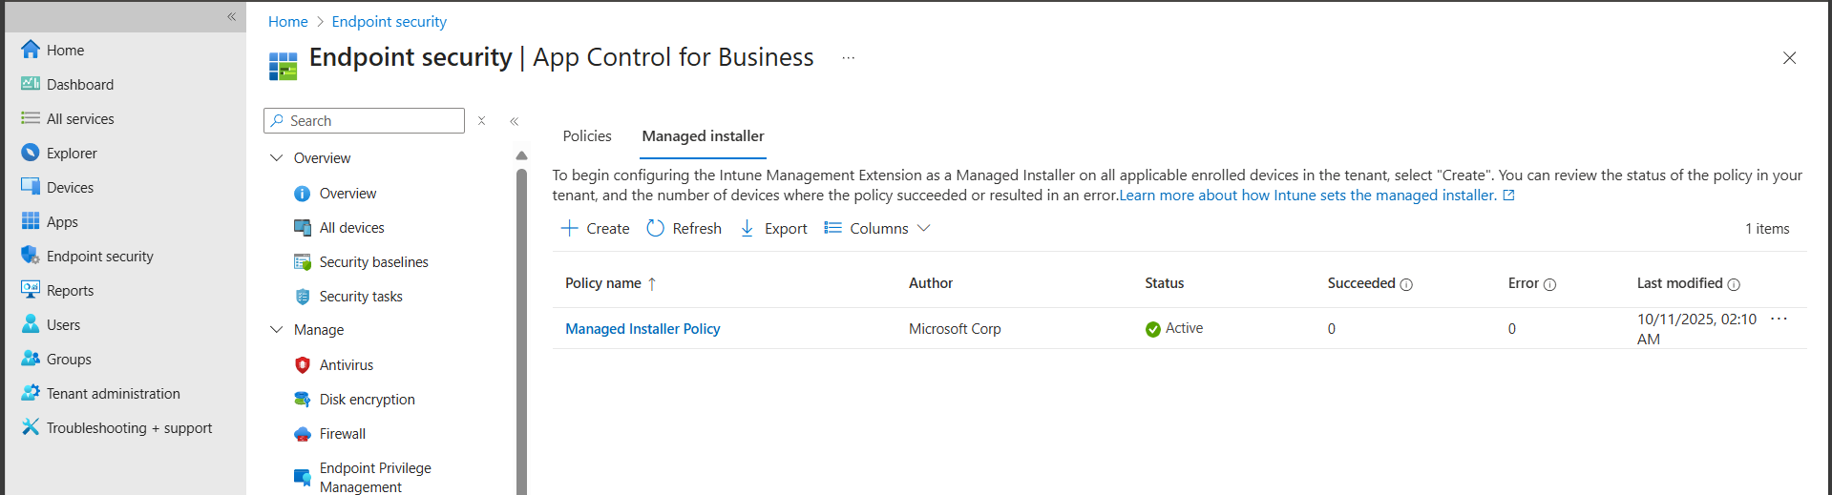
- Note: Users can only install apps deployed through Intune. Unapproved apps are blocked automatically, demonstrating enterprise app control.

- Configure Applications
- This policy blocks external extensions.
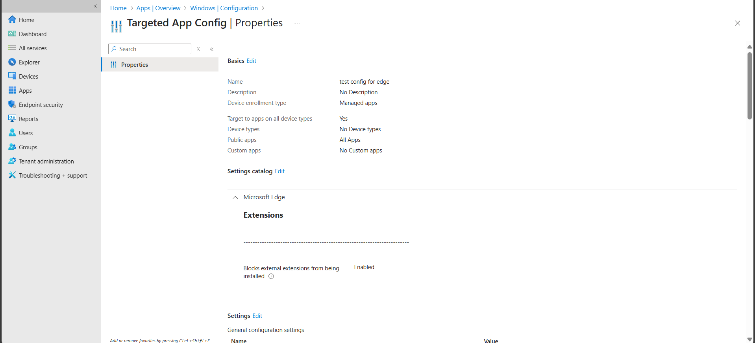
- This policy for microsoft 365 apps blocks hate content in all icrosoft 365 applications
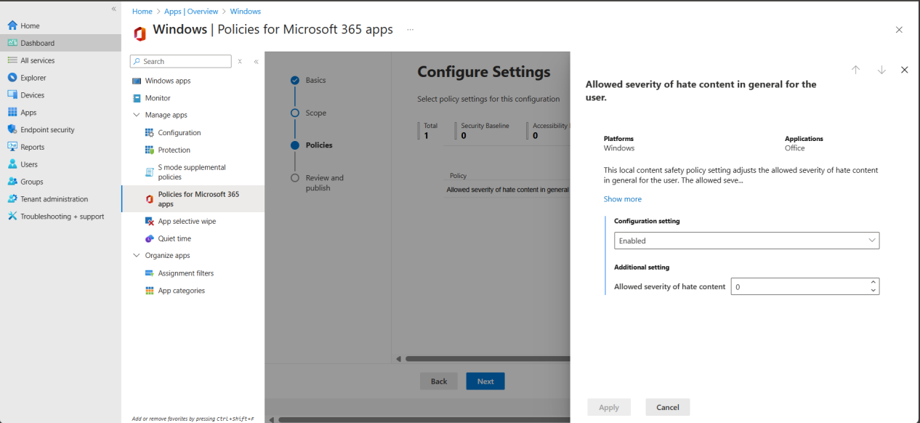

Part 7: Security Baselines

7.1 Security Baselines
- Go to Intune Admin Center → Endpoint security → Security baselines → Windows 11 baseline.
- Click Create profile and assign it to all devices (or a test group).
- Use the baseline default settings; do not modify unless required for lab testing.
- Key protections included in the baseline:
  - Microsoft Defender Antivirus enabled with real-time and cloud-delivered protection.
  - Firewall enabled for all network profiles (Domain, Private, Public).
  - BitLocker encryption enforced on system drives.
  - SmartScreen for apps and web.
  - Account protection and secure sign-in policies.
- Devices now comply with Microsoft-recommended security standards automatically.
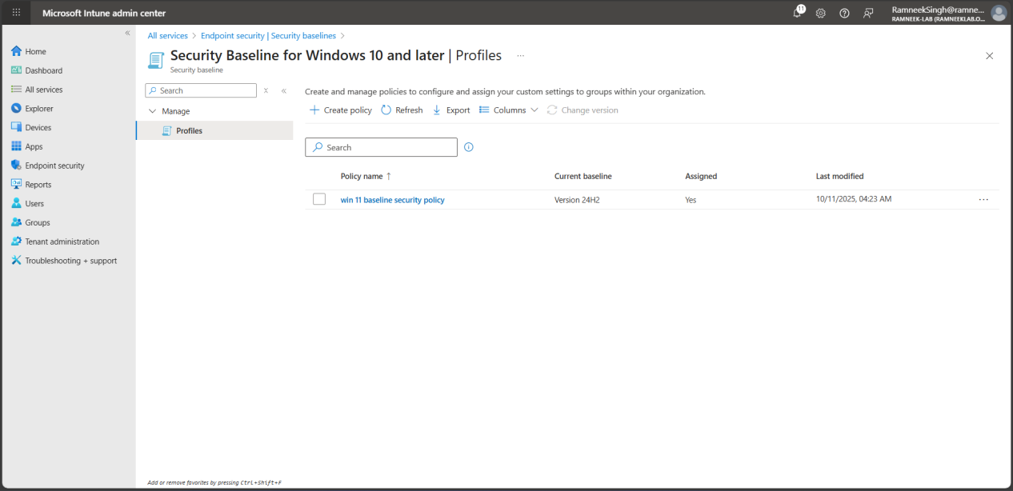
- Note: For this lab, the Windows 11 security baseline has been applied with all settings following Microsoft’s recommended defaults. This ensures enrolled devices comply with enterprise security standards, covering antivirus, firewall, device encryption, account protection, and application control. Even if no custom settings are changed, the baseline enforces these security policies automatically, providing a consistent and secure configuration across all devices.

Part 8: Device Maintenance, Updates, and Backup
This section demonstrates how to maintain device health, ensure systems stay up to date, and implement reliable backup and recovery options for enterprise-managed devices.

Configure Backup (OneDrive Known Folder Move)
- Go to the Intune Admin Center → Devices → Configuration Profiles → Create Profile.
- Platform: Windows 10 and later
- Profile type: Settings Catalog
- Enable Windows Backup.
- This allows automatic backup of personalization settings, system preferences, and Microsoft Store apps to the user’s Microsoft account.
- Under Configuration settings, search for OneDrive → Silently move Windows known folders to OneDrive.
- Enable Known Folder Move (KFM) for Desktop, Documents, and Pictures.
- Assign the policy to all enrolled users or your test group.
- Verify backup by checking that files on the user’s desktop or documents folder appear in OneDrive under PC backups.
- Note: OneDrive KFM automatically syncs user data to the cloud. If a device is lost or replaced, user files can be restored seamlessly during sign-in.
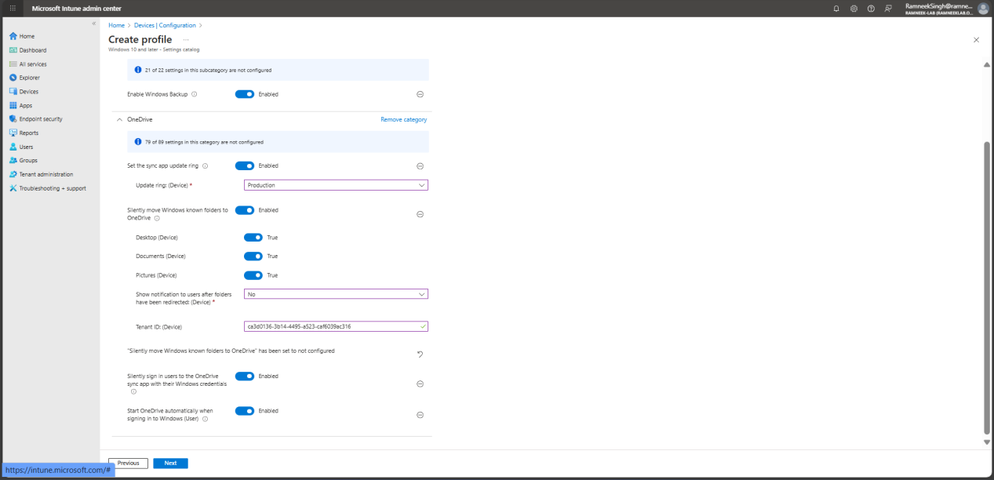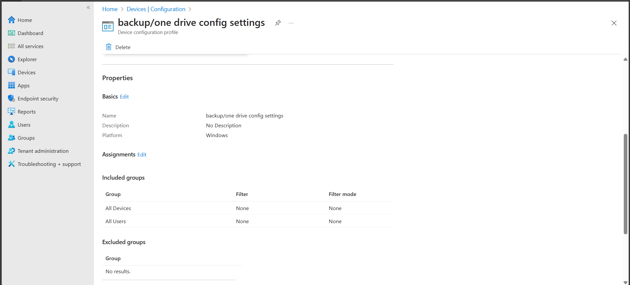

Configure Windows Updates and Rollback
This section ensures that all managed Windows 11 devices stay up-to-date with security patches and feature updates, while providing options to rollback in case of issues.
- Create an Update Ring
- In Intune, go to Devices → Windows → Update rings for Windows 10 and later → Create profile.
- Name: Windows 11 Update Ring.
- Configure settings:
- Assign to all devices or a test group.
- Click Create.
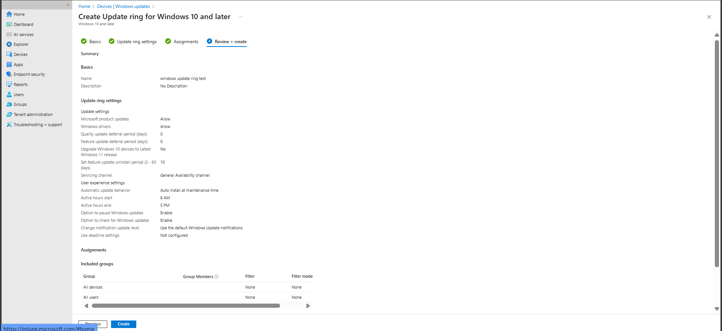
- Note: The default Windows Update for Business settings ensure devices stay current while minimizing disruption. Microsoft product and driver updates are allowed, with no deferral for quality or feature updates. Devices are not automatically upgraded from Windows 10 to Windows 11. Feature updates can be uninstalled within 10 days if issues occur. Updates are automatically installed during maintenance hours (8:00 AM – 5:00 PM), users can pause or manually check for updates, and default notifications are used. Backup solutions like OneDrive or restore points complement update rollback options.
- Feature Updates
- Go to Devices → Feature updates → Create policy.
- Set target version or keep default (latest).
- Set uninstall period (e.g., 10 days).
- Assign to devices.
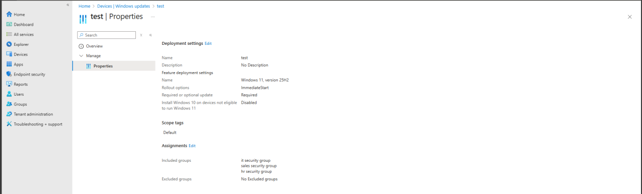
- Quality Updates
- Go to Devices → Quality updates → Create policy.
- Allow updates automatically (default).
- Assign to devices.
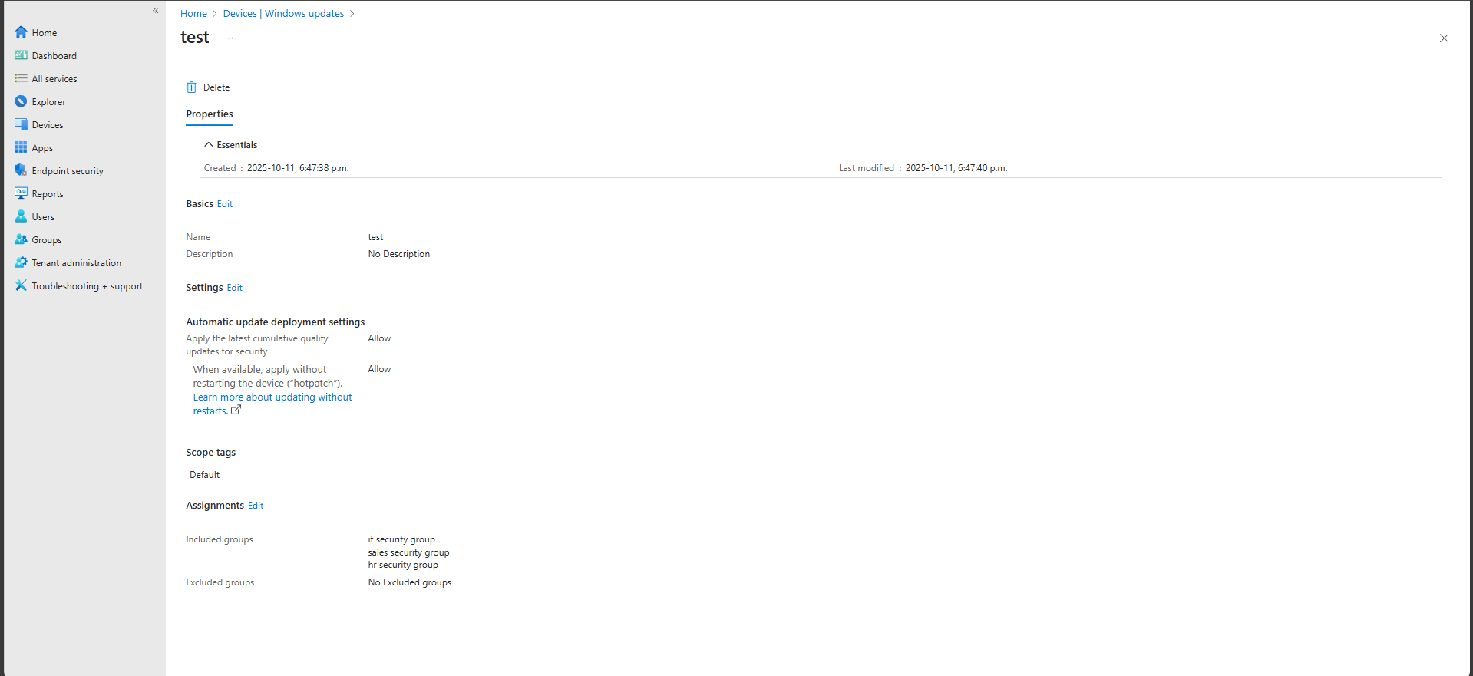
- Driver Updates
- Go to Devices → Driver updates → Create policy.
- Set Allow automatic driver updates.
- Assign to devices.
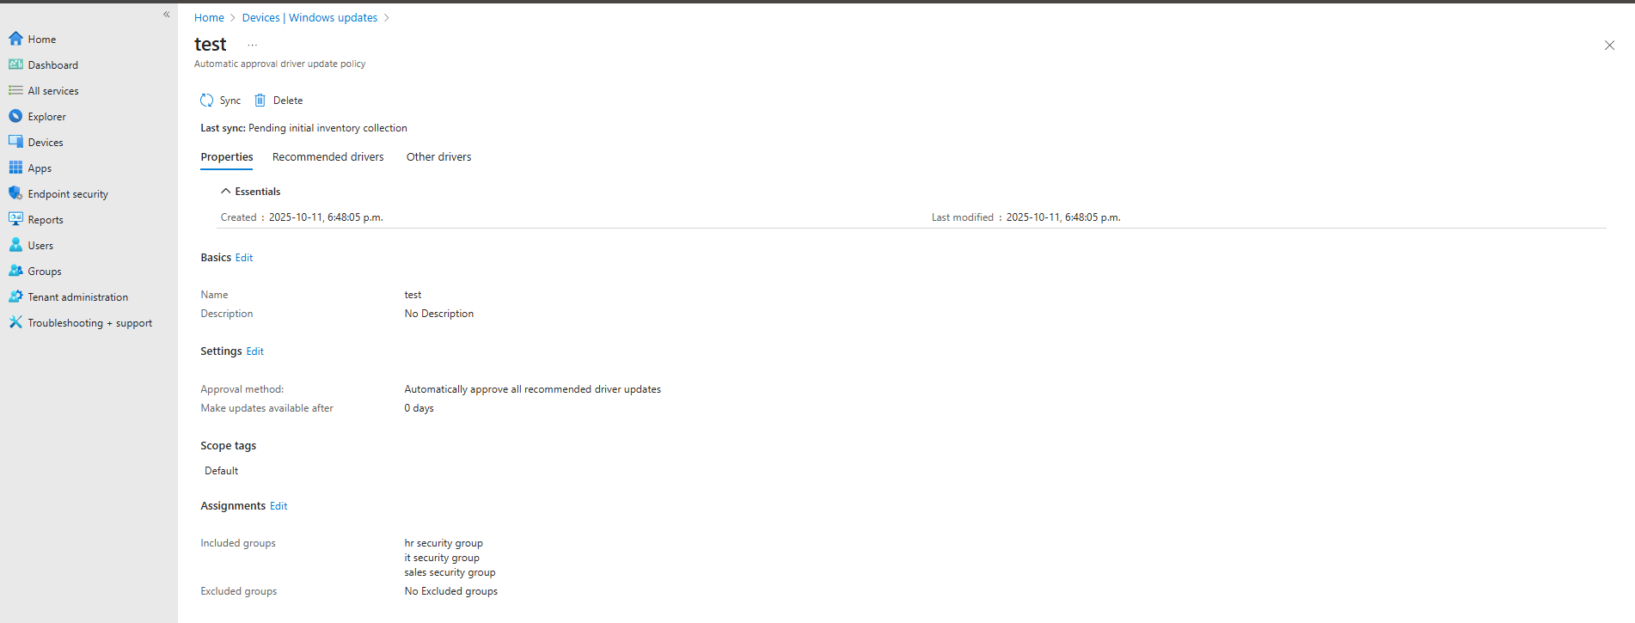
- Verification
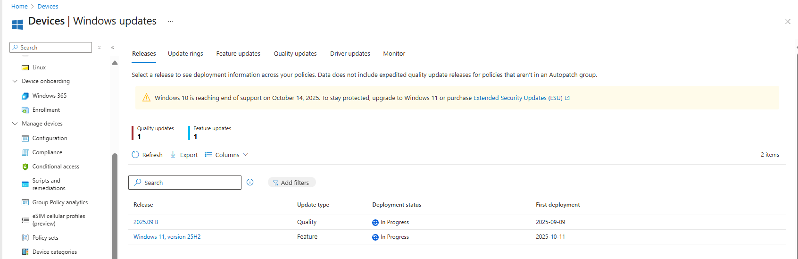
- Note: These settings demonstrate enterprise best practices for keeping devices up-to-date, secure, and recoverable with minimal disruption to users.

Part 9: Windows Autopilot and Enterprise Onboarding
In this part, we’ll demonstrate how modern enterprises use Windows Autopilot Device Preparation (APv2) to automatically set up and configure new Windows 11 devices — without imaging, USB drives, or manual setup. The goal is to simulate a zero-touch deployment (ZTD) experience similar to how new corporate laptops are delivered and configured out of the box.

9.1 Overview
Windows Autopilot Device Preparation replaces the older manual Autopilot process.
Instead of collecting and importing hardware hashes, it allows devices to automatically register with Intune once a user signs in with their Entra ID account. This greatly simplifies onboarding and eliminates the need for pre-registration.
When a new device connects to the internet and the user signs in with their organization’s Entra ID credentials:
- The device is automatically recognized as part of the organization.
- Intune applies the Autopilot Preparation policy, security baselines, and apps.
- The device is fully configured and ready for work — all automatically.

9.2 Steps
- Create a New Windows 11 VM (Simulating a New Device)
  - In Hyper-V or your virtualization tool, create a new VM and install a clean copy of Windows 11 Pro or Enterprise.
  - Do not sign in with any account during setup — stop at the initial sign-in screen.
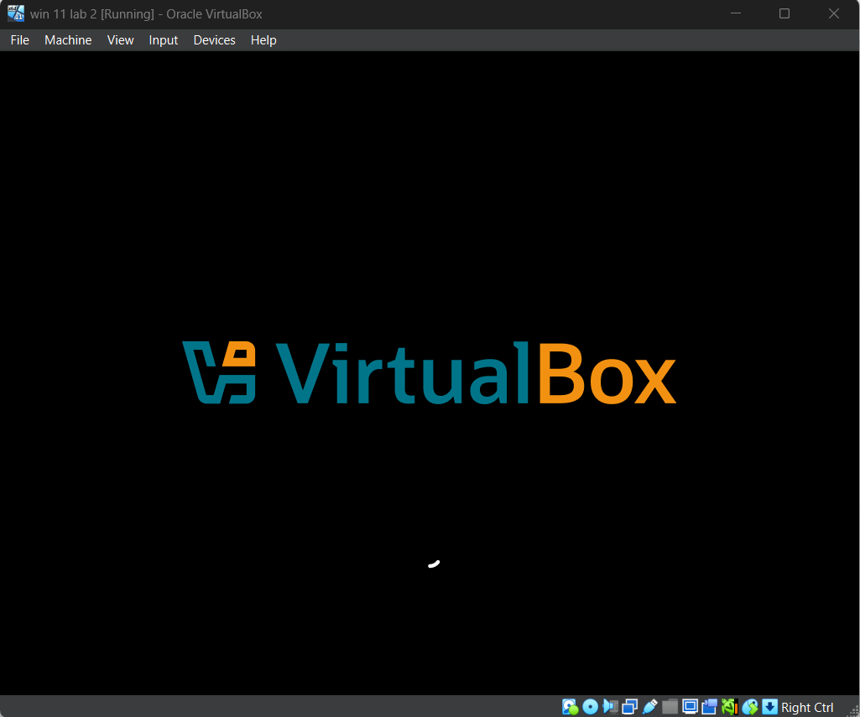
- Create an Autopilot Device Preparation Policy
  - Go to Intune Admin Center → Devices → Windows → Windows enrollment → Device preparation (preview).
  - Click Create policy.
  - Configure the following:
    - Name: Windows 11 ZTD Policy
    - Enrollment type: User-driven (Microsoft Entra ID join)
    - Assigned group: All users or a test user group
    - Apps and Policies: Select any required baseline, compliance, or configuration profiles.
  - Save and assign the policy.
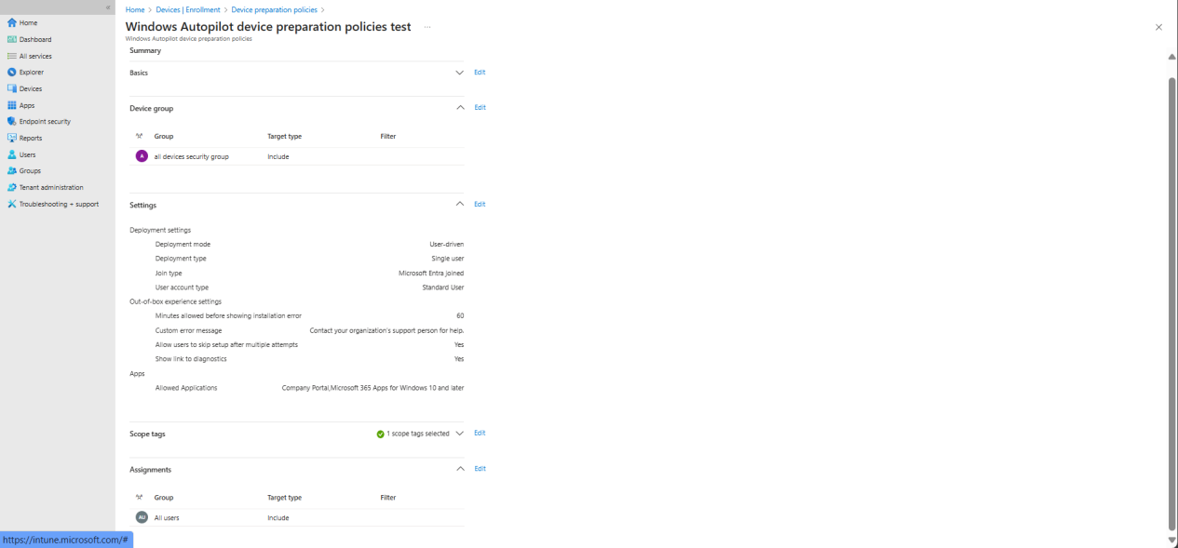
- Test the Zero-Touch Setup
  - Start the new VM.
  - Connect to the internet, then sign in with your Entra ID user account.
  - Windows will automatically detect the Autopilot Preparation policy, enroll the device into Intune, and begin applying apps and settings.
  - After setup completes, verify the device appears in Intune → Devices → Windows → All devices.
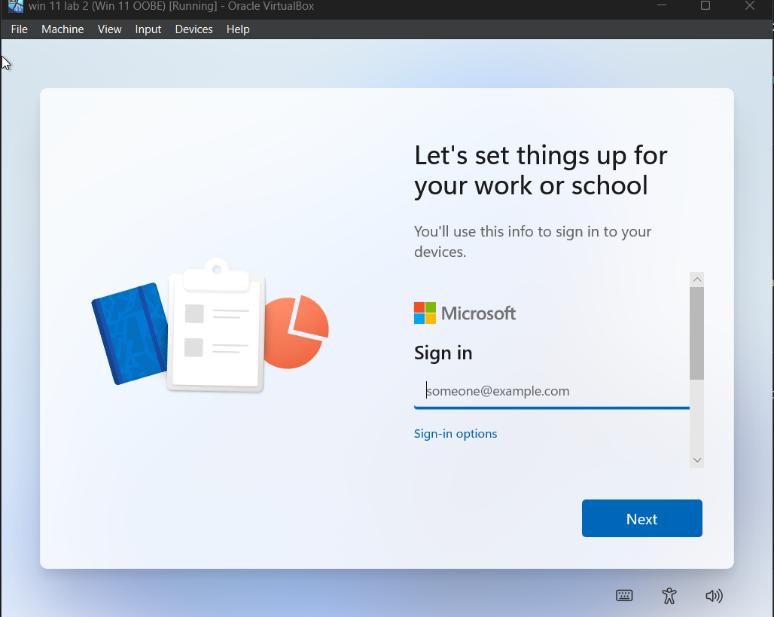

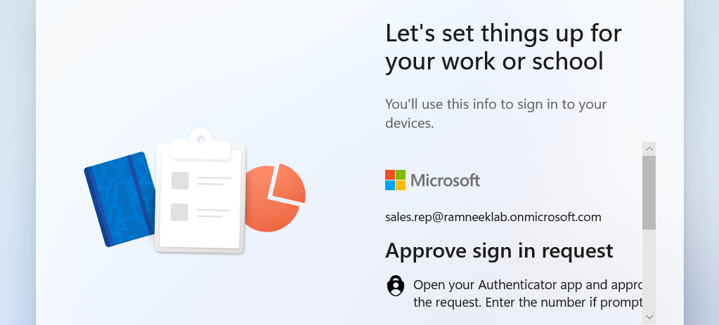
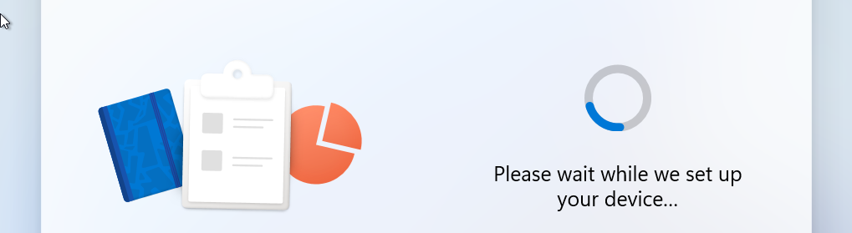
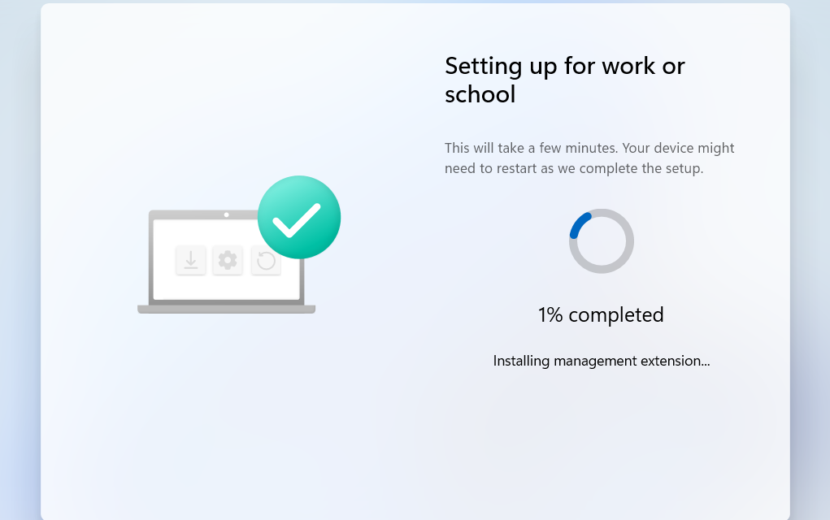

9.3 Verification
- In the Intune portal, confirm the new device shows as Enrolled via Autopilot Preparation.
- Check that policies and apps are automatically deployed.
- Test access to organizational resources (like Teams, OneDrive, etc.) to confirm successful onboarding.
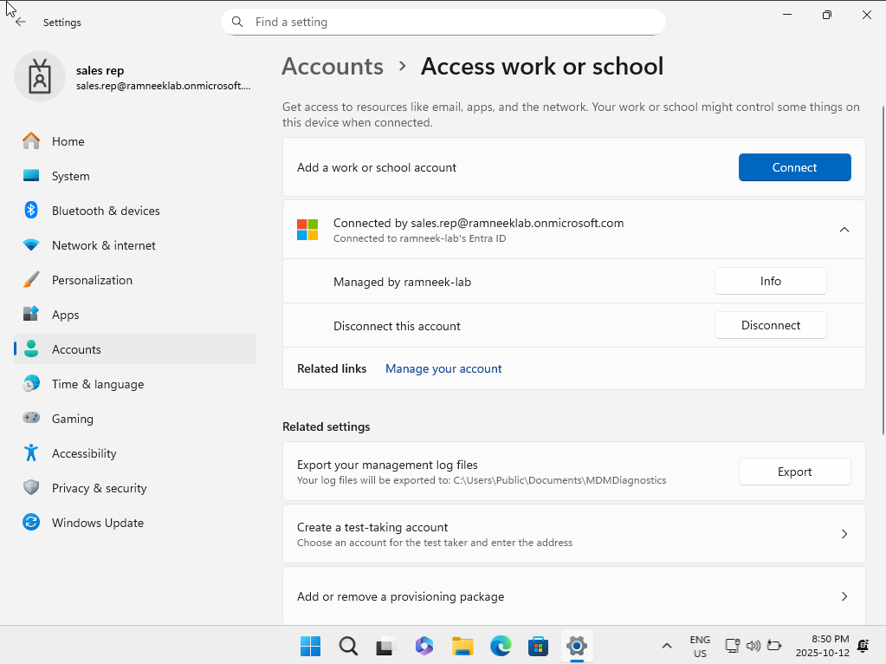
- Note: After signing in and enrolling a new device, configuration policies, apps, and scripts may take some time to apply. This delay is normal, especially in enterprise environments where multiple policies and applications are pushed to devices.

Part 10: Remediations and Scripts
Purpose: Demonstrate how automation can be used in Intune to detect and fix issues on user devices—improving efficiency for IT helpdesk operations.

10.1 Overview
Remediations and scripts in Intune allow IT admins to automatically identify and correct common device problems. Instead of manually troubleshooting, Intune runs PowerShell scripts on endpoints to maintain compliance and performance.
- Remediations are made up of two scripts:
  - Detection script: checks if a problem exists.
  - Remediation script: fixes the issue if detected.

10.2 Creating a Remediation Script
- Go to Intune Admin Center → Devices → Remediations.
- Select Create Remediation.
- Upload two PowerShell scripts:
  - Detection script – identifies the issue (e.g., checks if OneDrive is running).
  - Remediation script – resolves it (e.g., starts OneDrive if not running).
- Assign the remediation to a device group.
- Configure the schedule (e.g., hourly, daily).
- Monitor results under Reports → Remediations.
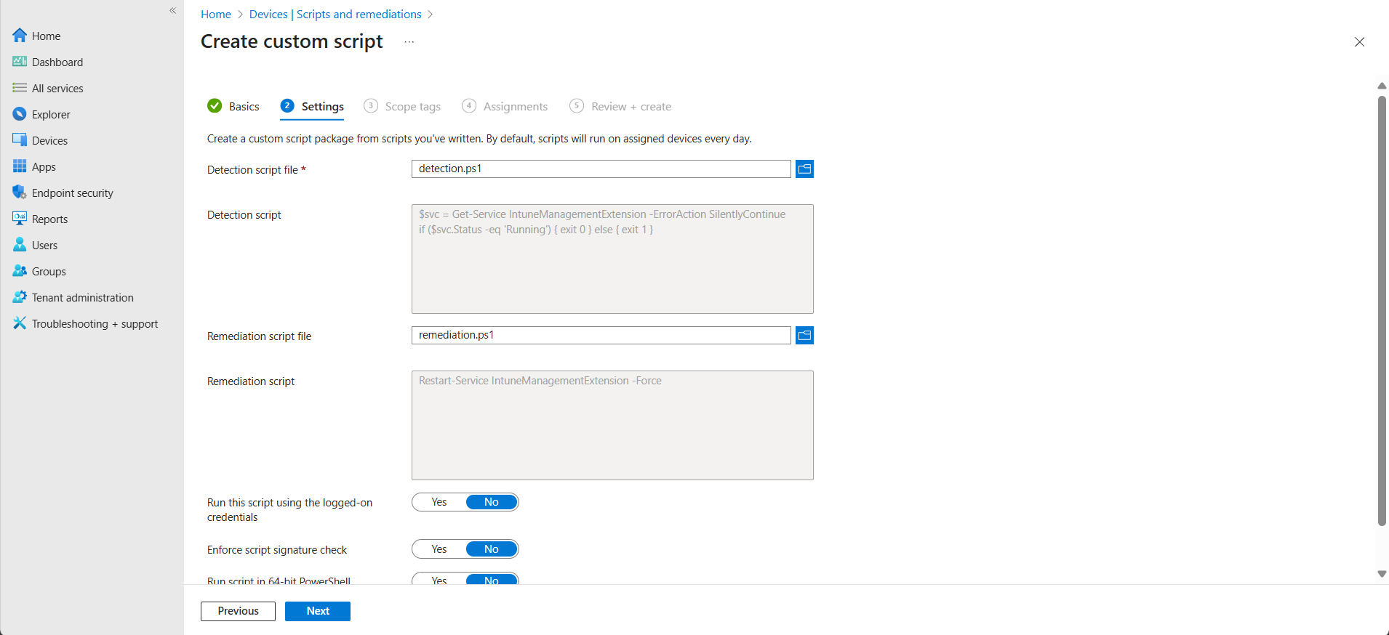
- Purpose: Automatically detect if the Intune Management Extension service (required for scripts, compliance, and remediations) has stopped, and restart it.

10.3 Regular PowerShell Scripts
- For tasks that don’t need detection/remediation logic, standard PowerShell scripts can be deployed through:
- Devices → Scripts → Add → Windows → Upload script → Assign to devices.
- These can handle:
  - App installs/uninstalls
  - Registry edits
  - Configuration fixes
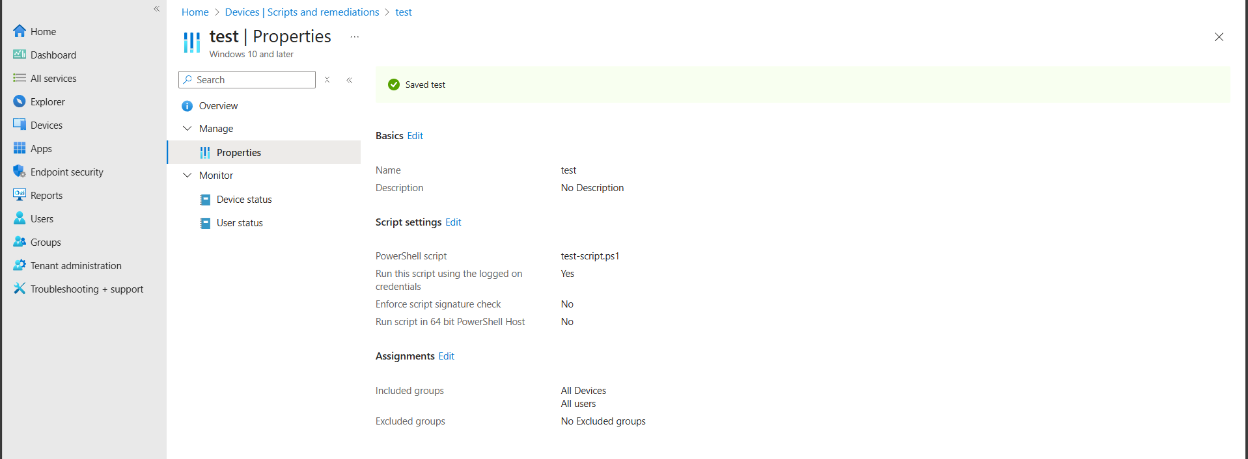
- When this script runs on the device, it automatically creates a file called
Intune_Test_File.txt on the user’s desktop with a short message inside.

